Current LNC Regions
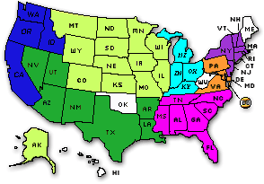
Region
Alaska, Colorado, Illinois, Iowa, Kansas, Minnesota, Missouri, Montana, South Dakota, Wisconsin, Wyoming, North Dakota, Nebraska
Region
California, Oregon, Washington, Idaho
Region
Kentucky, Michigan, Ohio, Indiana
Region
Florida, Tennessee, Alabama, South Carolina, Georgia, Mississippi, North Carolina
Region
Virginia, Pennsylvania, Maryland, Delware, District of Columbia
Region
Utah, New Mexico, Arkansas, Nevada, Louisiana, Arizona, Texas
Region
New York, Massachusetts, New Jersey, Vermont, Connecticut, New Hampshire
Orphaned Affiliates
West Virginia, Hawaii, Maine, Oklahoma, and Rhode Island

Forming LNC Regions
Use the Members column of the table to form representative regions for the Libertarian National Committee. One LNC representative is authorized for each 10% of party membership: 1413 members for a Single Region (10% of 14125) and 2825 members for a Double Region (20% of 14125). The region formation period opens February 23 and closes on May 24. State chairs should report newly formed regions to the National Secretary (Bob Sullentrup) using the Region Formation form on page 30 of the Delegation Chairs Manual. It’s never too early to start informally forming regions. I highly recommend forming regions at LSLA. Don’t put it off until the last minute.

