Chuck Moulton
1036 Hemlock Dr.
Blue Bell, PA 19422

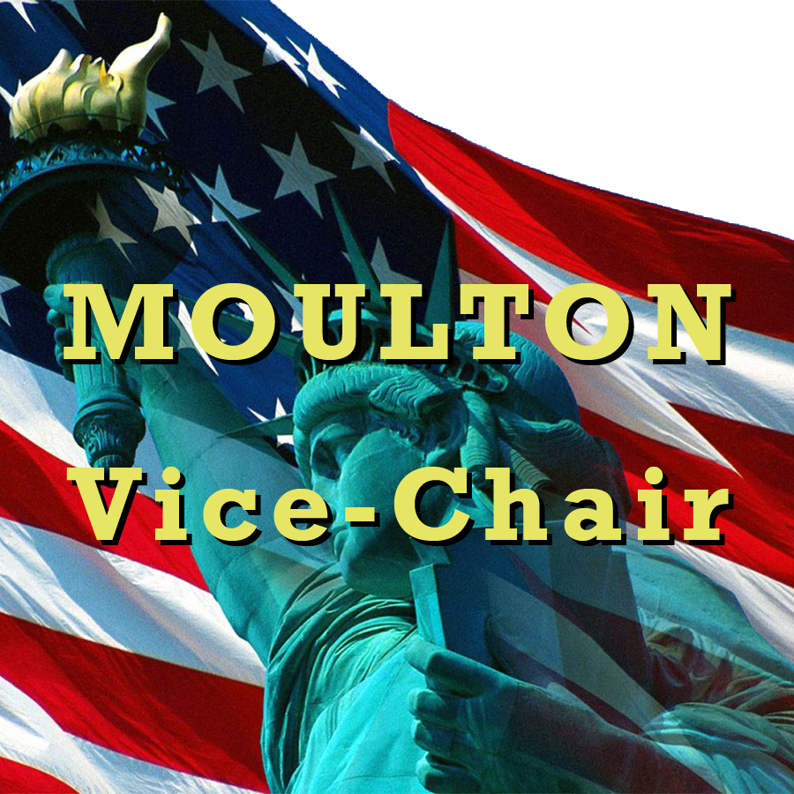
Mr. Delegate
123 Liberty St.
Philadelphia, PA 12345

