Current LNC Regions
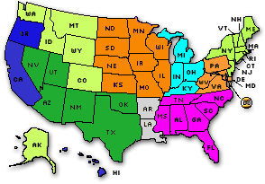
Region East
Connecticut, Maine, Massachusetts, New Hampshire, New Jersey, New York, Rhode Island, Vermont

Region West
Alaska, Colorado, Idaho, Montana, Washington, Wyoming

Region
California, Oregon, Hawaii

Region
Indiana, Kentucky, Michigan, Ohio

Region
Alabama, Florida, Georgia, Mississippi, North Carolina, South Carolina, Tennessee

Region East
Delaware, District of Columbia, Maryland, Pennsylvania, Virginia, West Virginia

Region West
Illinois, Iowa, Kansas, Minnesota, Missouri, Nebraska, North Dakota, South Dakota, Wisconsin

Region
Arizona, New Mexico, Nevada, Oklahoma, Texas, Utah

Note: Louisiana and Arkansas are currently not affiliated with any region

Forming LNC Regions

Use the Members column of the table to form representative regions for the Libertarian National Committee. One LNC representative is authorized for each 10% of party membership: 1551 members for a Single Region (10% of 15506) and 3101 members for a Double Region (20% of 15506). The region formation period opens April 2 and closes at 5pm PST on July 2. State chairs should report newly formed regions to the National Secretary, Bob Sullentrup. Prior to the convention, e-mail him at rwsully@charter.net. It’s never too early to start informally forming regions. Don’t put it off until the last minute.

