Foreign Exchange (3/21/2012) Econ 390-001

Definitions
- exchange rate – price of one currency in terms of another
  - e.g., dollars/euro ($/€) or euros/dollar (€/$)
- nominal exchange rate (e) – relative price of two currencies
- real exchange rate (q) – relative price of two output baskets
  - prices of a country’s goods and services relative to another country’s goods and services
- spot transaction – immediate (2 day) exchange of bank deposits
- spot exchange rate – exchange rate for spot transactions
- forward transaction – exchange of bank deposits at some future date
- forward exchange rate – exchange rate for forward transactions
- foreign exchange market – the financial market where exchange rates are determined
- appreciation – when a currency increases in value relative to another currency
- depreciation – when a currency decreases in value relative to another currency
- law of one price (LOOP) – the price of a good should be the same throughout the world (assuming transportation costs and trade barriers are low)
- arbitrage – taking advantage of a price difference between two markets
- theory of purchasing power parity (PPP) – exchange rates between any two currencies will adjust to reflect changes in the price levels of the two countries
- interest rate parity – the rate of return should be the same throughout the world (with capital mobility)
- exchange rate overshooting – short run exchange rate movements often overshoot their long run levels

Equations
- purchasing power parity
  - eP*/P = 1
- improved long run model
  - eP*/P = q
- interest rate parity
  - RoR = (1 + i)
  - RoR* = [E(e_{t+1})/e_{t}](1 + i*)
  - RoR = RoR*
Variable definitions
- e ≡ nominal exchange rate (in $/€)
- q ≡ real exchange rate (in $/€)
- P ≡ domestic price level (in $)
- P* ≡ foreign price level (in €)
- RoR ≡ domestic rate of return
- RoR* ≡ foreign rate of return
- i ≡ domestic interest rate
- i* ≡ foreign interest rate
- E(e_{t+1}) ≡ forward exchange rate
- e_{t} ≡ spot exchange rate

Principles
- Arbitrage causes the law of one price (LOOP). If prices are different, an entrepreneur can buy steel in the cheaper country and sell it in the more expensive country for a profit.
- PPP works in the long run, but not the short run.
- PPP is a specialized case of the improved long run model (where q = 1 due to the assumptions of PPP).
- If there are capital controls imposed, interest rate parity does not hold in the short run.
- Interest rate parity: if you invest money domestically (at i), you should get the same return as investing money abroad (at i*) converting it initially at the spot rate and back at the forward rate.
- Because the forward exchange rate impacts interest rate parity, all of the factors that effect the long run exchange rate enter into those expectations and can effect the short run exchange rate.
- The thing to keep in mind both for long term vs. short term exchange rates and for overshooting is that the asset market is much faster than the goods market.

Appreciation
- country’s goods more expensive abroad
- foreign goods become cheaper
- (€/$)↑ means dollar appreciates
- ($/€)↓ means dollar appreciates
- e↓ means dollar appreciates (e ≡ $/€)

Depreciation
- country’s goods become cheaper abroad
- foreign goods become more expensive
- (€/$)↓ means dollar depreciates
- ($/€)↑ means dollar depreciates
- e↑ means dollar depreciates (e ≡ $/€)

Long run
Factor | ER | Domestic Currency
domestic price level (P) ↑ | e↑ | depreciates
foreign price level (P*) ↑ | e↓ | appreciates
real exchange rate (q) ↑ | e↑ | depreciates
trade barriers ↑ | e↓ | appreciates
imports ↑ | e↑ | depreciates
exports ↑ | e↓ | appreciates
productivity ↑ | e↓ | appreciates

Long run (top 4 affect P or P*, bottom 4 affect q)
Factor | ER | Domestic Currency
domestic M^{S} ↑ | e↑ | depreciates
foreign M^{S}* ↑ | e↓ | appreciates
domestic inflation (π) ↑ | e↑ | depreciates
foreign inflation (π*) ↑ | e↓ | appreciates
domestic output D ↑ | e↓ | appreciates
foreign output D* ↑ | e↑ | depreciates
domestic output S ↑ | E? | ambiguous
foreign output S* ↑ | E? | ambiguous

Short run
Factor | ER | Domestic Currency
domestic interest (i) ↑ | e↓ | appreciates
foreign interest rate (i*) ↑ | e↑ | depreciates
expected future rate ↑ | e↑ | depreciates

Short run (through expected future exchange rate)
Factor | ER | Domestic Currency
domestic price level (P) ↑ | e↑ | depreciates
foreign price level (P*) ↑ | e↓ | appreciates
real exchange rate (q) ↑ | e↑ | depreciates
trade barriers ↑ | e↓ | appreciates
imports ↑ | e↑ | depreciates
exports ↑ | e↓ | appreciates
productivity ↑ | e↓ | appreciates

etc.

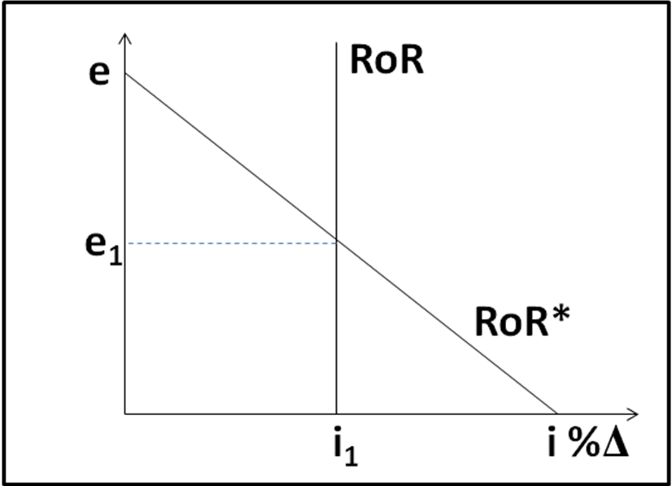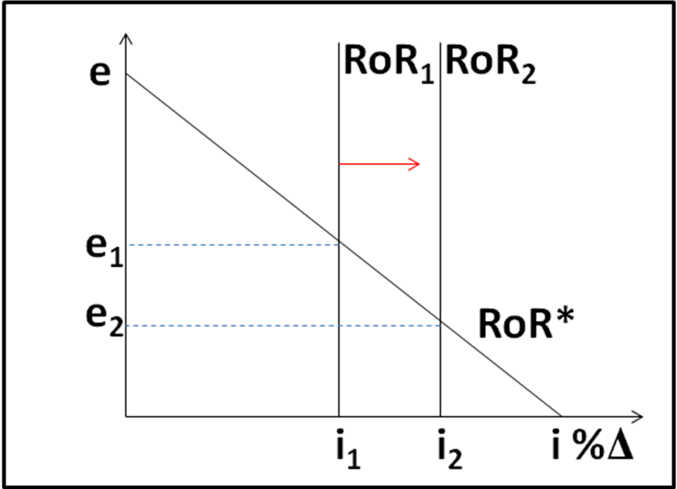
RoR = (1 + i) RoR* = [E(e_{t+1})/e_{t}](1 + i*) i↑ → shifts RoR right → e↓ → appreciates

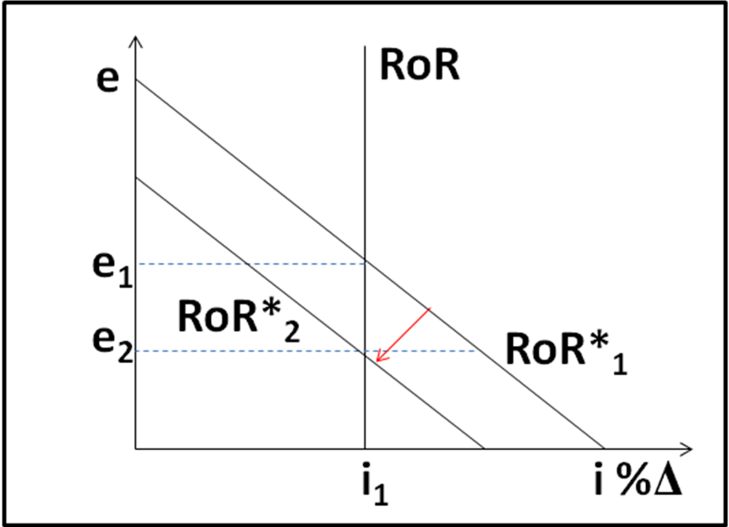
i*↓ → shifts RoR* left → e↓ → appreciates E(e_{t+1})↓ → shifts RoR* left → e↓ → appreciates

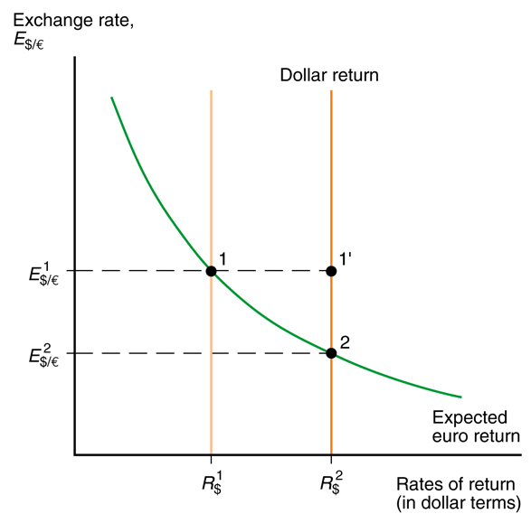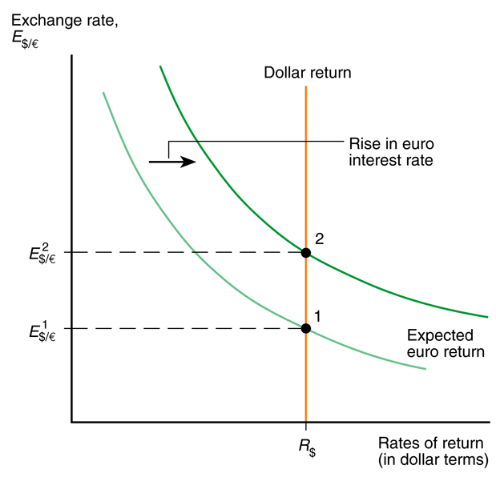
i↑ → shifts RoR right → e↓ → appreciates i*↑ → shifts RoR* right → e↑ → depreciates

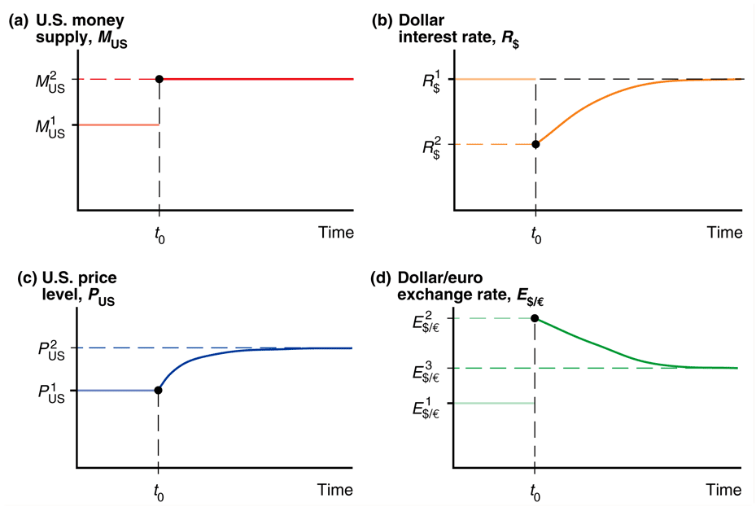
exchange rate overshooting: (a) leads to (d)

