Crash Course in Money (3/19/2012) Econ 390-001

Definitions
- barter (direct exchange) – trade for something that can be used directly in consumption or production
- double coincidence of wants – each person must want the good his trading partner is offering
- transaction costs – opportunity costs of finding a trading partner, negotiating a deal, and monitoring the terms
- medium of exchange (indirect exchange) – something not wanted for commodity value, but rather for trade value
- money – commonly accepted medium of exchange
- commodity money – money with a close relationship between money value and commodity value
- fiat money – money in which monetary value far exceeds trade value
- unit of account – common numerator of all prices
More properly:
- medium of account – good used as a pricing or accounting unit
- unit of account – specific quantity of the good used as a pricing or accounting unit
- store of value – separates act of buying from selling (saving with low transaction costs)
- standard of deferred payment – money is a good way of paying back loans
- degree of marketability – more highly marketable goods are easier to sell for a “good price” (best price with full information)
- network effect – the value of a good increases the more people use it
- uniform – purity can be tested at low cost (biting, sounding, or assaying)
- assay – chemically test the quality of metals
- durable – no extra carrying cost due to spoilage
- divisible (and fusible) – payment can be tailored to purchase size
- portable – high ratios of value to bulk
- stable value – not subject to seasonal variations
- coinage – the process of fashioning monetary metal into standardized marked discs
- seigiorage – profit that results from producing coins (difference between face value and metal value)
- purchasing power of money – the basket of goods and services that a single dollar can buy
- price level – weighted average of prices in the economy
- inflation – a rise in the price level (fall in PPM)
- deflation – a fall in the price level (rise in PPM)
- relative prices – implicit barter ratios between goods
- real variables – “constant” dollars
- nominal variables – “current” dollars
- aggregate output – total production of final goods and services in the economy
- aggregate income – Total income of factors of production (land, labor, capital) in the economy
- real money balance – quantity of money in real terms
- velocity of money – average number of times a unit of money turns over in a given period
- transactions motive – money is a medium of exchange that can be used to carry out transactions
- precautionary motive – people hold money as a cushion against an unexpected purchase need
- speculative motive – people hold money as an alternative store of wealth to bonds
- transactions demand – money demand for transactions
- portfolio demand – money demand as a store of value (captures precautionary and speculative)
- permanent income – present discounted value of all future earnings

Principles
- Transaction costs (especially search costs) can be very high under barter.
- Barter remains where laws or social norms retard indirect trade.
- Using a medium of exchange (indirect exchange) can make more beneficial trades possible.
- When a circulating medium of exchange becomes commonly accepted (widely adopted by most traders), it becomes money.
- Many forms of money have been adopted around the world.
- Carl Menger theorized that money came about through evolution from barter – aka, through the “invisible hand” (Adam Smith) or spontaneous order (F.A. Hayek).
- Traders carry an inventory of various media of exchange, preferring the most marketable commodities.
- Most civilizations converged to gold and/or silver.
- When traders from two regions with different commodity monies came into contact, the better of the two monies spread to the other region.
- Coins first appeared in ancient Lydia (Turkey) and China.
- The earliest coins were punched, later coins were stamped, finally coins were minted.
- Merchants would mark a piece of assessed gold to avoid the cost of re-assessing upon payout.
- Private mints were common around gold and silver mines.
- Marketability of coins was discontinuously greater than marketability of unminted gold.
- Marketability of money was discontinuously greater than that of other commodities.
- Price level is stated in terms of price indexes.
- Price levels move independently of relative prices.
- Capital letter variables are nominal. Lowercase letter variables are real. (nominal/P = real, e.g.: Y/P = y)
- The money supply can be in terms of any of the monetary aggregates: M1, M2, M3, MB, MZM.
- Equation of exchange is an identity, not a theory (V ≡ Py/M^{S})
- Right side of equation of exchange is nominal output (Y = Py)
- Quantity theory of money: ‾VM^{S} = ‾yP, P is flexible & y is sticky: ΔM^{S} → ΔP (doubling M^{S} will double P)
- Keynes: interest rates should be in a narrow band: when interest high, people expect it to fall.
- Keynes: If interest rates rise, then the price of a bond falls. So if i^{e}↑, expect a capital loss from bonds.
- Baumol & Tobin showed transactions and precautionary demand are also sensitive to the interest rate because people will vary how frequently they visit the bank.
- The permanent income hypothesis is that people spend money based on perceived average life income.
- Under Friedman’s theory, changes in interest rates have little effect on the demand for money.
- Friedman’s velocity isn’t constant, but it is stable: relationship between y_{P} and y is predictable.
- If something doesn’t affect M^{S} or M^{D}, then it can’t affect the price level.

Evolution
barter (direct exchange)

medium of exchange (indirect exchange)

commodity money (commonly accepted medium of exchange)

Places barter survives
- to evade or reduce taxes
- underground economy
- marriage, dating, sex
- new car (trade in old)
- health/dental benefits (less taxes)
Functions of money
- medium of exchange
- medium of account
- store of value
- standard of deferred payment

Characteristics of good money
- uniform
- durable
- divisible
- portable
- stable value

Quantity theory assumptions
- velocity is constant
- wages and prices are completely flexible

Government price indexes
- consumer price index (CPI)
- producer price index (PPI)
- GDP deflator

Keynes’ reasons individuals hold money
- transactions motive (+ related to y)
- precautionary motive (+ related to y)
- speculative motive (– related to i)

Transactions demand vectors
- population: N↑ → y↑ → M^{D}↑
- output/person: y/N↑ → y↑ → M^{D}↑
- vertical integration: merge↑ → M^{D}↓
- clearing system efficiency: eff.↑ → M^{D}↓

Transaction demand causes
- population: e.g., black death, baby boom
- output/person: e.g., Internet revolution
- vertical integration: e.g., oil company buys gas stations
- clearing system efficiency: e.g., credit cards
Portfolio demand vectors
- wealth: W↑ → M^{D}↑
- uncertainty: uncertainty↑ → M^{D}↑
- interest differential: i↑ → M^{D}↓
- anticipations about inflation: π_{e}↓ → M^{D}↑

Portfolio demand causes
- wealth: e.g., win the lottery
- uncertainty: e.g., travel to a foreign country
- interest differential: i.e., interest rate soars
- anticipations about inflation:
e.g., print money non-stop

Quantity theory of money: Liquidity preference theory:
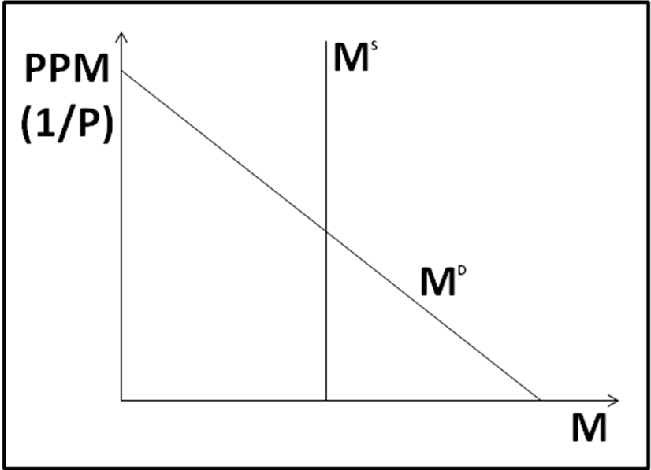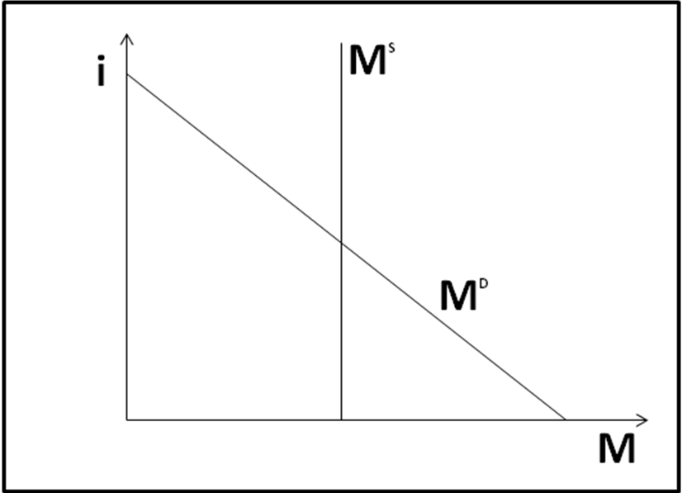

Equations
- M^{S}V = Py equation of exchange
- V ≡ Py/M^{S} definition of velocity
- Y = Py nominal output = price level x real output
- M^{D} = Py/V money demand for graphical model
- M^{S} = C money supply for graphical model
- ‾VM^{S} = ‾yP quantity theory of money: bar means constant
- M^{D}/P = f(i,y) liquidity preference theory: f_{i} < 0, f_{y} > 0
- M^{D}/P = f(y_{P}) Friedman’s quantity theory of money approximated

Variable definitions
- PPM ≡ purchasing power of money
- PPM ≡ 1/P
- P ≡ price level
- V ≡ velocity
- y ≡ aggregate output = aggregate income
- Y ≡ nominal output
- y ≡ real output
- M^{D} ≡ money demand
- M^{S} ≡ money supply
- M^{S}/P ≡ real money stock
- y_{P} ≡ permanent income
- M^{D}/P ≡ demand for real money balances
- π^{e} ≡ expected inflation rate

