Trade in Developing Countries (2/27/2012) Econ 390-001

Principles
- Import-substituting industrialization was a trade policy adopted by many low- and middle-income countries before the 1980s.
  - It aimed to encourage domestic industries by limiting competing imports.
  - Countries may have a potential comparative advantage in certain industries, but they cannot initially compete with well-established competitors in other countries.
  - Therefore governments should temporarily support them until they can compete internationally.
- Infant industry argument problems
  - Supporting industries now that will have a comparative advantage later may be wasteful.
  - With protection, infant industries may never grow up or become competitive.
  - There is no justification for government intervention unless there is a market failure that prevents the private sector from investing in the infant industry.
- Possible market failures
  - Financial market failure
    - Firms cannot save and borrow to invest in their production processes.
    - High tariffs could be a 2nd best policy instead of fixing financial market.
    - A far better solution is the 1st best policy: fix the financial market.
  - Property rights failure
    - Firms may not be able to privately appropriate the benefits of their investment in new industries because those benefits are public goods.
    - The knowledge created when starting an industry may not be appropriable (may be a public good) because of a lack of property rights.
    - High tariffs could be a 2nd best policy instead of establishing a system of property rights.
    - A far better solution is the 1st best policy: establish a system of property rights.
- Import-substituting industrialization in Latin American countries worked to encourage manufacturing industries in the 1950s and 1960s.
- The infant industry argument was not as valid as some had initially believed.
  - Import substituting countries grew slower than low tariff countries with export-oriented growth.
  - New industries did not become competitive due to of trade restrictions.
- Import-substitution was very wasteful:
  - complex, time-consuming regulations
  - high tariff rates for consumers
  - high tariff rates for firm inputs
  - inefficiently small industries
- Many governments lost faith in import substitution and began to liberalize.
  - In the mid-1980s India and Brazil dramatically lowered their tariff rates.
- The empirical evidence on trade liberalization is mixed.
  - Growth rates in Brazil & other Latin American countries slower than under import-substitution.
    - Perhaps attributable to other bad policies: lack of property rights & financial crises.
  - India has grown rapidly.
  - The Asian miracles Japan, Hong Kong, Taiwan, South Korea, Singapore, Malaysia, Thailand, Indonesia, and China have also grown rapidly – both in their export sectors and overall.
    - Other factors may have played a role in the amazing Asian growth.
      - high saving and investment rates
      - rapid growth in education
      - other economic reforms
Definitions
- infant industry argument – temporary protection of industries allows them to gain experience and thus economies of scale
- import-substituting industrialization – the strategy of encouraging domestic industry by limiting imports of manufactured goods

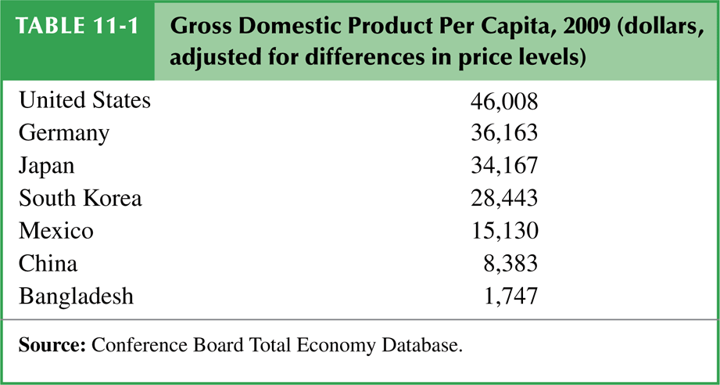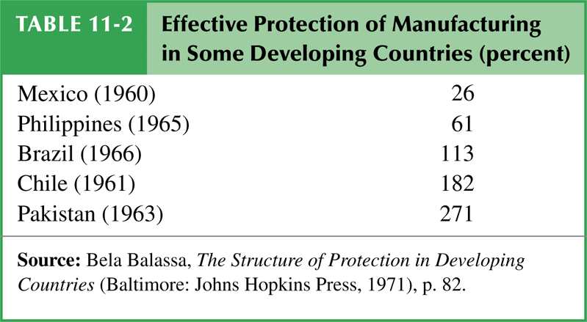

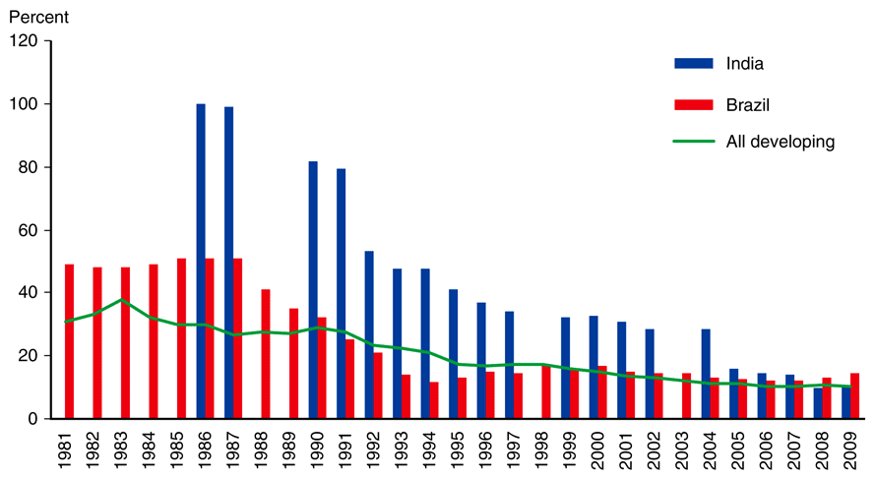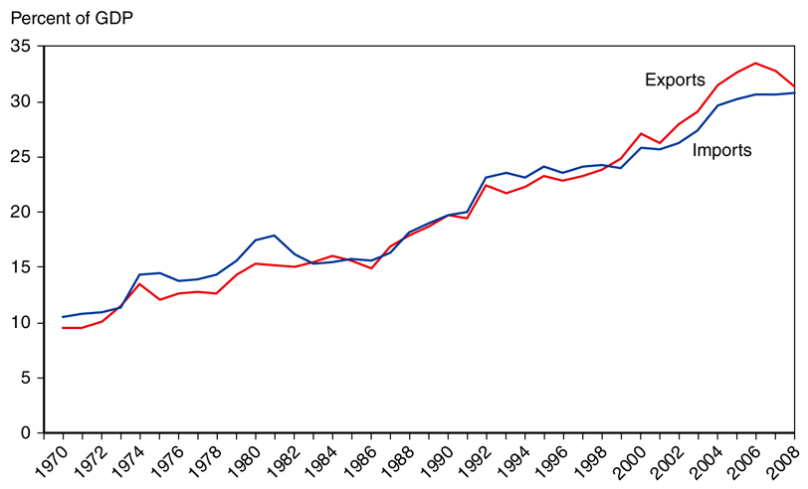
tariff rates in developing countries growth of developing country trade

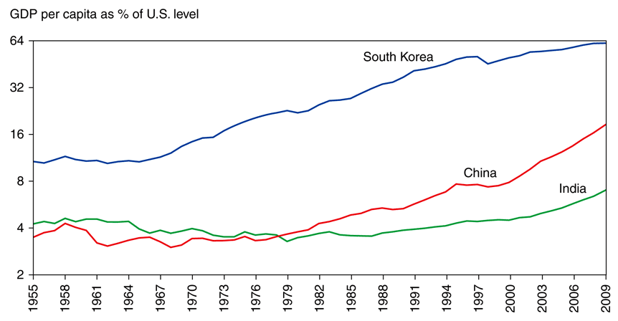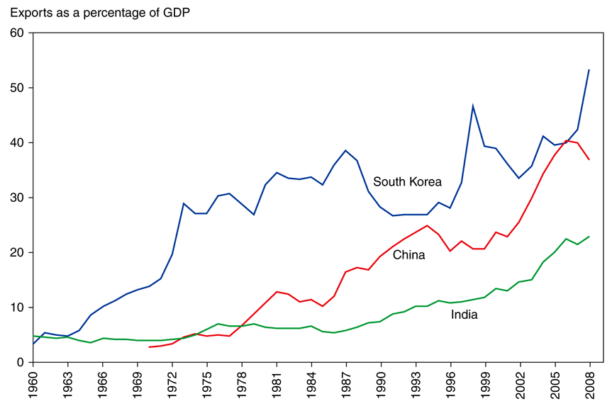
GDP in asian miracles exports in asian miracles

