Free Trade (2/24/2012) Econ 390-001

Definitions
- rent seeking – people and firms spend time and resources seeking quota rights and associated profits (often through bribes and political contributions)
- export tax – negative export subsidy
- marginal social benefit – additional benefit to society from private production
- theory of the second-best – if the best policy (fixing the market failures) is ruled out, then government intervention in an entirely different market may be a second-best way of fixing the problem
- median voter theory – political parties pick their policies to court the voter in the middle of the ideological spectrum (the median voter)
- collective action problem – a group of individuals has an incentive to act, but each individual alone has no incentive to act because costs of acting (time & resources) exceed tiny benefit
- unilateral tariff reduction – reduction in tariffs without regard to what others do
- bilateral tariff reduction – reduction in tariffs if a 2nd country does likewise
- multilateral tariff reduction– reduction in tariffs if a 3 or more countries do likewise
- preferential trade agreement – trade agreements between countries in which they lower tariffs for each other but not for the rest of the world
- most favored nation (MFN) principle – WTO members pledge all member countries will pay tariffs no higher than the nation that pays the lowest
- free trade area – free trade among members, individual trade policies towards non-members (e.g., NAFTA)
- customs union – free trade among members, a common external trade policy towards non-members (e.g., European Union)
- trade creation – high-cost domestic production is replaced by low-cost imports from other members
- trade diversion – low-cost imports from nonmembers are diverted to high-cost imports from member nations

Principles
- Arguments for free trade
  - Producers and consumers allocate resources most efficiently when governments don’t distort market prices through trade policy.
    - Thus small country welfare is highest with free trade.
  - Tariff rates are already low, so the estimated benefits of moving to free trade are small.
    - Remaining protection costs less than 1% of world GDP.
    - Gains would be larger for developing countries than advanced countries.
  - Free trade allows firms or industry to take advantage of economies of scale.
    - Protected markets limit gains from industry concentration.
      - Too many firms to enter, so firm production is inefficient.
  - Free trade provides dynamic benefits: competition and opportunities for innovation.
    - Entrepreneurs have an incentive to export more or compete with imports.
  - Free trade avoids rent seeking.
  - Free trade says that free trade is the best feasible political policy.
    - Even though there may be better policies in principle.
    - Any deviating policy would be quickly manipulated by political groups.
      - Leading to decreased national welfare.
- Arguments against free trade
  - For large countries, an import tariff and/or export tax could improve national welfare at the expense of other countries.
    - Tariffs generate terms of trade gains for a large countries.
      - This benefit may exceed production and consumption distortion losses.
    - There is an optimal tariff rate t_{O} that maximizes welfare.
      - A small tariff will lead to an increase in national welfare, but at some tariff rate, the national welfare will begin to decrease as efficiency loss exceeds terms of trade gain.
    - There is an optimal export tax rate e_{O} that maximizes welfare.
      - For a large country an export subsidy lowers the terms of trade.
      - For a large country an export tax raises the terms of trade.
    - This ignores the likelihood that other countries will retaliate by enacting their own trade restrictions, reducing welfare.
  - Domestic market failures may exist that cause free trade to be a suboptimal policy.
    - With a market failure, marginal social benefit is not accurately measured by the producer surplus, so welfare analysis misleads.
    - market failures
      - high unemployment
      - underutilized capital
      - bad property rights
      - technological benefits
      - environmental costs
      - uninformed buyers/sellers
    - When a tariff increases domestic production, it’s possible the benefit to society will increase due to the marginal social benefit compensating for a market failure.
    - The domestic market failure argument is an example of the theory of the second-best.
      - Government intervention distorting one market may increase national welfare by offsetting the consequences of market failures elsewhere.
      - The counter: domestic market failures should be corrected by a first-best policy: a domestic policy aimed directly at the source of the problem.
        - Correct high unemployment with domestic subsidies instead of tariffs.
    - It’s unclear when a market failure exists in the real world.
    - Politically powerful groups can manipulate government responses to market failures.
  - Unintended consequences from trade policies can make things worse (e.g., swallow a fly).
- Political models
  - Public choice theory shows us that political actors try to maximize their re-election chances rather than working for the national welfare.
  - Models
    - Median Voter Theory
    - Collective Action Problem
    - Mix of the 2
  - Median Voter Theory assumptions
    - 2 competing political parties
    - both want majority vote
  - Median Voter Theory implementation
    - Line up all the voters according to the tariff rate they prefer.
    - Both parties offer the same policy to capture the most votes courting the median voter.
  - MVT implies that a democracy should enact trade policy based on how many voters it pleases.
    - MVT predicts no tariffs because a few producers lose but many consumers benefit.
    - That prediction is wrong.
  - Collective action problem
    - Consumers as a group have an incentive to advocate free trade, but each individual consumer has no incentive (individual benefits tiny).
    - Thus consumers are not a strong opposition to tariffs.
    - Campaign funds often come from groups that don’t suffer from a collective action problem (special interests), such as advocates for high tariffs.
  - Mixed theory
    - politicians value popular policies
      - median voter theory
      - majority consumers
    - politicians value campaign funds
      - collective action problem
      - minority special interests: producers
- Protected interests
  - agriculture
    - small fraction of electorate
    - generous subsidies
    - trade protection
      - Common Agricultural Policy (EU)
      - 1000% tariff on rice (Japan)
      - sugar quota (USA)
  - clothing (textiles & apparel)
    - Multi-Fiber Agreement
      - multilateral w/ USA
      - quota licenses
      - phased out
    - total tariff reduction
      - 2001 to 2013
      - $14.1b (11.8b cloth)
      - to $4.6b ($2.3b cloth)
- Trade agreements
  - In 1930, the United States passed a the Smoot-Hawley tariff, which dramatically hiked tariff rates, causing trade to fall precipitously.
  - The U.S. attempted to unravel some of the damage through bilateral trade negotiations (offering to lower tariffs on U.S. imports if another country lowered its tariffs on U.S. exports).
  - Bilateral negotiations don’t take full advantage of international coordination.
    - Countries that have not made any concessions can benefit from others’ bilateral agreements (free riding on others’ low tariffs).
  - Multilateral agreements are superior to bilateral and unilateral actions because they help overcome the collective action problems which bias the political process toward protection.
    - Multilateral negotiations mobilize exporters to support free trade.
  - Multilateral negotiations also help avoid a trade war between countries.
    - A trade war could result if each country has an incentive to adopt protection, regardless of what other countries do.
    - Game theory shows an example of that situation.
      - Each country individually is better off with protection (20 > 10 and -5 > -10).
      - Both choose free trade is better than both choose protection (10 > –5).
      - A binding agreement to maintain (or transition to) free trade avoids the specter of both choosing protection.
  - In 1947, a group of 23 countries began trade negotiations under GATT.
  - In 1995 the WTO was established as a formal organization to negotiate, implement, and police multilateral trade agreements.
  - WTO goals
    - reduce tariff rates
      - multilateral negotiations
    - bind tariff rates
      - agree to no future hikes
    - eliminate nontariff barriers
      - convert subsidies and quotas to tariffs
        - more obvious
        - easier to negotiate
  - There are a few exceptions to the general rules:
    - Subsidies for agricultural exports are allowed.
    - Countries are also allowed to temporarily hike tariffs to address market disruptions caused by an import surge.
  - WTO agreements
    - General Agreement on Tariffs and Trade (GATT)
      - trade in goods
    - General Agreement on Tariffs and Services (GATS)
      - trade in services
    - Agreement on Trade-Related Aspects of IP (TRIPS)
      - international property rights
  - WTO dispute settlement procedure
    - Countries in a trade dispute can bring their case to a panel of WTO experts, which rules on whether member countries are breaking their agreements.
    - If a country doesn’t the panel’s decision, the WTO can punish it by letting other countries impose trade restrictions on it.
  - The last successful GATT multilateral negotiations was the Uruguay Round (ratified in 1994).
    - Reduced agricultural subsidies.
    - Phased out quotas on textiles and clothing (the Multi-Fiber Arrangement).
    - Quotas on imports from China were temporarily re-imposed by the U.S. due to surge in Chinese clothing exports when the MFA expired.
      - This is an example of the market disruption exception.
  - The latest round of negotiations (started in Doha, Qatar 2001) haven’t produced an agreement.
  - Most remaining protection is in agriculture, textiles, & clothing — politically organized.
- Preferential trade agreements
  - Under the WTO preferential trade agreements are generally not allowed.
  - Each country in the WTO is granted most favored nation status by other members.
  - However, preferential trade agreements are allowed if the lowest rate is zero.
    - Two types of preferential trade agreements have zero tariff rates: a free trade area and a customs union.
  - Counter-intuitively, preferential trade agreements can actually reduce national welfare.
    - Preferential trading agreements increase national welfare when new trade is created, but not when existing trade from the world is diverted to trade with member countries.

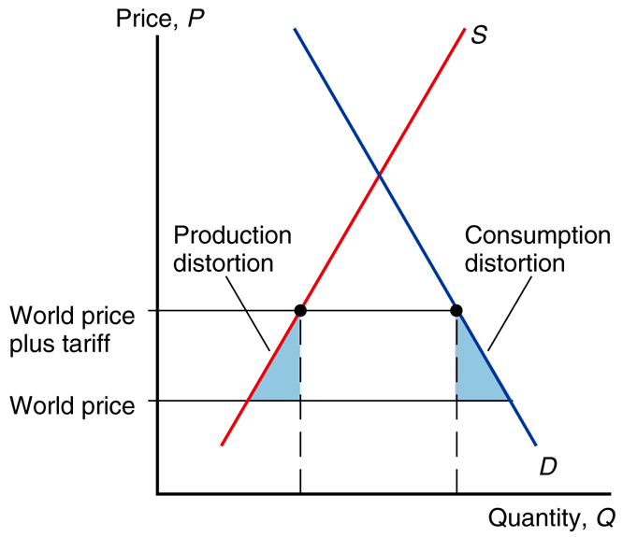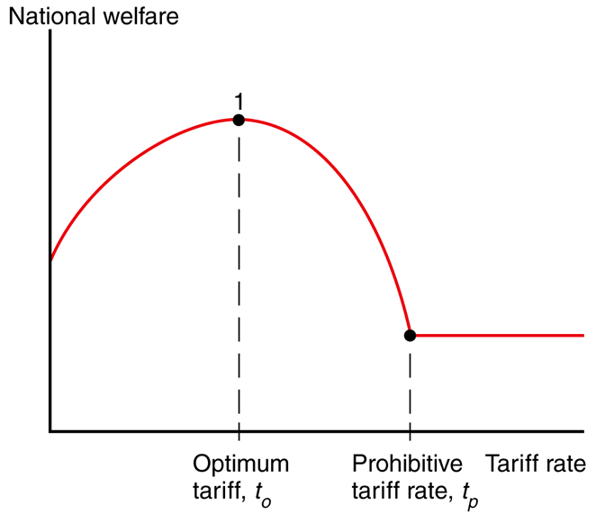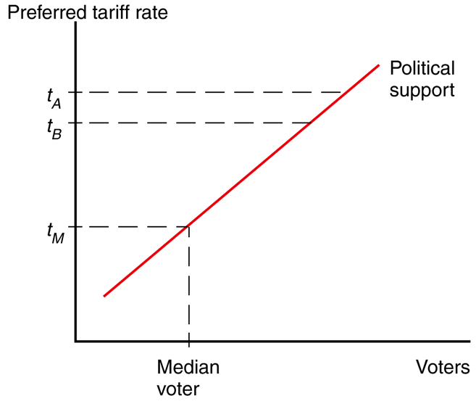
small country welfare highest optimum tariff (large country) median voter theory
with free trade (no distortions)

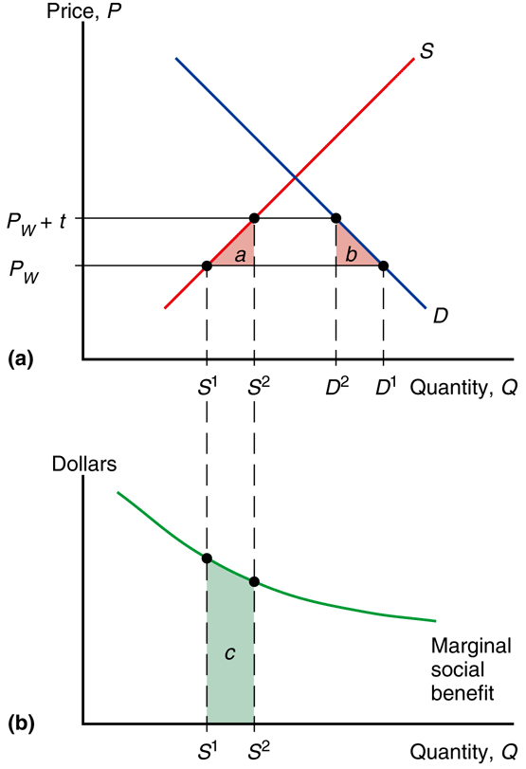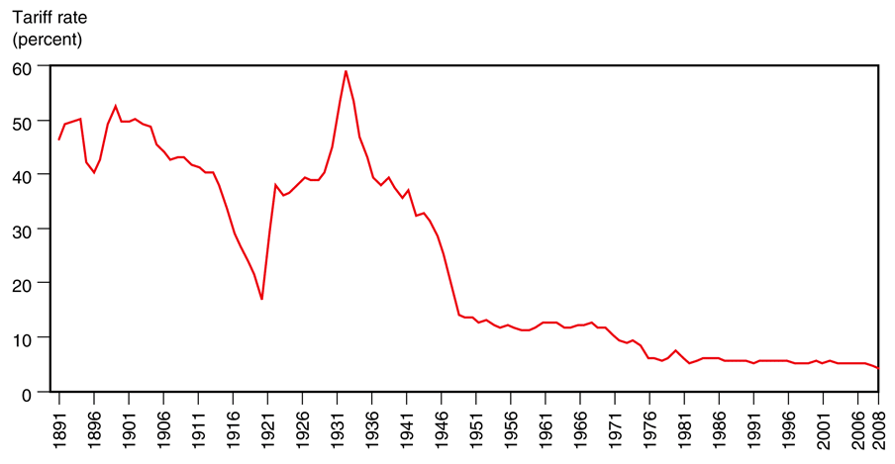
domestic market failure U.S. tariff rates
marginal social benefit

