Trade Policy (2/22/2012) Econ 390-001

Equations
- Trade
  - MD = D – S import demand
  - XS* = S* – D* export supply
  - MD = XS* equilibrium trade
    - D – S = S* – D*
  - D^{W} = S^{W} equilibrium trade
    - D + D* = S + S*
- Tariff
  - P_{T} – t = P_{T}* tariff price wedge
  - P_{T} = P_{W} + t tariff price (small country)
  - P_{S} – s = P_{S}* subsidy price wedge
- Government revenue / cost
  - t Q_{T} = (P_{T} – P_{T}*)(D₂ – S₂) tariff revenue
  - s Q_{S} = (P_{S} – P_{S}*)(S₂ – D₂) subsidy cost

Variables
- MD ≡ import demand
- D ≡ home demand
- S ≡ home supply
- XS* ≡ export supply
- D* ≡ foreign demand
- S* ≡ foreign supply
- D^{W} ≡ world demand
- S^{W} ≡ world supply
- P_{T} ≡ home price w/ tariff
- P_{T}* ≡ foreign price w/ tariff
- t ≡ tariff
- P_{S} ≡ home price w/ subsidy
- P_{S}* ≡ foreign price w/ subdisy
- s ≡ subsidy
- Q_{W} ≡ quantity exported/imported w/ free trade
- Q_{T} ≡ quantity exported/imported w/ tariff
- Q_{S} ≡ quantity exported/imported w/ subsidy

Definitions
- tariff – a tax on an import or export
- specific tariff – levied as a fixed charge for each unit of import or export
- ad valorem tariff – levied as a fraction of the value of imported or exported goods
- import demand – the difference between the quantity of a good that home consumers demand and the quantity that home producers supply at any price
- export supply – the difference between the quantity of a good that foreign producers supply and the quantity that foreign consumers demand at any price
- consumer surplus – amount that consumers gain from purchases
  - difference between the price actually paid and the max price they would be willing to pay
- producer surplus – amount that producers gain from sales
  - difference between the price actually received and the min price they would be willing to accept
- production distortion loss – too much produced at higher price
- consumption distortion loss – too little consumed at higher price
- export subsidy – a payment awarded to producers for exports
- specific subsidy – awarded as a fixed payment for each unit of export
- ad valorem subsidy – awarded as a fraction of the value of exported goods
- import quota – a restriction on the quantity of a good that may be imported
  - enforced by issuing licenses or quota rights
- quota rent – extra revenue that accrues to license holders.
- voluntary export restraint – works like an import quota, except imposed by exporting rather than importing country
- local content requirement – a regulation that requires a specified fraction of a final good to be produced domestically
- effective rate of protection – measures how much protection a trade policy provides
  - change in value that firms in an industry add to the production process when trade policy changes, which depends on the change in prices

Principles
- Trade
  - Suppose in autarky the price of wheat is higher in home than it is in foreign.
  - With trade wheat will be shipped from foreign to home until prices equalize.
  - Import demand
    - The MD curve is downward sloping.
      - As price increases, quantity of imports demanded decreases.
    - MD intersects the P axis at P_{A} (home price in autarky).
  - Export supply
    - The XS* curve is upward sloping.
      - As price increases, quantity of exports demanded increases.
    - XS* intersects the P axis at P_{A}* (foreign price in autarky).
- Tariffs
  - A tariff acts like a transportation cost.
    - Sellers won’t export unless home price exceeds foreign price by the amount of the tariff.
  - A tariff drives a wedge between the prices in home and foreign.
    - The price in home rises and the price in foreign falls relative to free trade.
  - The price with a tariff rises in the home country relative to free trade.
    - Home producers supply more.
    - Home consumers demand less.
    - Home thus imports less (falls from Q_{W} to Q_{T}).
  - The price with a tariff falls in the foreign country relative to free trade.
    - Foreign consumers demand more.
    - Foreign producers supply less.
    - Foreign thus exports less (falls from QW to QT).
  - Quantity of home imports demanded equals foreign exports supplied (at Q_{T}) when P_{T} – P_{T}* = t.
  - Home price may not rise by the full amount of the tariff because foreign export price declines.
  - When the home country is small, it has no effect on the foreign export price (which stays constant at the world price) because it is an insignificant part of the good’s world demand.
  - A tariff improves the terms of trade by lowering the price of imports in world markets.
  - Effects of a tariff (broad)
    - consumer surplus decreases
      - consumers worse off
    - producer surplus increases
      - producers better off
    - government collects revenue
      - tariff rate x imports
  - Effects of a tariff (graphical)
    - consumer surplus decreases
      - – (a + b + c + d)
    - producer surplus increases
      - + a
    - government collects revenue
      - + (c + e)
    - net benefit
      - – a – b – c – d + a + c + e
      - e – b – d
      - Usually negative (a loss).
  - Effects of a tariff (descriptive)
    - a – transfer to producers
    - b – production distortion loss
    - c – transfer to government
    - d – consumption distortion loss
    - e – terms of trade gain
  - Effects of a tariff (origins)
    - a – at expense of consumers
    - b – at expense of consumers
    - c – at expense of consumers
    - d – at expense of consumers
    - e – at expense of foreigners
- Export subsidies
  - An export subsidy lowers the price paid in importing countries.
  - An export subsidy worsens the terms of trade by lowering the price of exports in world markets.
  - Effects of a subsidy (broad)
    - consumer surplus decreases
      - consumers worse off
    - producer surplus increases
      - producers better off
    - government pays subsidy
      - subsidy rate x exports
  - Effects of a subsidy (graphical)
    - consumer surplus decreases
      - – (a + b)
    - producer surplus increases
      - + (a + b + c)
    - government pays subsidy
      - – (b + c + d + e + f + g)
    - net benefit
      - – b – d – e – f – g
      - This is always negative (a loss).
  - Effects of a subsidy (descriptive)
    - a – transfer to producers
    - b – production distortion loss
    - c – transfer to producers
    - d – consumption distortion loss
    - e – terms of trade loss
    - f – terms of trade loss
    - g – terms of trade loss
  - Effects of a subsidy (origins)
    - a – at expense of consumers
    - b – at expense of both
    - c – at expense of government
    - d – at expense of government
    - e – at expense of government
    - f – at expense of government
    - g – at expense of government
  - The European Union subsidizes exports of agricultural products.
    - This reduces world prices, costing European taxpayers $30 billion more than the benefits (in 2007).
- Import quota
  - A binding import quota pushes up the price of the import because the quantity demanded exceeds the quantity supplied.
  - When a quota is used instead of a tariff, the government receives no revenue.
  - Instead, revenue accrues to license holders (through quota rents).
  - Effects of an import quota (graphical)
    - consumer surplus decreases
      - – (a + b + c + d)
    - producer surplus increases
      - + a
    - licensees get quota rents
      - + c
    - net benefit
      - – b – d
- Voluntary export restraint
  - These restraints are usually requested by the importing country.
    - With the implicit or explicit threat of a tariff if the exporting country doesn’t comply.
  - The profits or rents from this policy are earned by foreign governments or foreign producers.
    - The exporter sells licenses instead of the importer.
  - The local content requirement may be specified in value terms, by requiring that some minimum share of the value of a good represent home value added, or in physical units.
  - Viewpoints
    - domestic producers
      - protects like import quota
    - firms w/ local content mandate
      - no strict import limit
      - ↑(home parts) → ↑imports
- Local content requirement provides neither government revenue nor quota rents.
  - The difference between the prices of home goods and imports is averaged into the price of the final good and is passed on to consumers.
- Other trade policies
  - export credit subsidies
    - subsidized loan to exporters
    - U.S. Export-Import Bank
  - government procurement
    - buy American
  - bureaucratic regulations
    - safety, health, quality, customs
- Summary
  - price up in adopting country
    - home producers
      - supply more & gain
    - home consumers
      - demand less & lose
  - size of home country
    - large
      - world price falls
    - small
      - world price fixed
  - government revenue
    - tariffs
      - increase
    - export subsidies
      - drain
    - import quotas
      - no effect
  - all create distortions
    - production loss
    - consumption loss

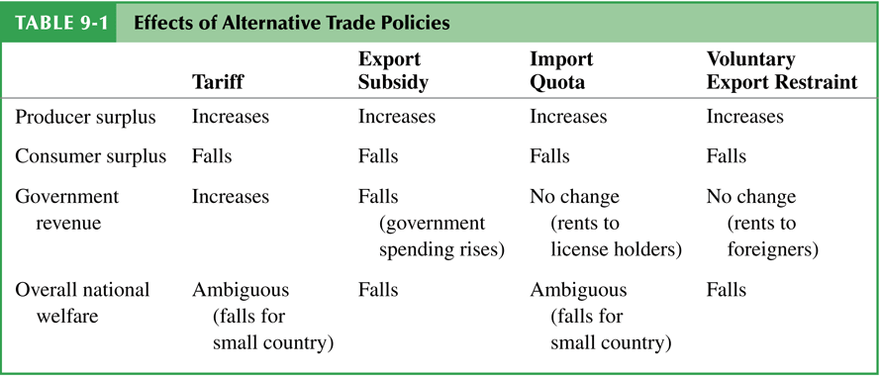
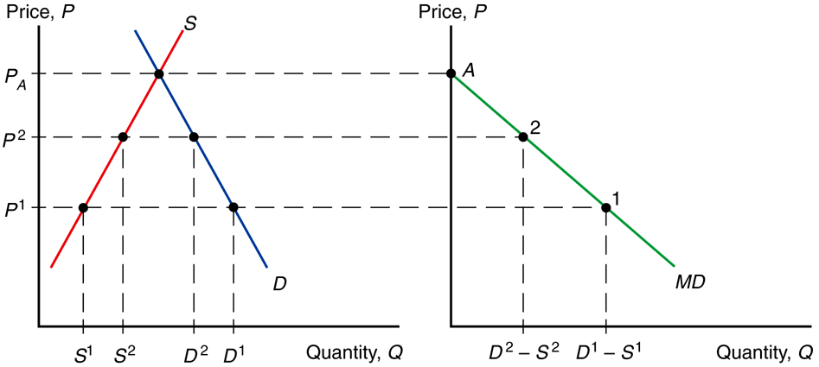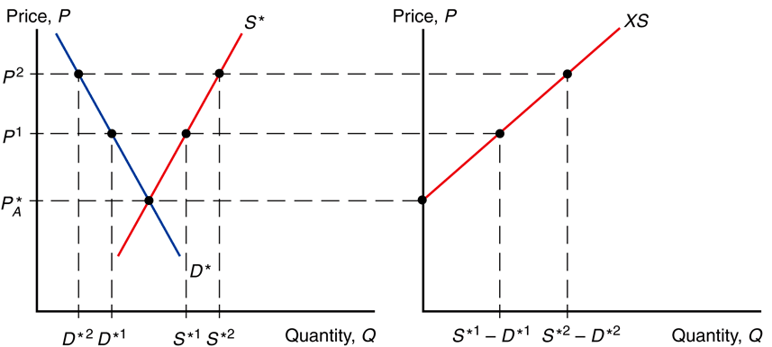
deriving the import demand curve deriving the export supply curve

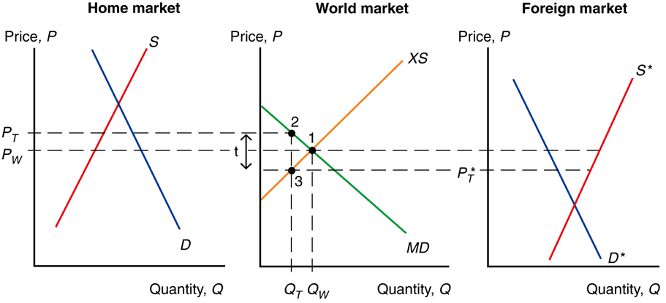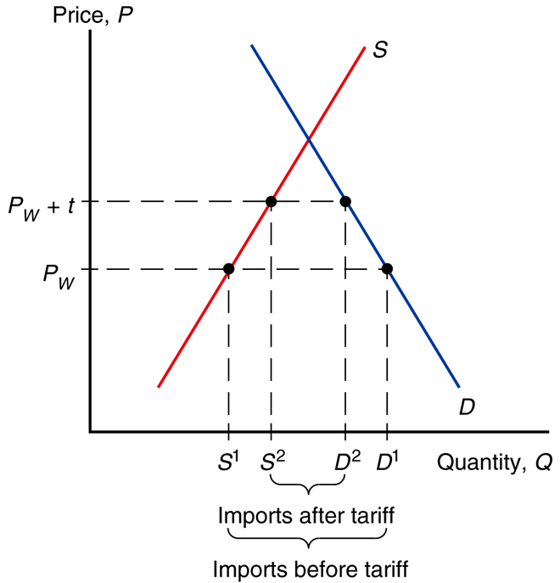
effects of a tariff tariff (small country)

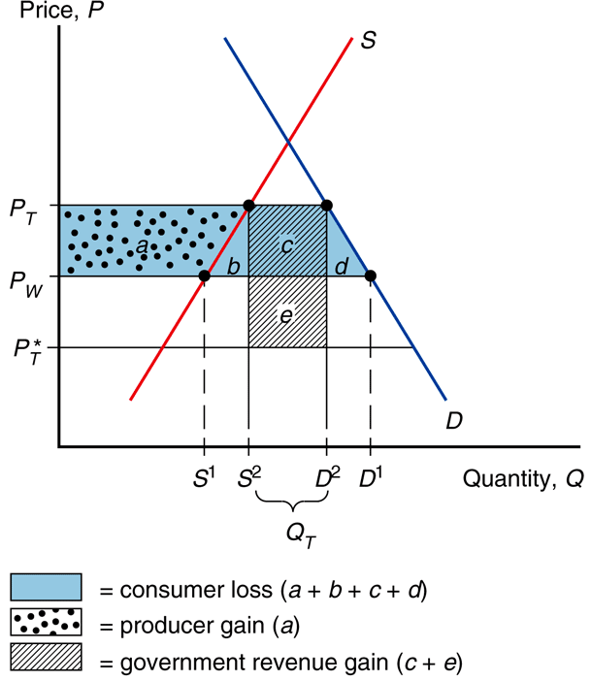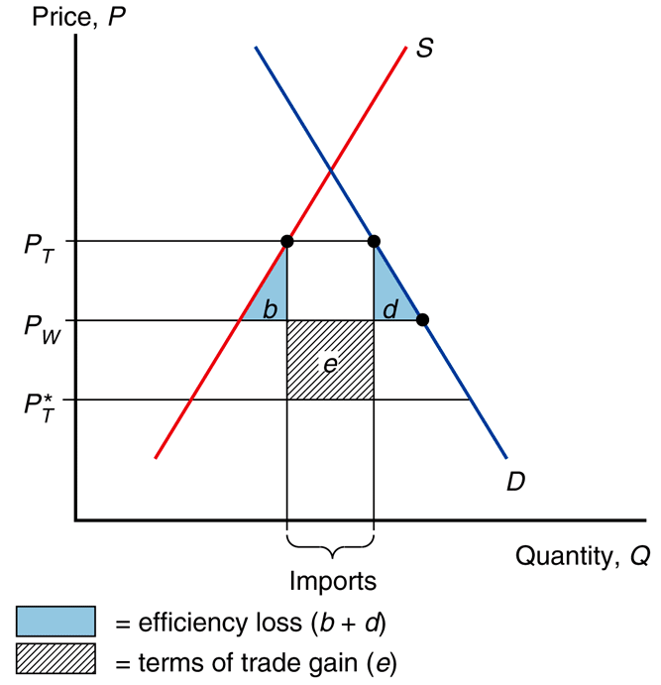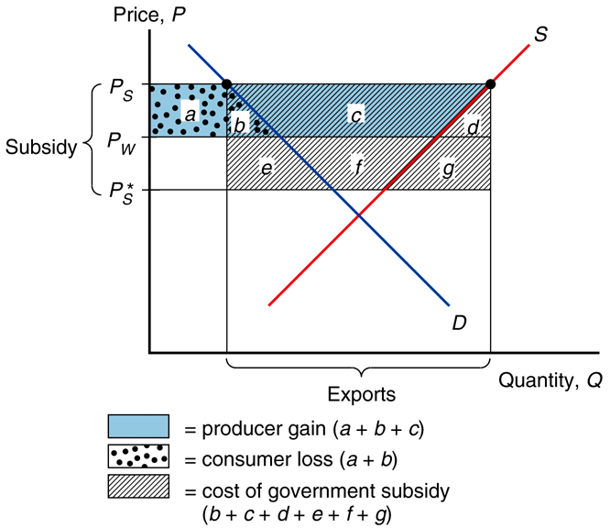
welfare effect of a tariff net welfare effect of a tariff welfare effect of an export subsidy

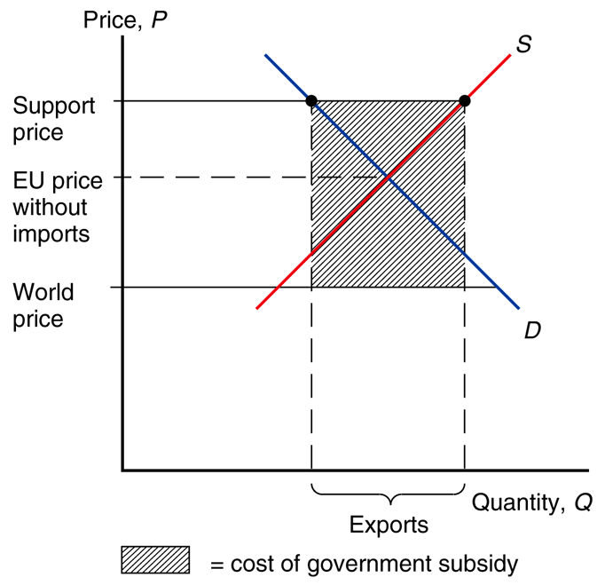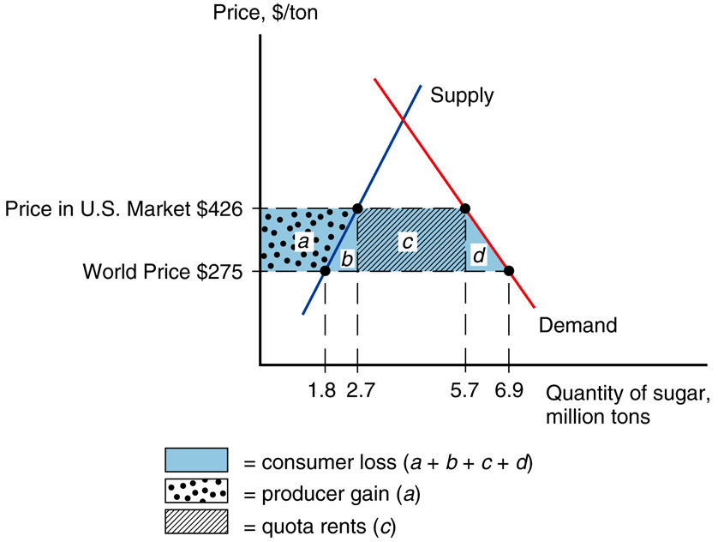
EU agriculture subsidy U.S. sugar import quota

