Sweatshops / Child Labor (2/20/2012) Econ 390-001

Principles
- Sweatshops intuitively appear bad, unfair, and immoral.
- We are accustomed to much higher wages and appreciably better working conditions.
  - Sweatshop workers don’t actually have that option.
  - Their next best alternative is something much worse (lower wages, harsher conditions, or both).
    - Many workers previously were farm laborers with longer hours and subsistence wages.
    - The choice of children is not between labor and school.
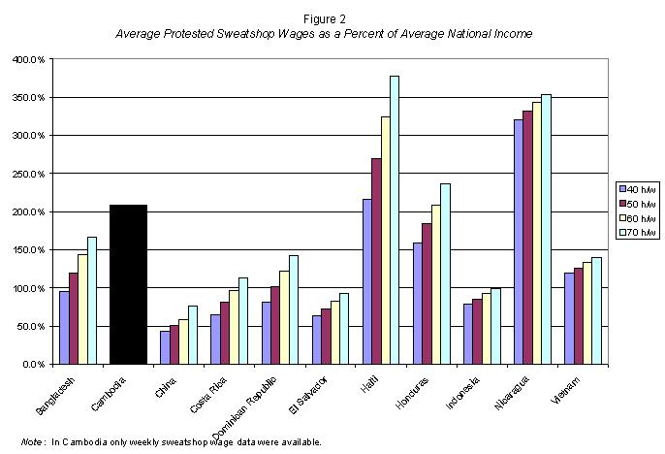
      - Instead it can be between child labor and starving.
- Fallacy of seen & unseen
  - sweatshop conditions
    - highly visible
    - caused by buyers
  - next best alternative
    - less obvious
    - unrelated to buyers
- Next best alternative
  - subsistence farming
  - scavenging for trash
  - prostitution
  - etc.

- Workers voluntarily choose sweatshops.
  - Working in sweatshops is their best alternative to eat and improve their lives.
  - 70 hour work week is normal.
- Figure 2 (protested sweatshops)
  - In 9 of 11 countries checked, sweatshop wages exceeded average income.
  - In Cambodia, Haiti, Nicaragua, & Honduras: sweatshop wages > double average income.
- Wages
  - The maximum each worker is paid is his productivity.
    - Otherwise the company would be taking a loss on each worker hired.
  - The minimum each worker is paid is his next best alternative.
    - Otherwise the worker would take a different job.
  - w_{alt} < w < P_{g}MPL_{g}
    - w_{alt} ≡ best alternative wage
    - w ≡ sweatshop wage
    - P_{g} ≡ sweatshop good price
    - MPL_{g} ≡ marginal product
  - Wages are low in the third world because productivity is low.
  - Insisting on wages above productivity (so-called “fair wages”) makes workers unemployable.
- Benefits
  - Sweatshop owners are indifferent between providing wages and benefits of the same value.
  - Possible benefits
    - health
    - safety
    - comfort
    - longer breaks
    - fewer working hours
  - Comfort and safety is a normal good, which means as income goes up workers demand more.
    - Because their wages are low, workers demand most of their compensation in wages.
  - When sweatshops are forced to provide better working conditions they must lower wages.
    - This makes workers worse off because they would have preferred the wages.
- Anti-sweatshop movement
  - Violating labor standards determines whether a factory is a sweatshop.
    - no child labor
    - minimum wages
    - occupational safety
    - maximum hours
  - protesters (all in 1st world countries):
    - unions
    - student groups
    - politicians
    - celebrities
    - religious groups
  - Some of anti-sweatshop groups want to prohibit imports from sweatshops.
    - Good intentions, bad results.
  - Boycotting sweatshop goods hurts the “exploited” workers.
    - Boycotts and import bans reduce demand for the product.
    - Reduces demand for workers.
    - Cuts wages by lowering the product price.
    - “Someone who intentionally gets you fired is not your friend.” – David Henderson
  - Mandated benefits hurts the “exploited” workers.
    - Minimum wages or mandated benefits raise compensation.
      - Perhaps above productivity.
    - Employers will respond by laying off workers.
    - To afford benefit mandates they will cut wages.
  - In 1993 Senator Tom Harkin proposed banning imports from countries that had child labor.
    - In response a factory in Bangladesh laid off 50,000 workers.
    - Many of them became prostitutes.
- Real solutions
  - Shutting down sweatshops is not the best way to lift workers out of poverty.
  - The best way s for countries to fix their institutions.
    - Respect private property and the rule of law.
    - Good institutions encourage entrepreneurs to invest in more factories.
    - More sweatshops and other opportunities will bid up wages.
    - Experience increases workers’ productivity.

