Internal Economies of Scale (2/10/2012) Econ 390-001

Equations
- Model
  - Q = S[1/n – b(P – P_{C})] monopolistic competition model
- Demand
  - Q = A – BP oligopoly demand
  - Q = (S/n + SbP_{C}) – SbP demand for monopolistic competition
  - Q = S/n when P_{C} = P
  - A = S/n + SbP_{C} A solved for monopolistic competition
  - B = Sb B solved for monopolistic competition
- Marginal Revenue
  - MR = P – Q/B
- Cost
  - C = F + cQ cost
  - MC = c marginal cost
  - AC = C/Q = F/Q + c average cost
  - AC = n(F/S) + c average cost for monopolistic competition
- Profit Maximization
  - MR = MC marginal revenue = marginal cost
  - P – Q/B = c marginal revenue = marginal cost
  - P = c + 1/(nb) equilibrium P for monopolistic competition
- Equilibrium # of Firms
  - AC = P zero profit when average cost = price (from profit max)
  - n(F/S) + c = c + 1/(nb) average cost = price

Variables
- Q ≡ firm units produced
- A ≡ constant for generic demand
- B ≡ constant for generic demand
- P ≡ price per unit charged by firm
- P_{C} ≡ competitors’ price per unit
- MR ≡ marginal revenue
- C ≡ total cost
- AC ≡ average cost
- MC ≡ marginal cost
- F ≡ fixed cost
- c ≡ marginal cost per unit
- S ≡ total sales by the industry
- n ≡ # of firms in the industry
- b ≡ sales/price responsiveness
Definitions
- internal economies of scale – cost per unit of output depends on the size of a firm (a firm’s average cost decreases with more output)
- perfect competition – firms are price takers; firms face horizontal demand curves
- imperfect competition – firms are price setters; firms face downward sloping demand curves
- pure monopoly – industry with only 1 firm
- oligopoly – industry with only a few firms
- marginal revenue – revenue from producing an additional unit of output
- marginal cost – cost of producing an additional unit of output
- intra-industry trade – two way exchange of similar goods
- dumping – setting a lower markup for exports than domestic sales
- anti-dumping duty – tax on an import equal to the difference between the actual and “fair” price (“fair” is the price in the domestic market)
- foreign direct investment – investment in which a firm in one country directly controls or owns a subsidiary in another country
- multinational corporation – a foreign company owns at least 10% of the stock of a subsidiary
- greenfield FDI – a company builds a new production facility abroad
- brownfield FDI – a domestic firm buys a controlling stake in a foreign firm; cross-border mergers & acquisitions
- horizontal FDI – the affiliate replicates the entire production process elsewhere in the world
- vertical FDI – the production chain is broken up, and parts of the production processes are transferred to the affiliate location
- outsourcing (offshoring) – a firm contracts with an independent firm to produce in the foreign location
- location decision – where (country) to produce?
- internalization decision – keep production in one firm, or produce by separate firms?
- vertical integration – consolidation of different stages of a production process

Principles
- Krugman (the textbook author) won the Nobel prize in economics for showing trade is caused not only by comparative advantages, but also by external and internal economies of scale.
- Internal economies of scale
  - Large firms have a cost advantage (firm’s AC decreases with more output).
  - There are only a few producers or goods are differentiated (rather than homogenous).
  - Integration causes better firms to thrive and expand, while worse firms contract.
  - This is an additional source of gains from trade (Smithean).
    - As production is concentrated the overall efficiency of the industry improves.
  - In imperfect competition, firms are aware that they can influence the prices of their products and that they can sell more only by reducing their price (they are price setters).
  - Monopoly profits are earned when P > AC.
  - Trade increases consumer welfare in two ways:
    - The variety of goods available increases.
    - Price drops because average cost falls.
  - Internal economies of scale leads to trade between similar countries with no comparative advantage differences between them.
    - Very different trade than comparative advantage: countries often will not specialize.
  - The model does not determine what country firms will locate in when the market is integrated.
- Monopolistic competition
  - A simple model of an imperfectly competitive industry.
  - Assumptions
    - Firms differentiate their products from competitors.
    - Firms take prices charged by rivals as given.
    - Firm sales are positively related to industry sales, competitors’ price; firm sales are negatively related to the number of firms and the firm’s price.
      - S↑ → Q↑, P_{C}↑ → Q↑, n↑ → Q↓, P↑ → Q↓
    - Firms are symmetric.
      - All firms face the same (linear) demand function.
      - All firms have the same cost function.
  - All firms should charge the same price and have equal share of the market Q = S/n.
  - AC is negatively related to the size of the market and positively related to the number of firms.
  - Maximized profits
    - Firms produce until marginal revenue equals marginal cost.
    - Price is negatively related to the number of firms (because of increased competition).
  - Equilibrium number of firms
    - The equilibrium number of firms occurs when average cost equals price.
      - If AC > P, firms will leave firms take losses
      - If AC < P, firms will enter firms make profits
      - If AC = P, equilibrium firms break even
    - The price that firms charge P decreases as n rises.
    - The average cost that firms pay increases as n rises.
  - Because trade increases market size, trade decreases average cost (S↑ → AC↓).
  - The number of firms in a new integrated market increases relative to each national market.
    - The new number of firms will be greater than each country’s number of firms in autarky, but less than the 2 countries’ number of firms in autarky totaled.
    - a < b < c < a + b
      - a ≡ # of firms in country A (autarky)
      - b ≡ # of firms: country B (autarky)
      - c ≡ # of firms: integrated
- Intra-industry trade
  - Small countries gain more from integration than large (larger variety increase, price drop).
  - 25–50% of world trade is intra-industry trade.
  - Most intra-industry trade is manufactured goods among advanced industrial nations.
- Winners and losers
  - Increased competition hurts the worst-performing firms (high MC) — they are forced to exit.
  - The best-performing firms (low MC) benefit from new sales opportunities and expand the most.
- Trade costs
  - Most U.S. firms don’t export – they only sell to U.S. customers.
    - In 2002 only 18% of manufacturing firms in the U.S. exported.
    - Even in industries that export much of what they produce (e.g., chemicals, machinery, electronics, transportation), fewer than 40% of firms export.
  - Trade costs reduce the number of firms within an industry that export.
    - They push the cost curve above the demand curve.
  - Trade costs reduce the volume of exports from firms that still export.
  - Exporting firms are bigger & more productive than firms in the same industry that do not export.
    - U.S. exporting firms are 2x larger on average than non-exporting firms.
    - The disparity is even larger in Europe.
- Dumping
  - Exporting firms respond to trade costs by lowering markup for exports.
    - A firm with a higher MC sets a lower markup over MC.
    - Trade costs raise MC.
  - But this is considered dumping, regarded as an “unfair” trade practice by countries.
    - Dumping is a profit-maximizing strategy, but it is illegal.
  - A U.S. firm may ask the Commerce Department to investigate if foreign firms are dumping.
    - The Commerce Department may impose an anti-dumping duty to protect the U.S. firm.
    - The International Trade Commission (ITC) determines if injury to the U.S. firm has occurred or is likely to occur.
    - If there is no injury, the anti-dumping duty is lifted.
  - Anti-dumping duties may be used excessively as an excuse for protectionism.
  - Dumping means consumers get goods cheaper.
- Predatory pricing
  - The problematic sort of dumping is a firm selling things below its cost (predatory pricing).
  - Predatory pricing is not effective an effective strategy in the free market.
    - Price discrimination is difficult due to arbitrage opportunities.
      - Herbert Dow bought cheap Bromide dumped in America to resell in Europe.
    - Entrepreneurs can wait out a predatory price setting oligopolist, let it burn through money with massive losses, then re-enter the market once the oligopolist stops.
- Foreign direct investment
  - Multinationals tend to be much larger and more productive than other firms (even exporters) .
  - Greenfield FDI tends to be more stable, while brownfield FDI tends to occur in surges.
  - Developed countries receive more FDI than developing and transition economies.
  - Vertical FDI is mainly driven by production cost differences between countries.
  - Horizontal FDI is mainly driven by locating production near a firm’s large customer bases.
  - Firms face a proximity-concentration trade-off.
    - High trade costs incentivize locating near customers (FDI).
    - Increasing returns to scale in incentivize concentration in fewer locations (exporting).
  - The FDI decision involves a cost savings & fixed cost trade-off.
    - If tQ > F, build a plant abroad.
    - If tQ < F, export.
      - t ≡ export cost per unit
      - F ≡ fixed cost of FDI plant
      - Q ≡ amount exported
    - If the savings from relocating a line exceeds the fixed cost of the new plant, relocate.
    - Cost savings can come from comparative advantages like cheaper labor.
- Internalization
  - Internalization occurs when it is more profitable to conduct transactions and production within a single organization.
  - internalization due to technology transfers:
    - Technology and knowledge transfers may be easier within a single organization.
      - Weak patent/property rights.
      - Hard to sell knowledge.
  - Internalization due to vertical integration:
    - Consolidating an input within a firm can avoid holdup problems.
    - But an independent supplier could benefit from economies of scale with many clients.
- Welfare
  - Relocating production (or parts of production) to take advantage of cost differences leads to gains from trade.
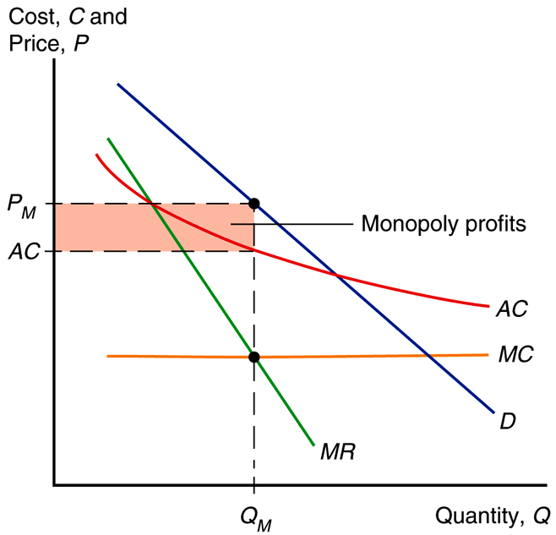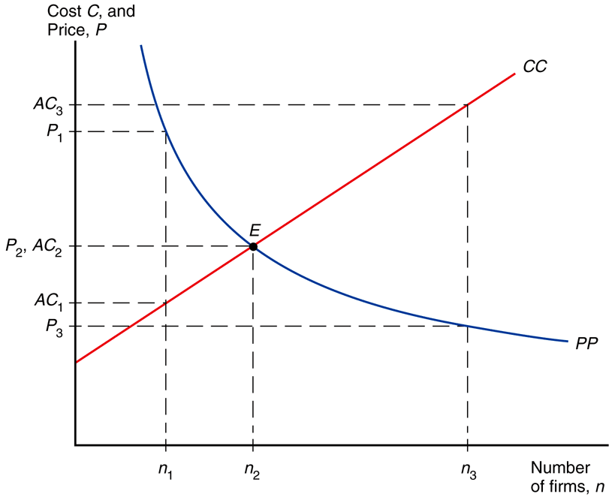
monopolistic competition pricing eqilibrium # of firms in monopolistic comp.

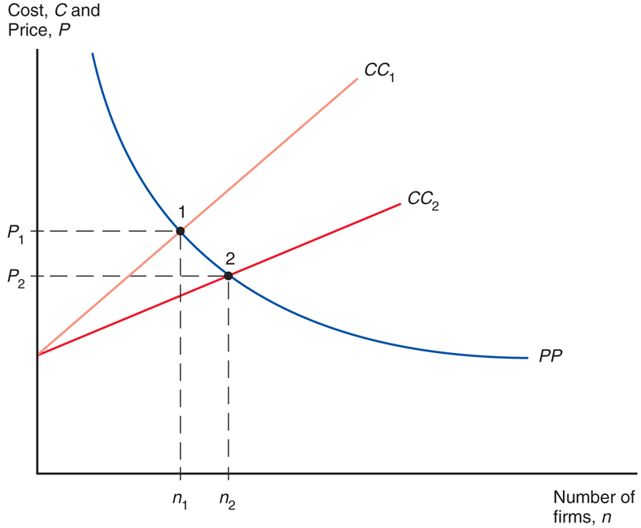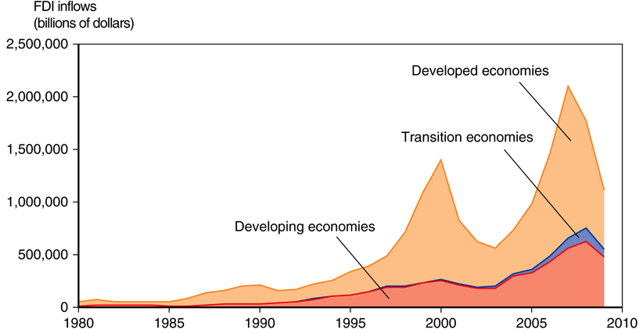
effects of a larger market (lower AC) foreign direct investment

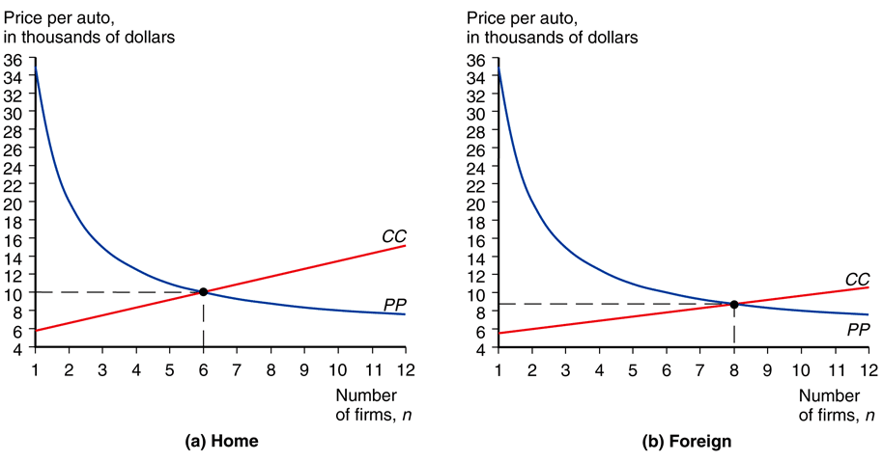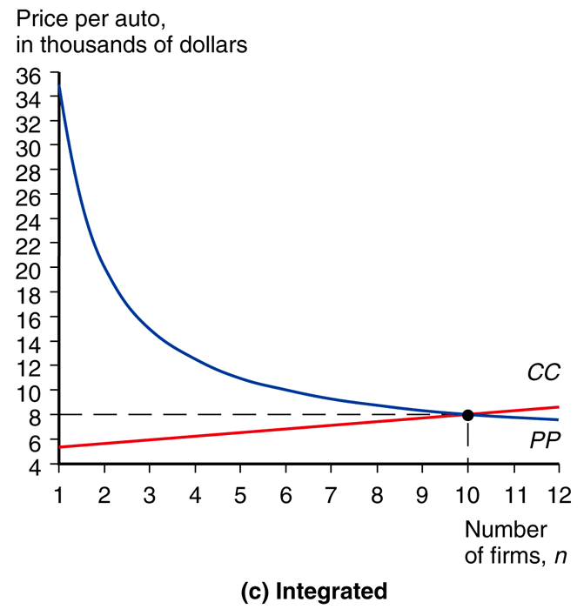
autarky integrating two markets

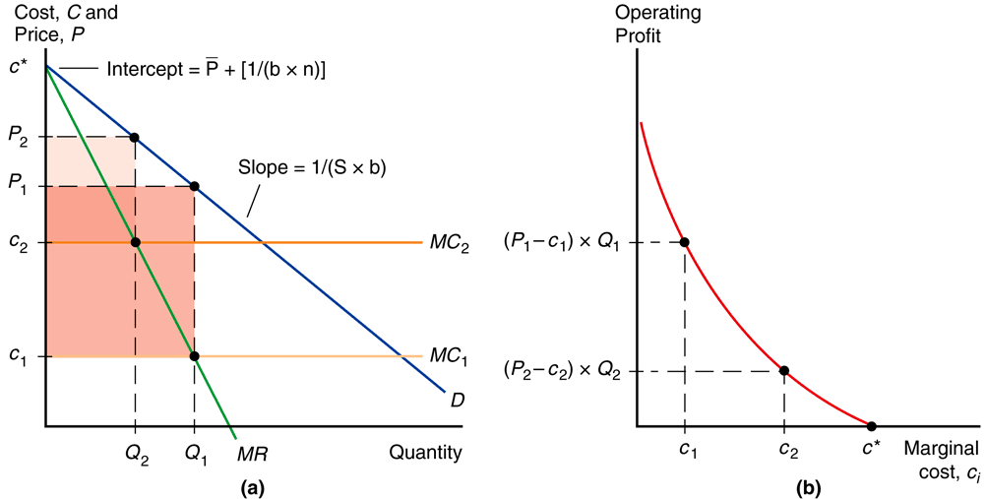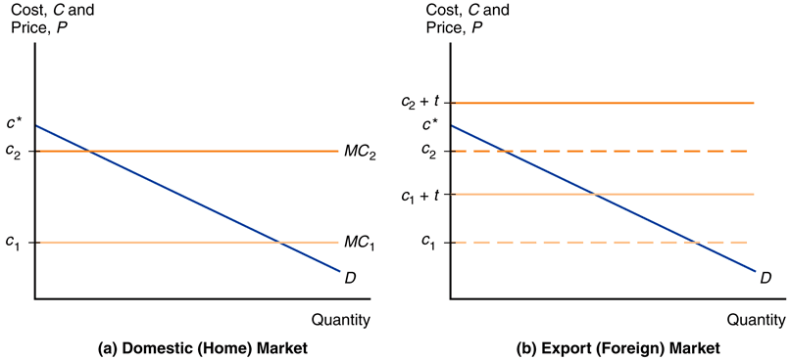
performance differences across firms export decisions with trade costs

