Standard Trade Model (2/6/2012) Econ 390-001

Equations
- budget constraints
  - V = P_{C}D_{C} + P_{F}D_{F} = P_{C}Q_{C} + P_{F}Q_{F} consumption = production
  - (D_{F} – Q_{F}) = (P_{C}/P_{F})(Q_{C} – D_{C}) value of imports = value of exports
- world relative supply & demand
  - RS^{W} = (Q_{C} + Q_{C}*)/(Q_{F} + Q_{F}*) world relative supply
  - RD^{W} = (D_{C} + D_{C}*)/(D_{F} + D_{F}*) world relative demand
- intertemporal production
  - C_{F}/C_{P} = 1/(1 + r) relative price of future consumption

Variable definitions
- production/consumption
  - Q_{C} ≡ cloth production
  - Q_{F} ≡ food production
  - D_{C} ≡ cloth consumed
  - D_{F} ≡ food consumed
- prices
  - P_{C} ≡ unit price of cloth
  - P_{F} ≡ unit price of food
- miscellaneous
  - (D_{F} – Q_{F}) ≡ imports of food
  - (Q_{C} – D_{C}) ≡ exports of cloth
  - (P_{C}/P_{F}) ≡ terms of trade
  - C_{F} ≡ future consumption
  - C_{P} ≡ present consumption
  - r ≡ real interest rate

Definitions
- indifference curve – combinations of cloth & food that leave the consumer equally well off (indifferent)
- terms of trade – price of exports relative to the price of imports
- biased growth – occurs in one sector more than others causing RS to change
- export-biased growth – expands a country’s PPF disproportionately in that country’s export sector
- import-biased growth – expands a country’s PPF disproportionately in that country’s import sector
- immiserizing growth – export biased growth worsens terms of trade so much that country would be better off if it hadn’t grown at all
- import tariff – tax levied on imports
- export subsidy – payments given to domestic producers that export
- intertemporal production possibility frontier – maximum possible mixes of current output & future output

Principles
- Standard trade model is a general model that includes other models as special cases:
  - Ricardian
  - Specific factors
  - Heckscher-Ohlin
- Assumptions
  - 2 countries: home & foreign.
  - 2 goods: cloth & food.
  - Each country’s PPF is a smooth curve.
    - PPF based on labor, capital, land, & technology.
  - A country’s PPF determines its relative supply function.
  - National RS functions determine a world RS function.
  - RS^{W} & RD^{W} determine international trade equilibrium.
- Indifference curve properties
  - downward sloping
    - less cloth needs more food for equal satisfaction
  - more is better
    - more cloth or food better than less
    - further from origin better
  - diminishing marginal substitution
    - extra cloth unit less valuable
    - convex to origin
- Terms of trade
  - A rise in terms of trade increases a country’s welfare.
    - An economy that exports cloth is better off when P_{C}/P_{F} rises.
    - Higher price of exports means a country can afford more imports.
  - A decline in terms of trade decreases a country’s welfare.
- Immiserizing growth
  - Immizerizing growth is export biased growth that worsens terms of trade so much that country would be better off if it hadn’t grown at all.
  - Immiserizing growth hasn’t been found in practice.
  - Gains from increasing productivity invariably overtake losses from reduced terms of trade.
  - Even if immiserizing growth existed, note that it wouldn’t mean trade itself is bad.
    - When terms of trade are reduced a country loses some of the gains from trade, but a country will never be better off in autarky than trading.
- Export subsidies on a good decrease the relative world price of that good by increasing RS of that good and decreasing RD of that good.
- Import tariffs on a good decrease the relative world price of that good (and increase the relative world price of other goods) by increasing the RS of that good and decreasing the RD of that good.

Model functions/graphs
- Relative supply
  - Economy maximizes value constrained by the PPF.
    - Produces at point where an isovalue line is tangent with the PPF.
  - Increasing the relative price of cloth makes the isovalue line steeper, changing production mix.
  - Determining the mix of cloth to food at each price ratio derives the relative supply curve.
    - As P_{C}/P_{F} rises, Q_{C}/Q_{F} rises. This makes the RS curve upward sloping.
- Relative demand
  - Assume the economy’s consumption decisions may be represented as if they were based on the tastes of a single representative consumer (changing income distribution doesn’t change demand).
  - Without trade:
    - Produce/consume where indifference curve is tangent to PPF.
  - With trade:
    - Consume where indifference curve is tangent to isovalue line.
    - Produce where isovalue line is tangent to PPF.
    - Export/import to get from Q to D.
  - RD curve is downward sloping.
    - As P_{C}/P_{F} rises, D_{C}/D_{F} falls.
  - Higher P_{C}/P_{F} makes the isovalue line steeper, which leads to a higher indifference curve.
    - Import more per export.
- World relative supply and demand
  - The intersection of RS^{W} & RD^{W} determines relative prices.
  - RS^{W} is between RS & RS*.
  - RD^{W} overlaps RD & RD* because there are no differences in preferences.
  - Example graph (“relative price convergence”)
    - RS^{W} intersects RD^{W} at (P_{C}/P_{F})¹
    - Home’s RS (Q_{C}/Q_{F}) exceeds home’s RD (D_{C}/D_{F}); home exports cloth & imports food.
    - Foreign’s RD (D_{C}/D_{F}) exceeds foreign’s RS (Q_{C}/Q_{F}); home exports food & imports cloth.
- Biased growth
  - Cause of biased growth
    - Ricardian model: technological progress in one sector
    - Heckscher-Ohlin model: increase in one factor of production
  - Biased growth changes a country’s relative supply.
  - Biased growth changes world relative supply.
    - This is the mechanism for changing terms of trade.
    - World relative supply sets the terms of trade.
  - Biased growth in cloth will lower P_{C}/P_{F} and lower the terms of trade for cloth exporters.
    - Export-biased growth reduces a country’s terms of trade, reducing its welfare & increasing the welfare of foreign countries.
  - Biased growth in food will raise P_{C}/P_{F} and raise the terms of trade for cloth exporters.
    - Import-biased growth increases a country’s terms of trade, increasing its welfare & decreasing the welfare of foreign countries.
- Import tariffs & export subsidies
- Import tariffs & export subsidies drive a wedge between prices in world and domestic markets.
    - Domestic P_{C}/P_{F} will be more or less than world P_{C}/P_{F}.
    - Producers & consumers will respond accordingly by shifting production & consumption.
- Import tariff
    - Home country imposes a tariff on food imports.
    - Domestic P_{C}/P_{F} falls relative to a constant world P_{C}/P_{F} (price wedge).
      - P_{F} goes up domestically due to the tariff, so domestic P_{C}/P_{F} falls.
    - Domestic producers will produce less cloth and more food.
      - RS^{W} decreases (shifts left).
    - Domestic consumers will consume more cloth and less food.
      - RD^{W} increases (shifts right).
    - World P_{C}/P_{F} rises due to the shifts in RS^{W} & RD^{W} from domestic changes.
    - Terms of trade rise & home’s welfare may increase.
      - Magnitude of this effect depends on the size of the home country.
      - Small: not much effect on RS^{W} & RD^{W} (and thus terms of trade).
      - Large: may increase welfare at the expense of foreign countries.
- Export subsidy
    - Home country imposes a subsidy on cloth exports.
    - Domestic P_{C}/P_{F} rises relative to a reduced world P_{C}/P_{F} (price wedge).
      - World P_{C} goes down due to the subsidy, so domestic P_{C} rises relatively.
    - Domestic producers will produce more cloth and less food.
      - RS^{W} increases (shifts right).
    - Domestic consumers will consume less cloth and more food.
      - RD^{W} decreases (shifts left).
    - World P_{C}/P_{F} falls due to the shifts in RS^{W} & RD^{W} from domestic changes.
    - Terms of trade fall & home’s welfare decreases to the benefit of the foreign country.
- Export subsidies by foreign
    - What matters is how foreign’s actions change world P_{C}/P_{F}.
    - Export subsidies by foreign on goods the U.S. imports
      - reduce the world price of U.S. imports
      - increase the terms of trade for the U.S.
    - Export subsidies by foreign on goods the U.S. exports
      - reduce the world price of U.S. exports
      - decrease the terms of trade for the U.S.
- Import tarriffs by foreign
    - What matters is how foreign’s actions change world P_{C}/P_{F}.
    - Import tariffs by foreign on goods the U.S. exports
      - reduce the world price of U.S. exports
      - decrease the terms of trade for the U.S.
    - Import tariffs by foreign on goods the U.S. imports
      - reduce the world price of U.S. imports
      - increase the terms of trade for the U.S.
- Intertemporal trade
  - The standard trade model can be modified to analyze international borrowing and lending.
  - Two goods are current and future consumption.
    - The same good at different times, rather than different goods at the same time.
  - Countries usually have different opportunities to invest.
  - Example
    - Home has a PPF biased to current consumption.
    - Foreign has a PPF biased to future consumption.
      - Foreign has better investment opportunities.
    - Home exports current consumption and imports future consumption.
    - Home lends by consuming less than it produces now.
    - Foreign repays by consuming less than it produces later.
  - The relative price of future consumption is 1/(1 + r).
    - The price of time is the real interest rate r.
    - 1/(1 + r) is determined by the intersection of RS^{W} & RD^{W}.

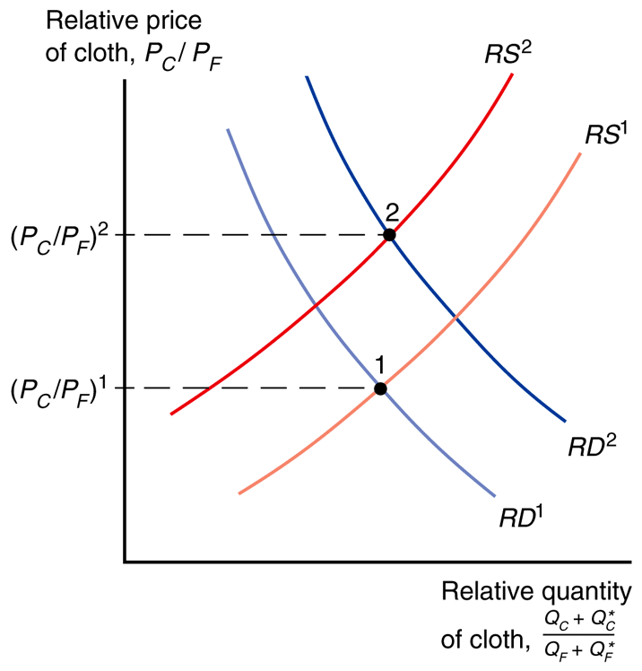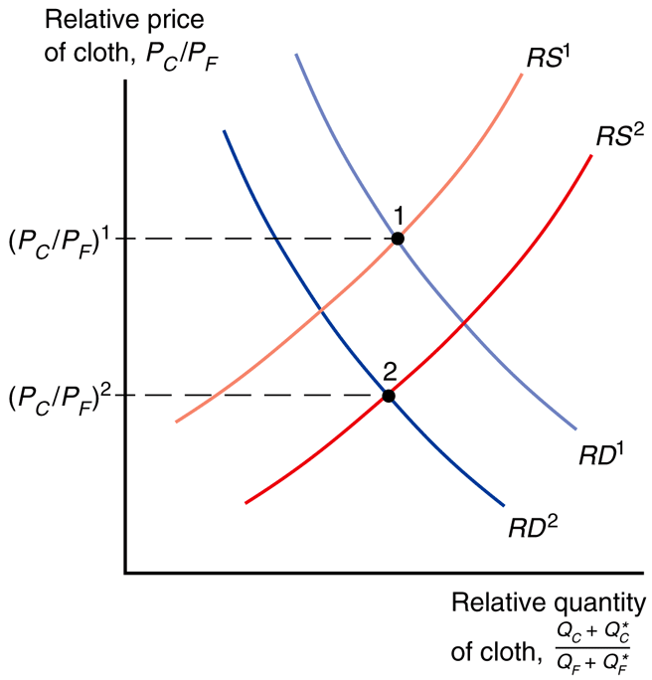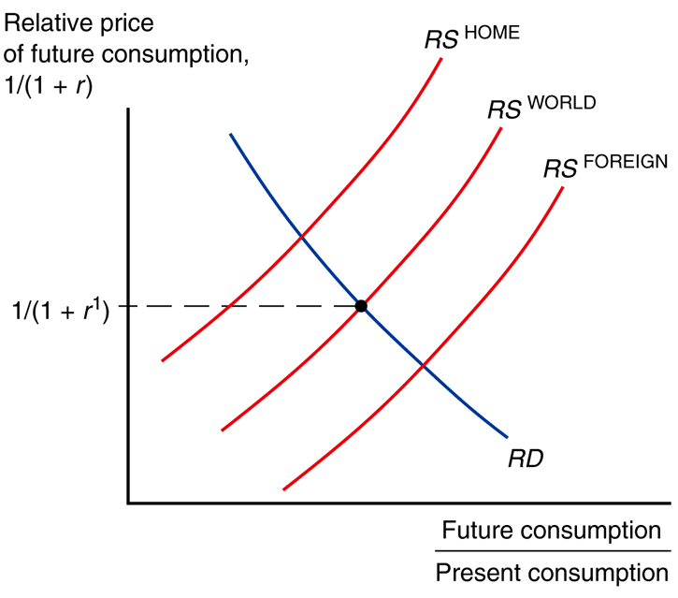
import tariff in food export subsidy in cloth intertemporal consumption
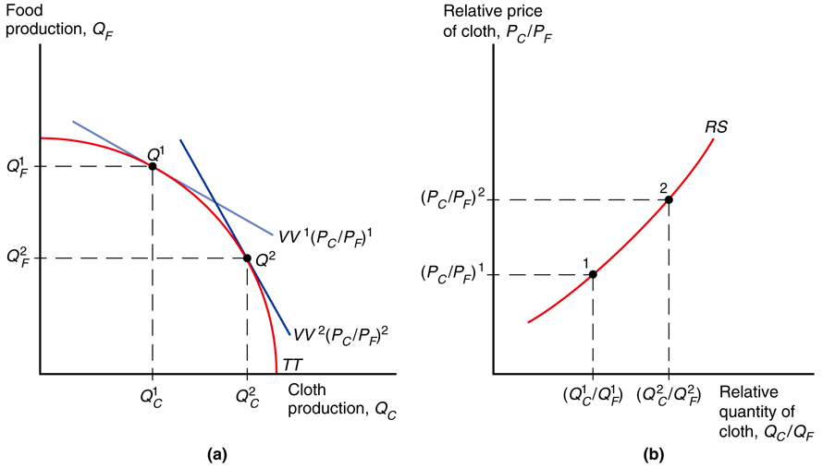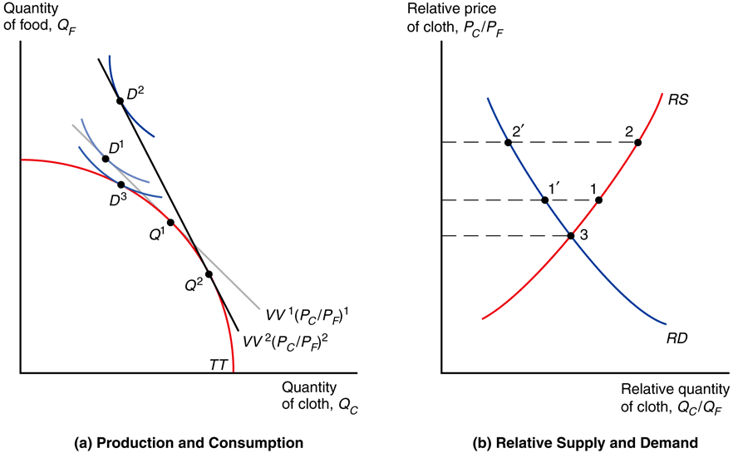
deriving relative supply deriving relative demand
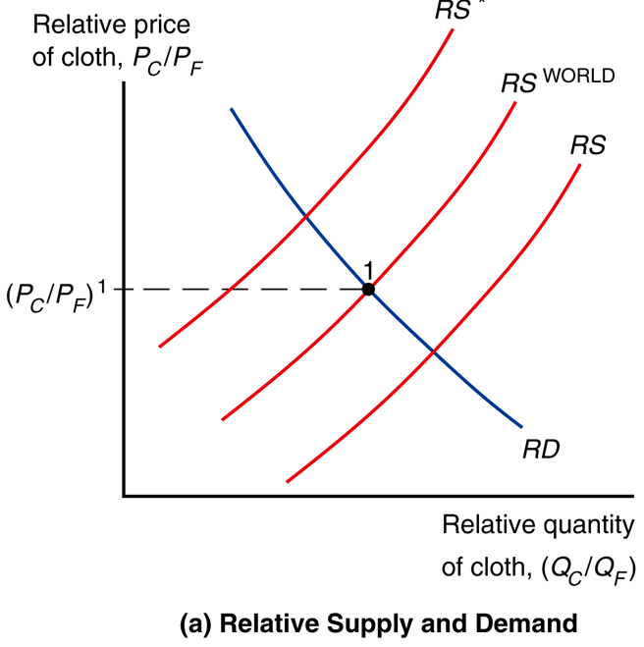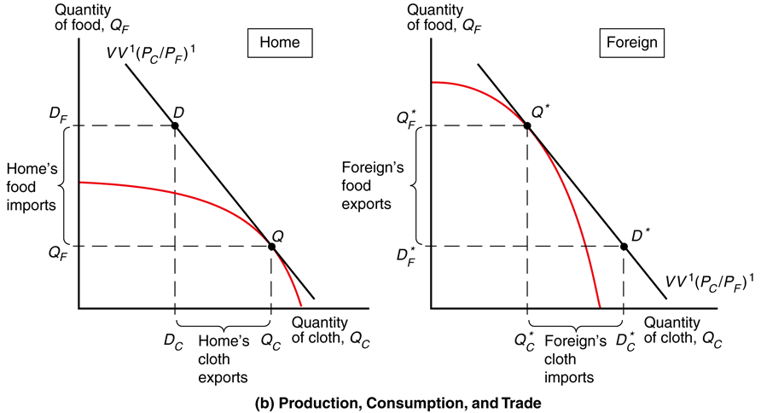
relative price convergence consumption, production, and trade
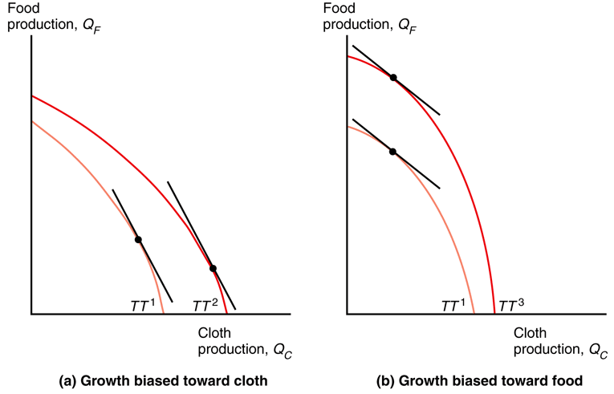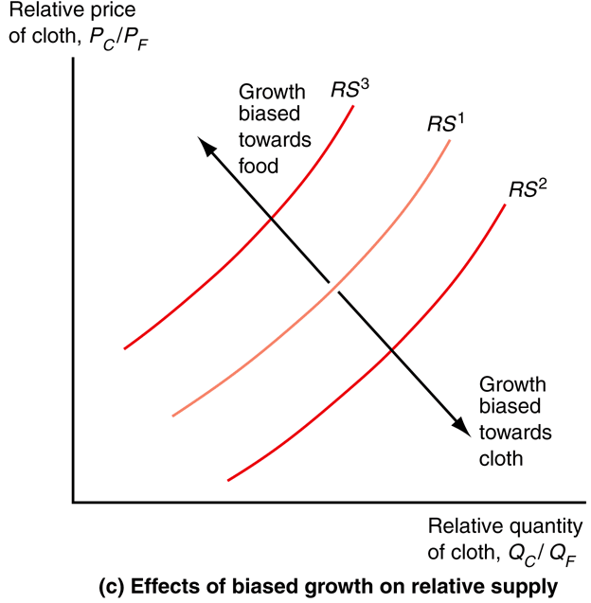
biased growth PPF biased growth RS

