Specific Factors Model (2/1/2012) Econ 390-001

Equations
- production functions
  - Q_{C} = Q_{C}(K, L_{C}) production function for cloth
  - Q_{F} = Q_{F}(T, L_{F}) production function for food
- factor price
  - w = P_{C}MPL_{C} = P_{F}MPL_{F} equilibrium wage
  - r_{K} = P_{C}MPK equilibrium rental rate of capital
  - r_{T} = P_{F}MPT equilibrium rental rate of land
- budget contraints
  - P_{C}D_{C} + P_{F}D_{F} = P_{C}Q_{C} + P_{F}Q_{F} budget constraint (consumption = production)
  - (D_{F} – Q_{F}) = (P_{C}/P_{F})(Q_{C} – D_{C}) budget constraint (imports value = exports value)
- miscellaneous
  - -P_{C}/P_{F} = -MPL_{F}/MPL_{C} relative price = opportunity cost
  - L_{C} + L_{F} = L allocation of labor between cloth and food
  - Q_{C}P_{C} = Kr_{K} + L_{C}w cloth revenue = capital costs + labor costs
  - Q_{F}P_{F} = Tr_{T} + L_{F}w food revenue = land costs + labor costs

Variable definitions
- production/consumption
  - Q_{C} ≡ cloth production
  - Q_{F} ≡ food production
  - D_{C} ≡ cloth consumed
  - D_{F} ≡ food consumed
- marginal product (high MPL means high productivity)
  - MPL_{C} ≡ marginal product of labor for cloth
  - MPL_{F} ≡ marginal product of labor for food
  - MPK ≡ marginal product of capital for cloth
  - MPT ≡ marginal product of land for food
- factors of production
  - L ≡ total supply of labor
  - K ≡ supply of capital (capital stock)
  - T ≡ supply of land
- prices
  - P_{C} ≡ unit price of cloth
  - P_{F} ≡ unit price of food
  - w ≡ wage rate
  - r_{K} ≡ rental rate of capital
  - r_{T} ≡ rental rate of land
- income distribution
  - w/P_{C} ≡ real wage in terms of cloth
  - Kr_{K}/P_{C} ≡ real income of capital owners in cloth
  - Tr_{T}/P_{F} ≡ real income of landowners in food
- miscellaneous
  - (D_{F} – Q_{F}) ≡ imports of food
  - (Q_{C} – D_{C}) ≡ exports of cloth
  - (P_{C}/P_{F}) ≡ relative price of cloth
  - (MPL_{F}/MPL_{C}) ≡ opportunity cost of cloth

Definitions
- specific factor - factor that can only be used in the production of a particular good
- mobile factor - factor that can move between sectors
- production function - relates output of a good to amount of inputs (factors)
- marginal product of labor - addition to output generated by adding 1 person hour
- diminishing marginal returns - decrease in marginal (per unit) output as the amount of a single factor of production is increased while other factors of production stay constant
- budget constraint - combinations of goods available for consumption given an income
- income distribution – division of revenues among factors of production

Principles
- The Specific Factors Model aims to explore how trade affects income distribution.
- Specific Factors Model assumptions
  - 2 goods: cloth & food.
  - 3 factors of production: labor (L), capital (K), & land (T).
  - Perfect competition in all markets.
  - Cloth produced using capital and labor (not land).
  - Food produced using land and labor (not capital).
  - Labor is a mobile factor.
    - can move between sectors
  - Land and capital are both specific factors.
    - used only in the production of one good
- Reasons for income distribution effects
  - resources can’t move instantly/costlessly between industries
  - industries use different mixes of factors of production they demand.
- Why do economists favor free trade despite distribution effects?
  - distribution effects are not specific to international trade
    - Winners and losers in all trade – not just international trade.
    - Shifting consumer preferences and technology advances, helps some and hurts others.
  - allowing trade and compensating losers better than blocking trade
    - Preserves more of the gains for society than blocking trade.
  - winners from trade are less politically organized than losers
    - Gainers are typically less concentrated, informed, and organized than losers.
    - Losers can convince politicians to block trade with tariffs and quotas.
    - As a counterweight, should favor free trade in general.
- Factors of production
  - Capital is a specific factor.
  - Land is a specific factor.
  - Labor is a mobile factor.
- Trade shifts jobs from the import sector to the export sector (labor is a mobile factor).
  - Not instantaneous … there can be temporary unemployment.
- No obvious correlation between imports (trade) and unemployment in the U.S.
- Only 2.5% of involuntary displacements stemmed from plants moved overseas / import competition.
- Empirically there has been real wage convergence due to international migration.
  - Wages don’t actually equalize because of immigration restrictions.
- Real wages start out higher in destination countries than in origin countries.
- Real wages rose faster in origin countries than in destination countries.
Model functions/graphs
- Production function
  - When labor moves from food to cloth, output of food falls while output of cloth rises.
  - Shape reflects the law of diminishing marginal returns.
    - Each unit of labor adds less output than the last.
    - Each worker has less capital with which to work.
  - Marginal product of labor is the first partial derivative for labor of the production function.
    - MPL_{C} is downward sloping because of diminishing marginal returns to labor.
- Production Possibilities Frontier
  - Diminishing marginal returns to labor leads to a curved PPF.
    - See 4 quadrant diagram:
      - lower left quadrant: allocation of labor
      - lower right quadrant: cloth production function
      - upper left quadrant: food production function
      - upper right quadrant: PPF for cloth and food
  - At the production point PPF must be tangent to budget constraint
    - PPF slope is opportunity cost of cloth in terms of food (-MPL_{F}/MPL_{C}).
      - The slope of the PPF is steeper with more cloth.
    - Budget constraint slope is relative price of cloth to food (-P_{C}/P_{F}).
- Allocation of labor
  - The wage equals the value of the marginal product of labor in manufacturing and food sectors.
    - Employers maximize profits by demanding labor up to the point where the value produced by additional hour equals the marginal cost of employing worker that hour.
  - Demand for labor in the cloth sector is MPL_{C}P_{C}. (measured left to right)
  - Demand for labor in the food sector is MPL_{F}P_{F}. (measured right to left)
  - Demand curves intersect at w and the allocation of labor between sectors.
  - The two sectors must pay the same wage because labor can move between sectors.
- Income distribution
  - Equal (proportional) change (P_{C} up 10% & P_{F} up 10%)
    - ΔP_{C}/P_{C} = Δw/w = ΔP_{F}/P_{F}
      - 10% = 10% = 10%
    - No real changes.
      - Output of cloth and food don’t change.
      - Labor in cloth and food don’t change.
      - Real wages (w/P_{C} & w/P_{F}) don’t change.
      - Real incomes of capital owners (Kr_{K}/P_{C}, Kr_{K}/P_{F}) don’t change.
      - Real incomes of landowners (Tr_{T}/P_{C}, Tr_{T}/P_{F}) don’t change.
  - Change in relative prices (P_{C} up 10%, P_{F} constant)
    - ΔP_{C}/P_{C} > Δw/w > ΔP_{F}/P_{F}
      - 7% > ~2.5% > 0%
    - Real changes.
      - Output of cloth rises; output of food falls.
      - Labor in cloth rises; labor in food falls.
      - Real wages in terms of cloth (w/P_{C}) fall; real wages in terms of food (w/P_{F}) rise.
      - The welfare change for workers is ambiguous.
      - Real incomes of capital owners (Kr_{K}/P_{C}, Kr_{K}/P_{F}) rise.
      - Real incomes of landowners (Tr_{T}/P_{C}, Tr_{T}/P_{F}) fall.
- Relative supply/demand
  - Assume preferences are the same across countries, so relative demand is RD^{W}.
  - Before trade P_{C}/P_{F} is at the intersection of a RS & RD^{W}.
    - Without trade, consumption must equal production.
  - After trade P_{C}/P_{F} is the intersection of RS^{W} & RD^{W}.
    - Trade allows consumption to differ from production.
    - Import/export for the differences.
  - International trade shifts P_{C}/P_{F}, so factor prices change.
  - Income distribution effects
    - Trade benefits the factor specific to the export sector in both countries.
    - Trade hurts the factor specific to the import sector in both countries.
    - Trade has ambiguous effects on mobile factors.
    - It is possible to redistribute income so that everyone gains.
      - But doesn’t necessarily happen.
- Budget constraint for trading economy
  - Budget constraint with trade lies above the PPF.
- International labor mobility
  - Workers migrate to where wages are highest.
  - Without migration:
    - Workers in the Home country earn a low real wage (point C).
    - Low MPL (productivity) due to less land per worker.
    - Workers in the Foreign country earn a high real wage (point B).
    - High MPL (productivity) due to more land per worker.
  - With migration:
    - Real wages in Home and Foreign reach equilibrium (point A).
    - Emmigration from Home reduces L and raises Home real wages.
    - Immigration to Foreign increases L* and lowers Foreign real wages.
    - World output rises: labor moves to where it is more productive.
  - Income distribution effects
    - Workers initially in Home benefit (real wages rise)
    - Workers initially in Foreign lose (real wages decline).
    - Landowners in Foreign gain from the inflow of workers.
    - Landowners in Home lose from the outflow of workers.

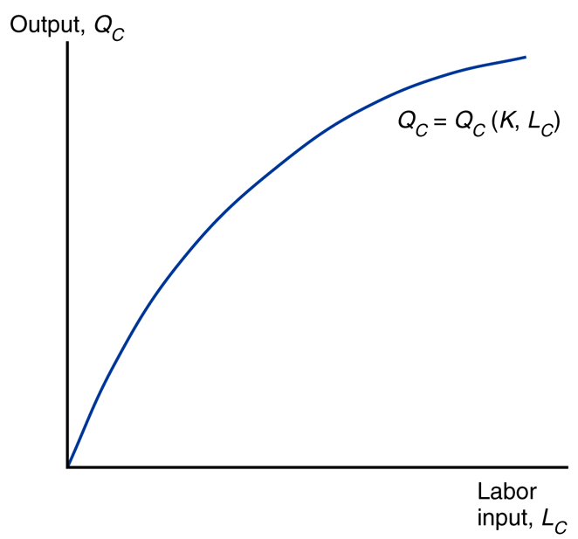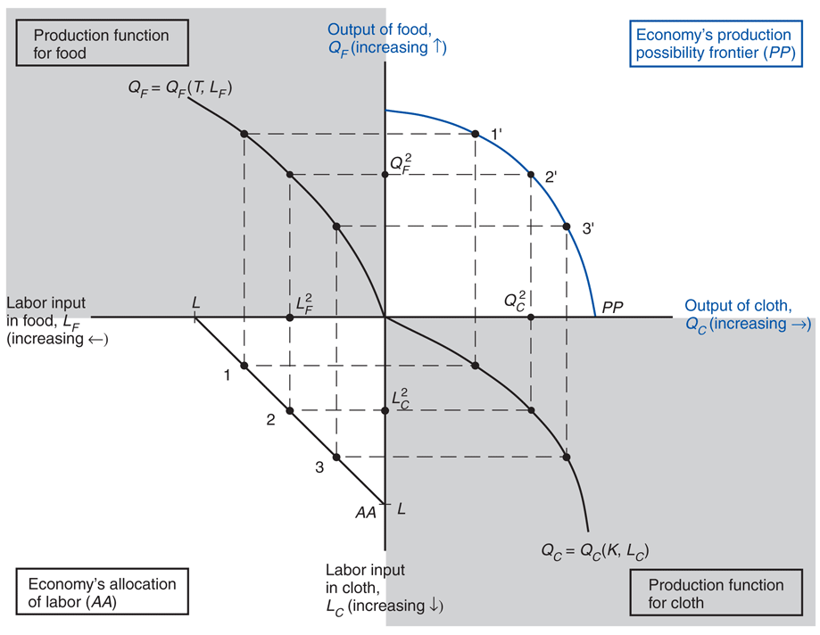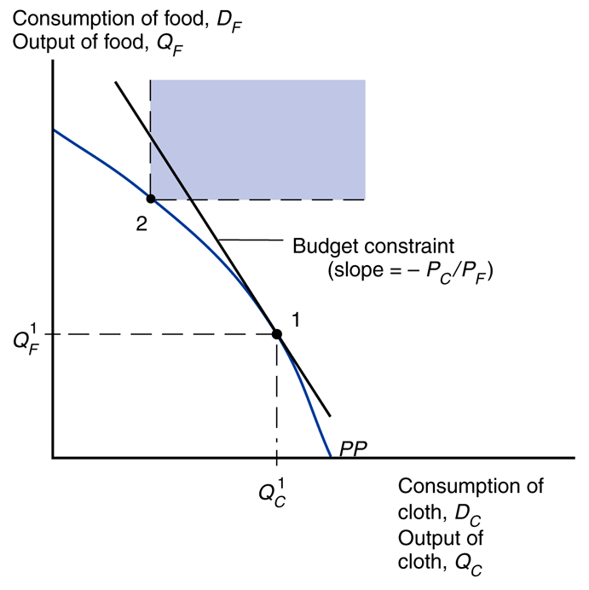
Production Function Production Possibilities Frontier (derive) Production Possibilities Frontier

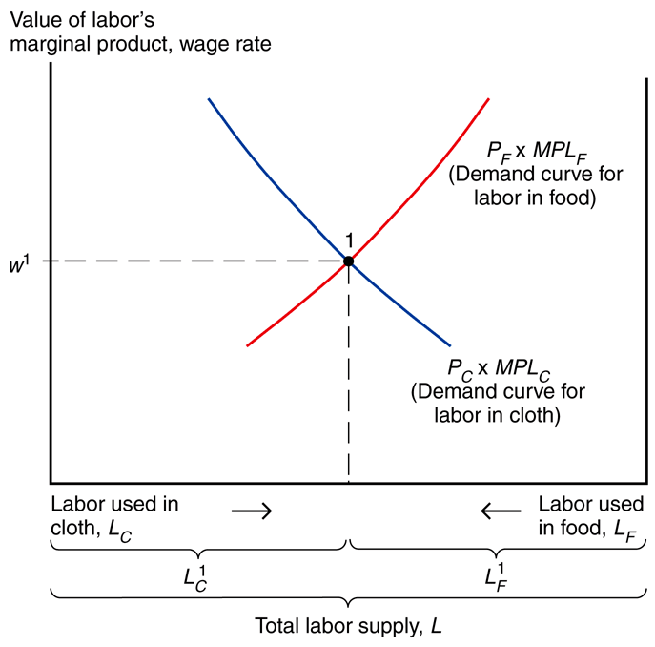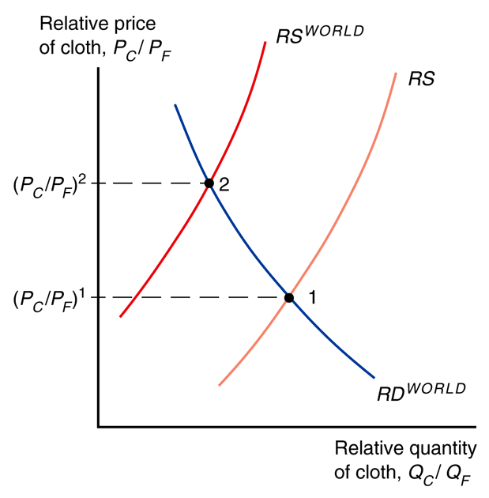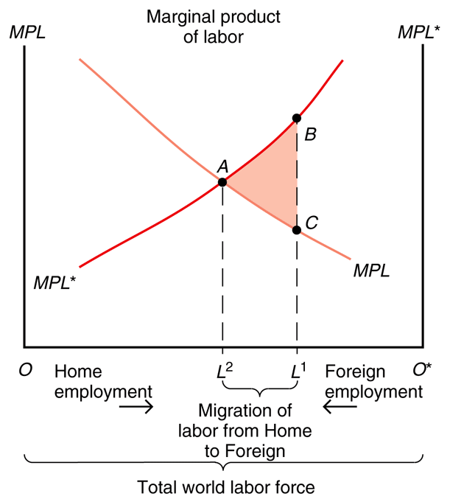
Allocation of Labor Trade and Relative Prices International Labor Mobility

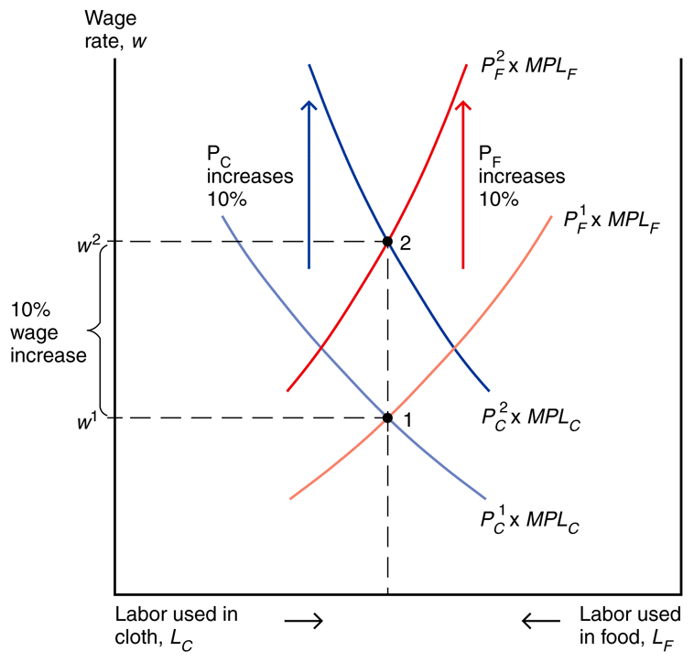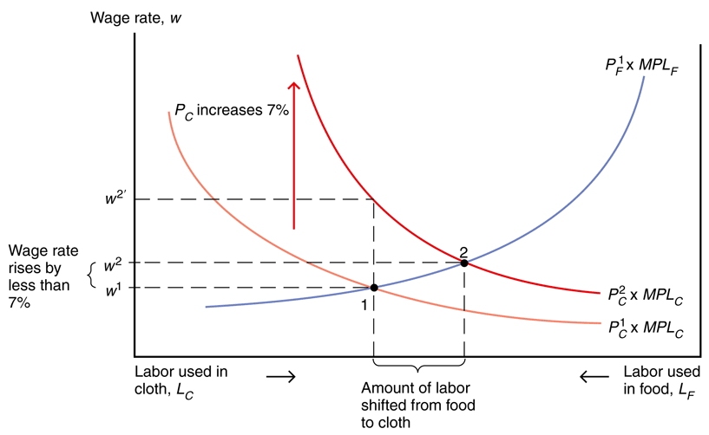
Income distribution: proportional rise Income distribution: relative rise in prices

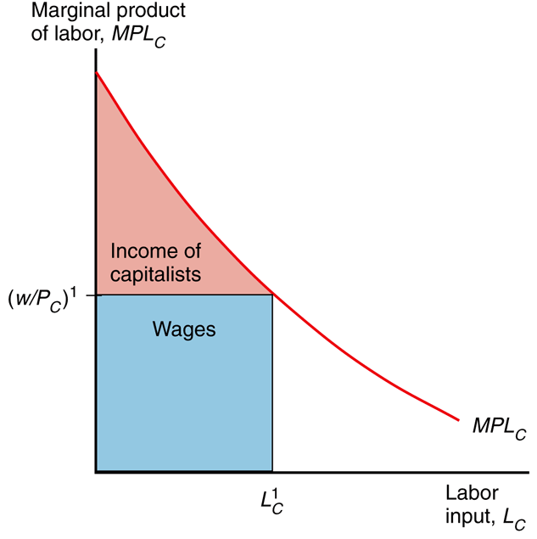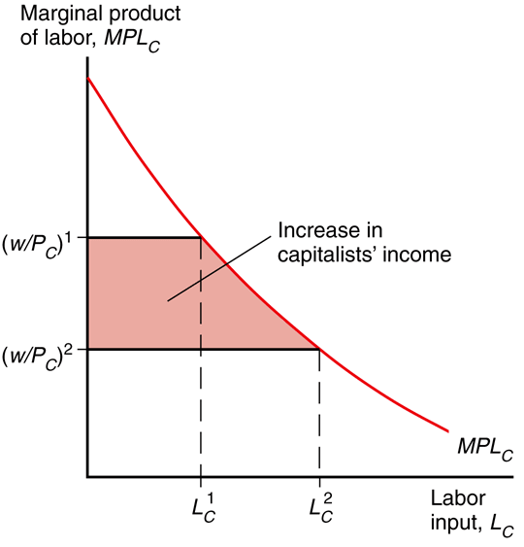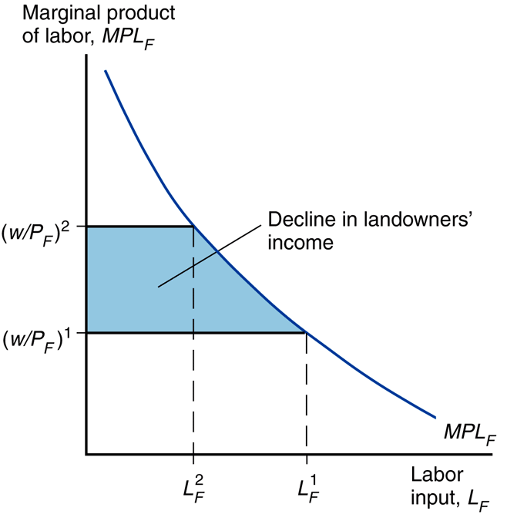
Income Distribution Rise in Capitalist Income Decline in Landowner Income

