Ricardian Model (1/30/2012) Econ 390-001

Equations
- a_{LC}Q_{C} + a_{LW}Q_{W} ≤ L country production possibilities frontier (PPF)
  - Q_{W} = L/a_{LW} – (a_{LC}/a_{LW})Q_{C} linear formulation
    - L/a_{LW} y-intercept
    - – (a_{LC}/a_{LW}) slope
  - Q_{C} = L/a_{LC}, Q_{W} = 0 max cheese
  - Q_{W} = L/a_{LW}, Q_{C} = 0 max wine
- w_{C} = P_{C}/a_{LC} wage for cheese
- w_{W} = P_{W}/a_{LW} wage for wine
- a_{LC} < a_{LC}* absolute advantage for home in cheese
- a_{LC}/a_{LW} < a_{LC}*/a_{LW}* comparative advantage for home in cheese
  - a_{LC}/a_{LW} opportunity cost of cheese
- wage insights (go with higher wage)
  - P_{C}/a_{LC} > P_{W}/a_{LW} produce only cheese
  - P_{C}/a_{LC} < P_{W}/a_{LW} produce only wine
  - P_{C}/a_{LC} = P_{W}/a_{LW} produce both
- opportunity cost insights (if price beats OC)
  - P_{C}/P_{W} > a_{LC}/a_{LW} produce only cheese
  - P_{C}/P_{W} < a_{LC}/a_{LW} produce only wine
  - P_{C}/P_{W} = a_{LC}/a_{LW} produce both
- RS = (Q_{C} + Q_{C}*)/(Q_{W} + Q_{W}*) world relative supply curve
  - P_{C}/P_{W} = a_{LC}/a_{LW} 1st step
  - RS = (L/a_{LC})/(L*/a_{LC}*) jumps when totally specialized
  - P_{C}/P_{W} = a_{LC}*/a_{LW}* 2nd step
- (P_{C}/a_{LC})/(P_{W}/a_{LW}*) relative wage (specialized countries)
  - w = w_{C} = P_{C}/a_{LC} wage in home country
  - w* = w_{W}* = P_{W}/a_{LW}* wage in foreign country
- a_{L1}*/a_{L1} > a_{L2}*/a_{L2} > a_{L3}*/a_{L3} multi-good economy
  - a_{Li}*/a_{Li} relative productivity (> means home better)
  - a_{L1}*/a_{L1} > a_{L2}*/a_{L2} > w/w* > a_{L3}*/a_{L3} cut linup at relative wage rates (home left, foreign right)

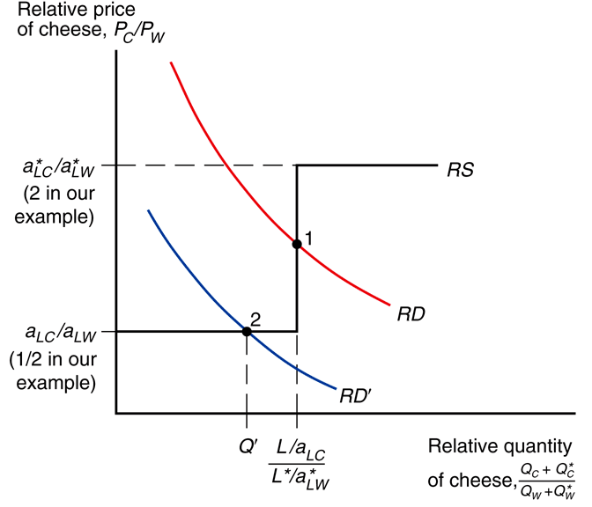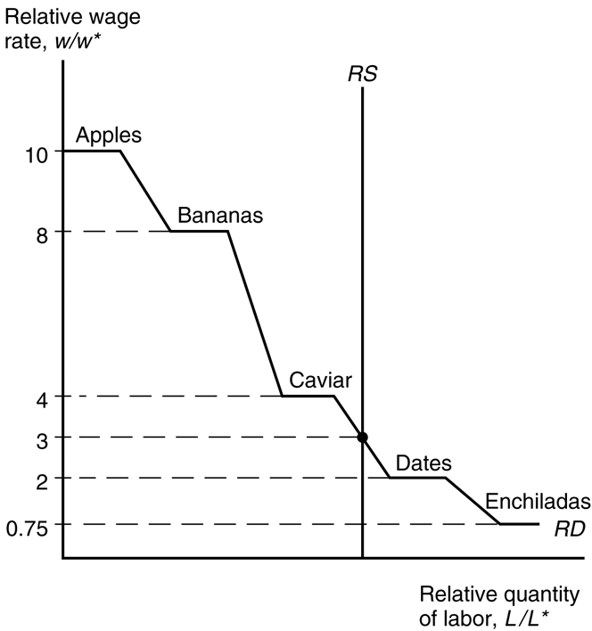
2 good Ricardian model Many good Ricardian model
Variable definitions
- unit labor requirements (high unit labor means low productivity)
  - a_{LC} ≡ unit labor requirement for cheese in home country
  - a_{LC}* ≡ unit labor requirement for cheese in foreign country
  - a_{LW} ≡ unit labor requirement for wine in home country
  - a_{LW}* ≡ unit labor requirement for wine in foreign country
- labor
  - L ≡ total labor hours in home country
  - L* ≡ total labor hours in foreign country
- production
  - Q_{C} ≡ cheese production in home country
  - Q_{C}* ≡ cheese production in foreign country
  - Q_{W} ≡ wine production in home country
  - Q_{W}* ≡ wine production in foreign country
- price
  - P_{C} ≡ unit price of cheese
  - P_{W} ≡ unit price of wine
- wage
  - w_{C} ≡ hourly wage for cheese
  - w_{W} ≡ hourly wage for wine
  - w ≡ wage in home country
  - w* ≡ wage in foreign country

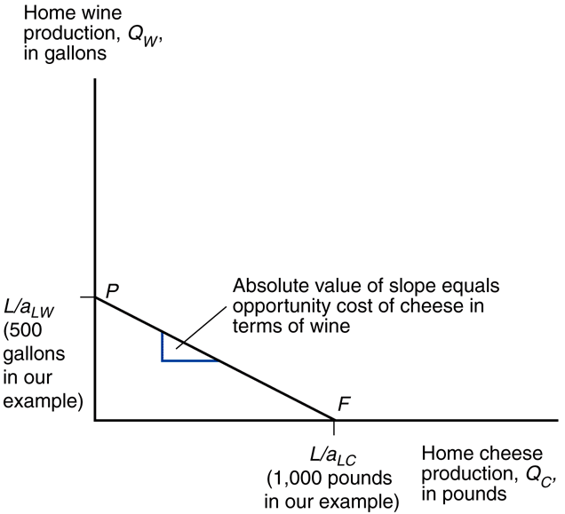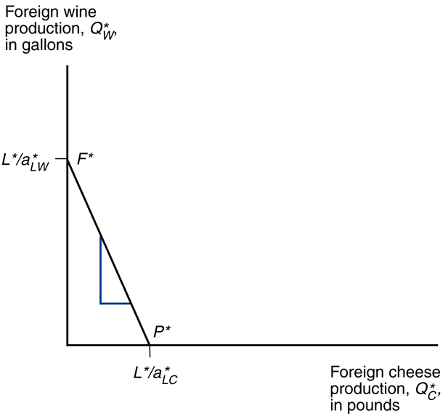
Home PPF Foreign PPF

Definitions
- opportunity cost – the cost of an activity in terms of a foregone alternative
- absolute advantage – the ability of a country to produce a product using fewer resources than other countries
- comparative advantage – the ability of a country to produce a product at a lower opportunity cost than other countries
- productivity – amount of product produced in a unit of time
- unit labor requirement – number of hours of labor required to product a unit of product
- production possibility frontier – maximum possible production of two products at different mixes
- nontraded goods – goods each country produces for itself (no imports or exports)
- relative wage – ratio of the amount workers are paid per hour in two countries
- autarky – economic self-sufficiency; no trade
Principles
- Two reasons for trade (micro and macro)
  - Smithean (efficiency / economies of scale)
  - Ricardian (comparative advantage)
- Adam Smith detailed the benefits of specialization and division of labor The Wealth of Nations.
  - Each worker could become an expert in a small area, greatly increasing efficiency.
- David Ricardo came up with the Law of Association (comparative advantage).
  - Even if someone is absolutely more productive at 2 activities, if he is comparatively more productive at 1 activity than another relative to someone else, he should specialize and trade.
- Trade makes both countries better off.
- Conceptualizing gains from trade:
  - indirect production
    - A country can produce wine, or produce cheese and trade it for wine.
    - The latter is indirectly producing wine.
  - expanded consumption
    - Comparative advantage & specialization leads to an increase in world production.
    - Trade allows each country to expand consumption beyond production possibilities.
  - conservation of resources
    - Instead of expanding production and consumption, the world can produce the same amount as before but do it more efficiently.
    - In the Ricardian model this means leftover labor hours (liesure).
    - In other models it could mean saved land/capital.
- One of the reasons countries specialize in a particular good is because of climate.
  - You can grow oranges in Alaska with heat lamps, but that would be very inefficient!
  - Winter in the northern hemisphere = summer in the southern hemisphere.
    - Agricultural products may be shipped between Brazil and the U.S. when out of season.
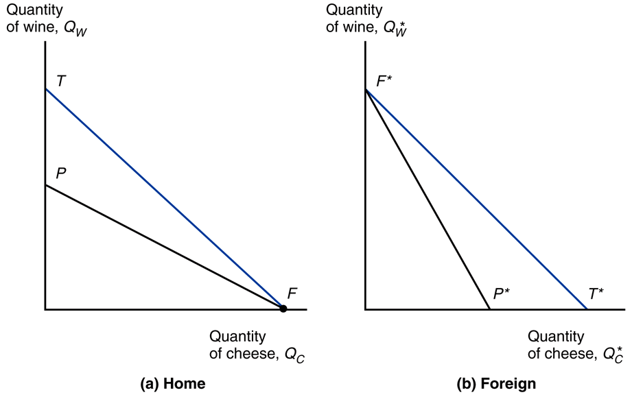
- Ricardian model assumptions
  - Labor is the only factor of production
  - Labor productivity varies across countries
    - due to differences in technology
  - Labor productivity in each country is constant
  - Supply of labor in each country is constant
  - Two goods: wine and cheese
  - Labor gets all good revenues through wages
    - Works in industry paying highest wage
  - Two countries: home and foreign
- Ricardian model insights: Gains from trade: expanded consumption
  - With constant prices, relative prices will dictate the proportions of the goods produced.
  - In a single factor economy all the profit accrues to that factor (labor).
  - Labor will go to where it can earn the highest wages.
  - In general the relative wage (w/w*) will be between the productivity advantages.
  - Empirically wages are proportional to productivity.
- These myths are false
  - Free trade is beneficial only if a country is more productive than foreign countries.
  - Free trade with countries that pay low wages hurts high wage countries.
  - Free trade exploits less productive countries.
- Why don't countries completely specialize?
  - >1 factor of production
  - protectionism
  - transportation costs

