Introduction, World Trade (1/25/2012) Econ 390-001

Equations
- T_{ij} = AY_{i}Y_{j}/D_{ij} gravity model
- T_{ij} = A(Y_{i})ª(Y_{j})^{b}/(D_{ij})^{c} generalized gravity model

Variable definitions
- T_{ij} ≡ value of trade between countries i & j
- Y_{i} ≡ GDP of country i
- Y_{j} ≡ GDP of country j
- D_{ij} ≡ distance between countries i & j
- A ≡ constant term
- a,b,c ≡ exponents for regression

Definitions
- import – a good or service brought into a country for sale
- export – a good or service sent out of a country for sale
- gross domestic product (GDP) – total value of all final goods and services produced in an area per period
- tariff – a tax on imports or exports
- quota – a quantity restriction on imports or exports
- export subsidy – a payment to producers that export
- broken window fallacy – fallacy of taking into account easy to see positive effects of a policy, but not taking into account negative hidden effects of a policy
- utility – total satisfaction from consuming (or not consuming) a good or service
- reverse inequality of value – both parties to the trade value what they’re getting more than what they’re giving up
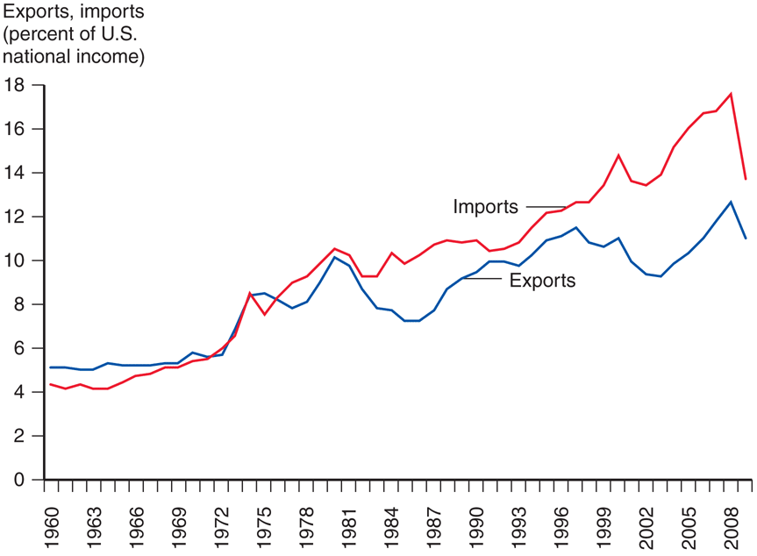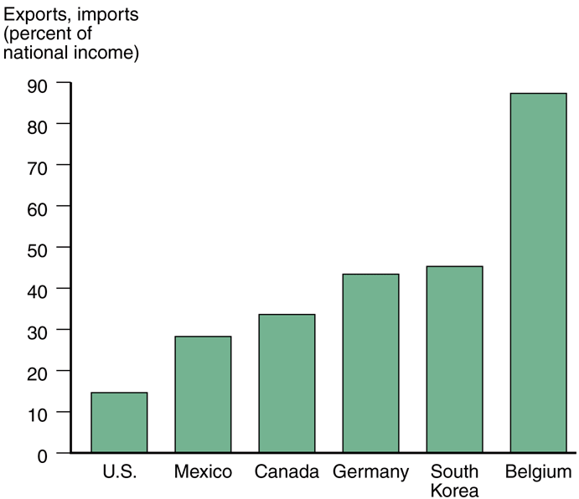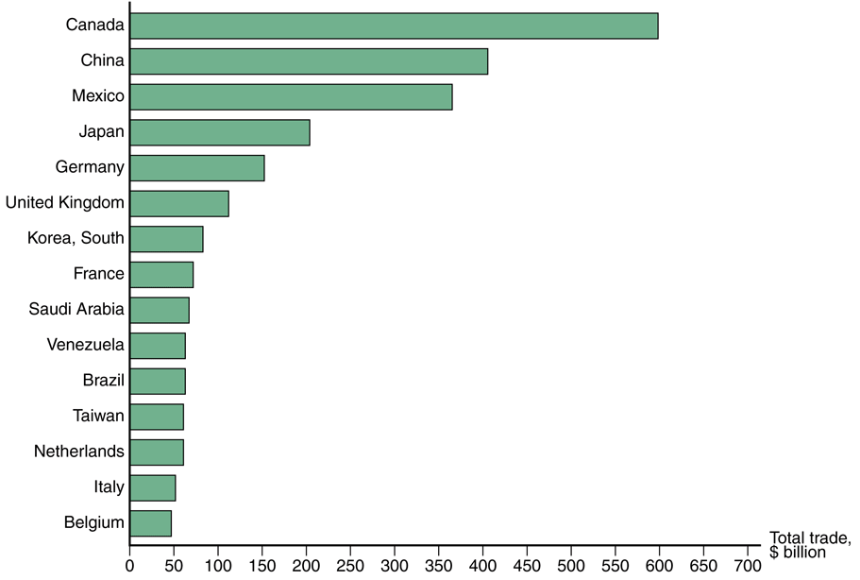
Fig. 1-1: Exports and Imports Fig. 1-2: Exports and Imports as Fig. 2-1: Total U.S. Trade with
as a % of U.S. National Income a % of National Income in 2007 Major Partners, 2008
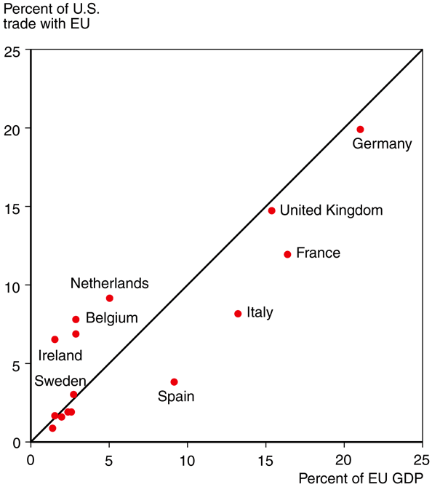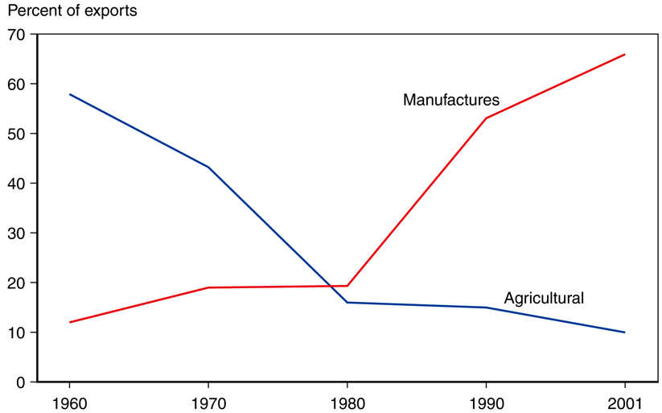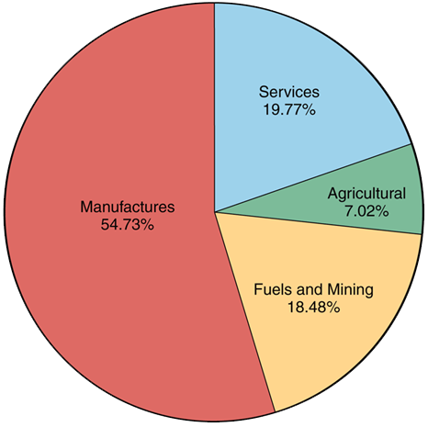
Fig. 2-2: The Size of European Fig. 2-6: The Changing Composition Fig. 2-5: The Composition
Economies, and the Value of of Developing-Country Exports of World Trade, 2008
Principles
- Gross domestic product is different from gross national product.
  - GDP is scoped by location, GNP is scoped by ownership.
- The idea that disasters are good for the economy is an example of the Broken Window Fallacy (Bastiat).
  - Does breaking windows increase output with a multiplier? No! Money would have been spent on something else with a similar multiplier. The broken window is “what is seen,” whereas the alternative purchase is “what is unseen” (the opportunity cost).
- Work is a means to an end, not an end in and of itself.
  - WORK IS NO DAMN GOOD.
  - CONSUMPTION IS GOOD.
  - LEISURE IS GOOD.
- Often real income or GDP is used as a proxy for utility, but it is not a perfect proxy.
- Price is objective; value is subjective.
- Reverse inequality of value makes trades mutually advantageous, which is why people trade voluntarily.
  - Trade is not a zero sum game with a winner and a loser.
  - Trade is a positive sum game. Both parties are winners.
- Gains from trade can be thought of graphically as consumer surplus and producer surplus.
- It’s important to remember the limitations of models.
  - Models simplify, but often economists prefer a simple model to a correct one.
  - A model is only as good as its assumptions.
- Imports & exports (% of U.S. GDP) rises over the last 40 years.
- Imports > exports (financed by capital inflows: foreign investment in U.S.).
- Other countries rely far more on trade for their GDP than the U.S. does.
- 5 largest U.S. trading partners: Canada, China, Mexico, Japan, & Germany.
- Country’s GDP directly related to volume of imports & exports.
  - exports: larger economies produce more goods & services (more to sell)
  - imports: larger economies generate more income (more to buy)
- Other factors
  - distance – transportation costs, communication
  - cultural affinity – cultural ties → economic ties
  - geography – ocean harbors, lack of mountains
  - multi-national corporations – trade among divisions
  - borders – tariffs, customs, different language/money
- 1% increase in distance causes 0.7% to 1% decrease in trade.
- The U.S., Canada, & Mexico have a free trade agreement: the North American Free Trade Agreement (NAFTA, signed 1994). Even with free trade though, borders matter.
- The negative effect of distance is decreasing due to modern transportation and communication.
- The bulk of world trade is manufactured products.
- Developing countries are trending away from agriculture to manufacturing.
- A lot more services could be offshored / outsourced.

Problems with GDP
- Statistical Problems
  - Measurement errors
  - Price index interaction
- Conceptual Problems
  - Don’t include all output
    - Underground economy
    - Non-monetary activity

  - Don’t accurately measure output
    - Intermediate goods
    - Non-market prices
- Output is not a perfect proxy for welfare
  - Leisure
  - Terms of trade
  - Marginal utility ≠ total utility
  - War is bad

