The Great Depression (5/3/2011) Econ 310-008

Definitions
- buying on margin – purchase of an asset by paying the margin and borrowing the balance from a bank
- margin call – lender’s demand on an investor using margin to deposit additional money or securities so that the margin account is brought up to the minimum margin
- tariff – tax imposed on a product when it is imported into a country
- retaliatory tariff – tariff imposed by a foreign country to punish the government for its high tariffs
- jawboning – attempt to persuade others to act in a certain way by using the pressure of a high office

Principles
- Keynes advocated a counter cyclical public spending policy.
- Irving Fisher believed the Great Depression was caused by margin calls leading to a debt-deflation spiral.
- Friedman and Schwartz believed the depression was caused by contractionary monetary policy by the Federal Reserve, as shown in their book A Monetary History of the United States 1867-1960.
- In 1928 the Fed began contracting due to the stock bubble.
- Late in the Depression the Fed believed it had a loose policy, but did not take into account bank failures which made the money supply still contractionary.
- Ludwig von Mises and F.A. Hayek believed the Great Depression was an Austrian Business Cycle.
- Barry Eichengreen theorized in Golden Fetters that it was caused by the international gold standard.
- Tariffs hurt consumers and help producers, but producers are helped far less than consumers are hurt.
- President Herbert Hoover was a big believer in wage & price floors.
- FDR created programs designed to keep prices and wages high.
- In 1942 FDR set income tax rates above $25,000 at 100% by executive order.
- In the 1920’s M^{s} expanded by 40%, but the price level was stable because M^{d} also increased.
- Milton Friedman pointed out that when you see unemployment high for a decade, it is not a rise in cyclical unemployment, but rather a rise in the natural rate of unemployment.
- The real endof the Great Depression is after WWII when unemployment lowered for voluntary work.
- The Great Depression was the first recession with interventionism; all other presidents didn’t intervene.
- No bank failures in Canada during Great Depression.
- 1839-1843 was a deflation like 1929-1933, but it occured with price flexibility and full employment.

Aggregate theories
- Keynesian – J.M. Keynes
- Debt Deflation – Irving Fisher
- Monetarist – Milton Friedman
- ABCT – F.A. Hayek & L.v. Mises
- Golden Fetters – B. Eichengreen

Other theories
- tariffs
- wage & price floors
- income tax
- make-work projects
- consumer loans
- gold standard
- regime uncertainty
1929-1933
- unemployment rose 3% to 25%
- money supply deflated
  - M1 fell 25%
  - M2 fell 35%
- 9,000 banks failed
- international trade
  - imports declined 66%
  - exports declined 61%
- real wages increased
  - P dropped faster than W

Keynesian
- blamed aggregate demand failure
- advocated government spending
  - massive public works projects
- wrote pamphlets, books, and op-eds
  - “A Means to Prosperity” (1933)
  - General Theory of Employment, Interest and Money (1936)
  - “An Open Letter to President Roosevelt” (1933)

Debt-Deflation
- margin calls
  - margin requirements were 10%
  - margin calls when stocks declined
  - selling made stocks decline more
- banks
  - didn’t re-lend called in loans
  - borrowers default, banks insolvent
  - bank runs, bank panics, bank failures
- spirals in margin calls & bank failures
  - massive deflation

Monetarist
- money supply
  - M1 declined by 25% 1929-1933
  - M2 declined by 35% 1929-1933
- Federal Reserve
  - looked at interest rates, not M1
  - tight policy 1928 (stock market)
  - believed loose later, really tight
    - due to bank failures
  - doubled reserve requirements 1936
    - led to double dip recession

Austrian Business Cycle Theory
- boom
  - artificially low interest rates
  - 1920’s expansion
  - stock bubble
- bust
  - 1929 stock market crash
  - malinvestments revealed
  - Great Depression

Golden Fetters
- gold exchange standard
  - restrictions on printing money
    - 15% minimum gold backing
- must import gold to print money
  - only trade surplus countries
    - United States – contracted
    - France – feared hyperinflation
- LM contracted worldwide
  - deflation
  - output declined

Wage & Price Floors
- Herbert Hoover
  - head of U.S. Food Administration
    - rationed food for nation (World War I)
  - Secretary of Commerce
    - massive business regulation
  - President
    - jawboned business leaders
    - kept wages & prices high
- Franklin D. Roosevelt
  - National Industrial Recovery Act
    - work hours: max hours
    - wages & salaries: min wage
    - prices: price floors
  - Agricultural Adjustment Act
    - farm subsidies
    - raise food prices

Make-Work Projects
- Civilian Conservation Corps
  - trees, parks, roads
- Works Progress Administration
  - bridges, dams, schools
  - arts, drama, media, literacy
- projects often unnecessary
  - Broken Window Fallacy
- no incentive for productivity

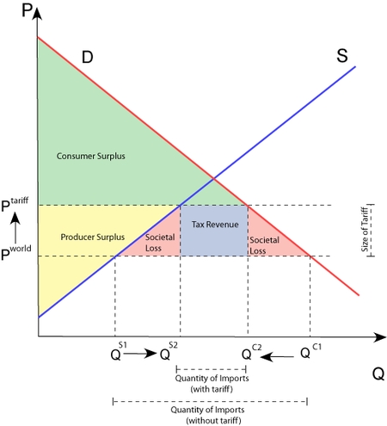
Smoot-Hawley Tariff Act
- passed in 1930
- signed by President Herbert Hoover
- 1,028 economists asked for veto
- 23 countries threatened retaliation
- Smoot and Hawley not re-elected
- raised tariffs on 20,000 goods
- tariff rate varied (depends on good)
- imports declined 66% 1929-1933
- exports declined 61% 1929-1933
- caused 1929 stock market crash

Income Tax
- Andrew Mellon
  - Secretary of Treasury 1921-1932
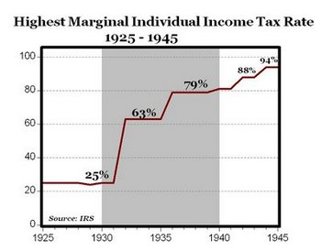
    - Harding, Coolidge, Hoover
  - cut income tax 77% to 25%
  - economy boomed in 1920’s
- Franklin D. Roosevelt
  - raised income tax
    - 25% to: 63%, 79%, 88%, 94%
  - 100% tax by executive order
    - (see Laffer Curve)
  - Great Depression

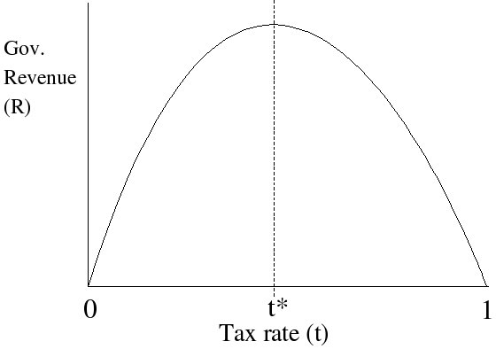
Miscellaneous
- consumer loans
  - banks called in loans quicker
    - only 1 missed payment
  - consumer spending declined
- gold standard (note backing)
  - internationally: 15% gold
  - Federal Reserve: 40% gold
- regime uncertainty
  - taxes, regulation, etc. vary
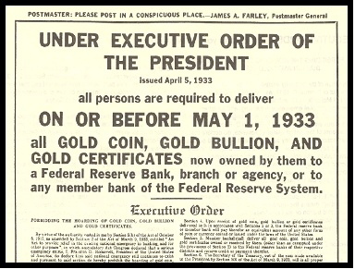
  - don’t invest

Severity vs. Duration
- AD (severity)
  - bank panics
  - 1/3 fall in M2
- SRAS (duration)
  - government cartels
  - wages & prices rigid
- LRAS
  - tariffs
  - international trade

