International Financial System (4/12/2011) Econ 310-008

Definitions
- fixed exchange rate – a currency's value is matched to the value of another single currency or to a commodity (e.g., gold)
- floating exchange rate – a currency's value is allowed to fluctuate to the foreign exchange market
- managed float (dirty float) – floating ER: but government sometimes intervenes (buying or selling foreign assets to influence exchange rates)
- crawling peg – fixed ER: but allowed to fluctuate between a narrow band of rates
- gold standard – fixed ER: currencies pegged to gold
- Bretton Woods – (1944-1971) fixed ER: dollar pegged to gold, other currencies pegged to dollar
- currency board – fixed ER: domestic currency backed 100% by a foreign currency with a permanent peg
- dollarization – fixed ER: adoption of a foreign currency as the domestic currency (e.g., the dollar)
- currency union – fixed ER (inside): countries join together for a common currency, which operates like a fixed regime (dollarization) among member countries and either fixed or floating with rest of the world
- capital controls – restrictions on foreign investment; restrictions regulating the flow in and out of the capital account
- perfect capital mobility – no capital controls
- impossible trinity – a country cannot have all 3 of the following at the same time: fixed exchange rate, capital mobility, independent monetary policy
- international reserves (foreign exchange reserves) – central bank holdings of assets denominated in a foreign currency
- foreign exchange interventions – central bank international financial transactions made to influence foreign exchange rates
- unsterilized foreign exchange intervention – FEI that effects the monetary base
- sterilized foreign exchange intervention – FEI with an offsetting open market operation that leaves the monetary base unchanged
- devaluation – setting the exchange rate peg (e) to a higher level
- revaluation – setting the exchange rate peg (e) to a lower level
- speculative attack – the massive selling (shorting) of a country’s currency assets, with the hope of a devaluation, which would net a huge profit
- balance of payments (BoP) – net movement of funds between a nation and a foreign country
- current account (CA) – net movement of goods and services between a nation and a foreign country
- trade balance (TB) – exports minus imports
- capital account (financial account, FA) – net movement of capital (assets) between a nation and a foreign country
- International Monetary Fund – setup under Bretton Woods to help countries maintain fixed exchange rates (loans to countries with BoP problems); now acts as an international LOLR during financial crises
- World Bank – provides long-term loans to developing countries for economic development projects

Equations
- BoP = CA + FA Balance of Payments
- CA = TB + NFIA + NUT Current Account
- TB = EX – IM Trade Balance

Principles
- Fixed exchange rates make trade and investment between two countries on the same peg easy (minimize exchange rate risk).
- Floating exchange rates have a more flexible monetary policy and don’t have to waste resources defending the peg.
- The United States and most other countries were on a fixed exchange rate regime until 1971 (first the gold standard, then Bretton Woods).
- In order to defend a fixed exchange rate, the central bank must intervene when the exchange rate fluctuates.
- When the domestic currency depreciates (e↑), the central bank must sell foreign assets (international reserves) to restore the old exchange rate.
  - If it runs out of reserves, it must either devalue or switch to a floating regime.
- When the domestic currency appreciates (e↓), the central bank must buy foreign assets (international reserves) to restore the old exchange rate.
  - Central banks may accumulate a lot of international reserves (e.g., China has > $2 trillion).

Exchange rate regimes
- gold standard (fixed)
- currency union (fixed inside)
- dollarization (fixed)
- currency board (fixed)
- traditional fixed (fixed)
- crawling peg (fixed)
- managed float (floating)
- pure float (floating)

Impossible trinity examples
- United states
  - fixed exchange rate
  - independent monetary policy
  - capital mobility
- Euro (currency union)
  - fixed exchange rate
  - independent monetary policy
  - capital mobility

Impossible trinity Mundell-Fleming perfect capital mobility no capital mobility
 | float | fixed
FP | + | 0
MP | + | 0
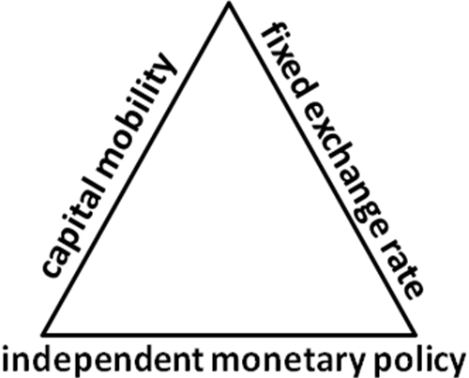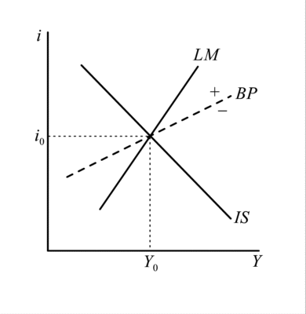
 | float | fixed
FP | 0 | +
MP | + | 0

