Foreign Exchange (4/12/2011) Econ 310-008

Definitions
- exchange rate – price of one currency in terms of another
  - e.g., dollars/euro ($/€) or euros/dollar €/$)
- spot transaction – immediate (2 day) exchange of bank deposits
- spot exchange rate – exchange rate for spot transactions
- forward transaction – exchange of bank deposits at some future date
- forward exchange rate – exchange rate for forward transactions
- foreign exchange market – the financial market where exchange rates are determined
- appreciation – when a currency increases in value relative to another currency
- depreciation – when a currency decreases in value relative to another currency
- law of one price (LOOP) – the price of a good should be the same throughout the world (assuming transportation costs and trade barriers are low)
- arbitrage – taking advantage of a price difference between two markets
- theory of purchasing power parity (PPP) – exchange rates between any two currencies will adjust to reflect changes in the price levels of the two countries
- interest rate parity – the rate of return should be the same throughout the world (with capital mobility)

Equations
- eP*/P = 1 purchasing power parity
- RoR = (1 + i) interest rate parity
- RoR* = [E(e_{t+1})/e_{t}](1 + i*) interest rate parity
- RoR = RoR* interest rate parity

Variable definitions
- e ≡ exchange rate (in $/€)
  - Note: Throughout the chapter Mishkin refers to exchange rate as euro/dollar. That is the opposite of the way most Americans and most economists think of the exchange rate.
- P ≡ domestic price level (in $)
- P* ≡ foreign price level (in €)
- RoR ≡ domestic rate of return
- RoR* ≡ foreign rate of return
- i ≡ domestic interest rate
- i* ≡ foreign interest rate
- E(e_{t+1}) ≡ forward exchange rate
- e_{t} ≡ spot exchange rate

Principles
- Arbitrage causes the law of one price (LOOP). If prices are different, an entrepreneur can buy steel in the cheaper country and sell it in the more expensive country for a profit.
- PPP works in the long run, but not the short run.
- If there are capital controls imposed, interest rate parity does not hold in the short run.
- Interest rate parity: if you invest money domestically (at i), you should get the same return as investing money abroad (at i*) converting it initially at the spot rate and back at the forward rate.
- Because the forward exchange rate impacts interest rate parity, all of the factors that effect the long run exchange rate enter into those expectations and can effect the short run exchange rate.

Appreciation
- country’s goods abroad become more expensive
- foreign goods in the country become cheaper
- (€/$)↑ means dollar appreciates
- ($/€)↓ means dollar appreciates
- e↓ means dollar appreciates (e ≡ $/€)

Depreciation
- country’s goods abroad become cheaper
- foreign goods in the country become more expensive
- (€/$)↓ means dollar depreciates
- ($/€)↑ means dollar depreciates
- e↑ means dollar depreciates (e ≡ $/€)

Long run determinates of e
- relative price levels
- trade barriers
- imports vs. exports
- productivity

Factor | Exchange Rate | Domestic Currency
domestic price level ↑ | e↑ | depreciates
trade barriers ↑ | e↓ | appreciates
imports ↑ | e↑ | depreciates
exports ↑ | e↓ | appreciates
productivity ↑ | e↓ | appreciates

Factor | Exchange Rate | Domestic Currency
domestic interest rate ↑ | e↓ | appreciates
foreign interest rate ↑ | e↑ | depreciates
forward exchange rate ↑ | e↑ | depreciates

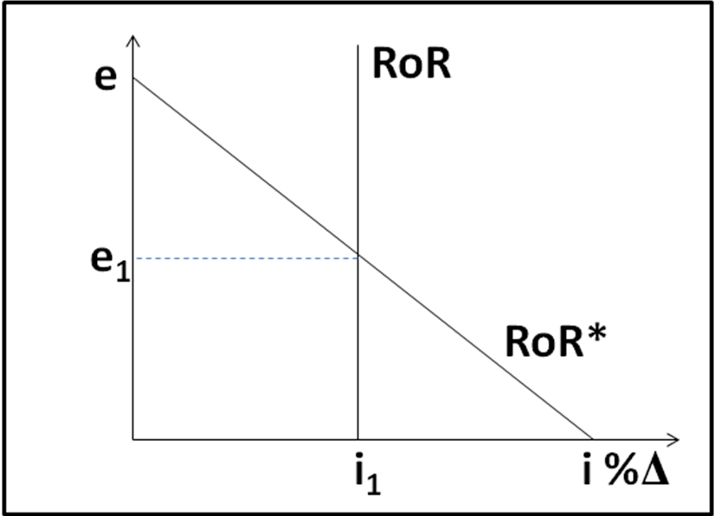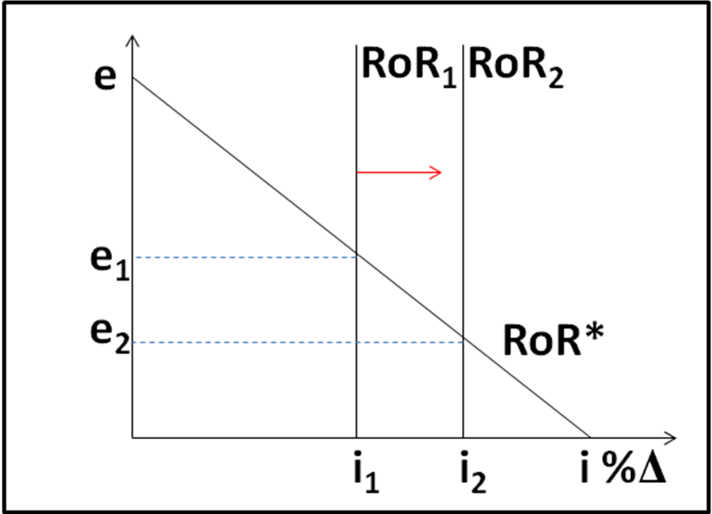
RoR = (1 + i) RoR* = [E(e_{t+1})/e_{t}](1 + i*) i↑ → shifts RoR right → e↓ → appreciates

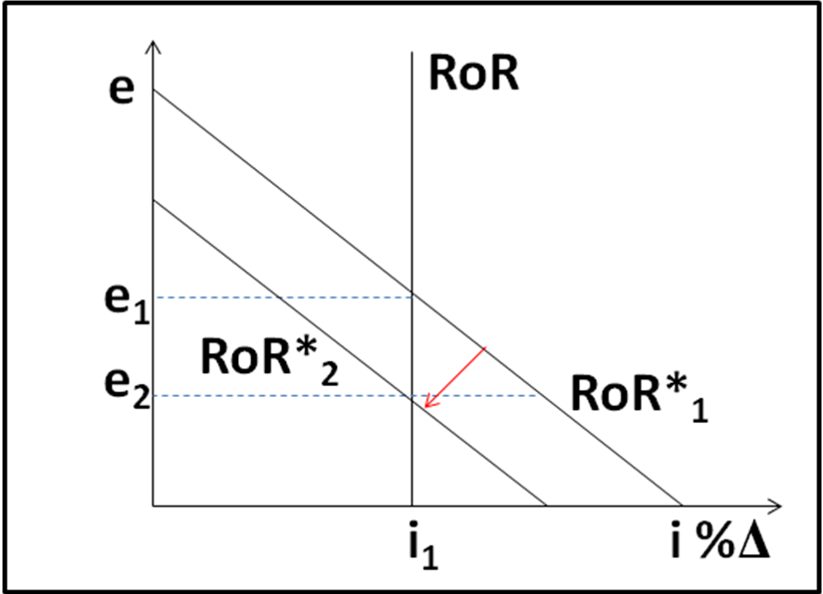
i*↓ → shifts RoR* left → e↓ → appreciates E(e_{t+1})↓ → shifts RoR* left → e↓ → appreciates

