Monetary Policy Tools (4/5/2011) Econ 310-008

Definitions
- federal funds rate – interest rate to borrow from other banks
- basis point – 1/100 of 1%; 0.01% = 1 basis point
- float – temporary net increase in the total amount of reserves: the Federal Reserve system credits a check to the depositing bank before it debits the withdrawing bank (affects monetary base)
- treasury deposits – temporary net decrease in the total amount of reserves: U.S. Treasury takes deposits out of banks and deposits them with the Federal Reserve instead (affects monetary base)
- repurchase agreement (repo) – temporary open market purchase
- matched sale purchase transaction (reverse repo) – temporary open market sale
- term auction facility – discount loans via competitive auctions (less stigma for borrowing banks relative to normal discount window)
- term securities lending facility – lend treasury securities to primary dealers for terms longer than overnight (to supply more securities for collateral)

Principles
- The federal funds rate is the primary target for monetary policy from the Federal Reserve. It is not set directly – rather, it is indirectly manipulated using other policy tools.
- Since 1995 the Federal Reserve explicitly announces a federal funds rate target at each FOMC meeting.
- The federal funds rate is targeted by manipulating the supply and demand for bank reserves.
- Repos and reverse repos typically mature in 1-15 days.

Variable definitions
- R^{d} ≡ demand for reserves
- R^{s} ≡ supply of reserves
- i_{ff} ≡ federal funds rate
- i_{d} ≡ discount rate
- i_{er} ≡ interest rate paid on reserves
- DL ≡ discount lending
- R_{n} ≡ non-borrowed reserves*
- * not borrowed through discount loans
Supply & demad curves for reserves
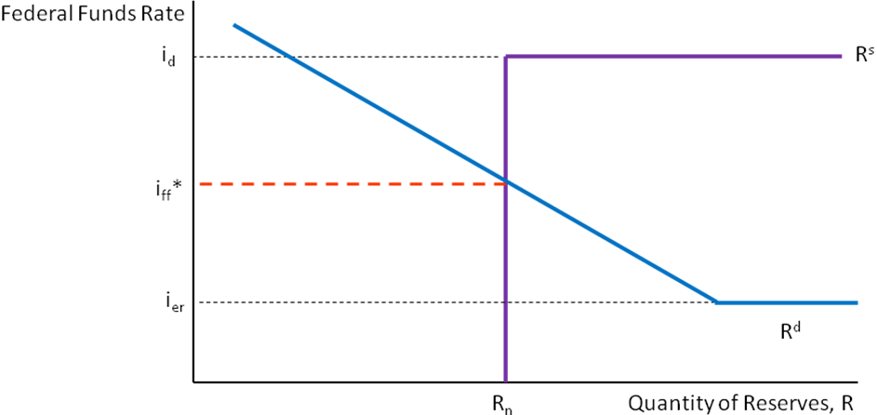

Tools for federal funds rate
- open market operations
- discount rate
- required reserve ratio
- interest rate paid on reserves

Reserve demand curve
- demand curve slopes down
  - i_{ff}↓ → opportunity cost of ER↓ → ER↑
- demand curve perfectly elastic (flat) at i_{er}
  - if i_{ff} below i_{er}, arbitrage
- i_{er} floor on federal funds rate

Reserve supply curve
- aggregate reserves of banks
- discount rate (borrowing from Fed)
  - substitute for borrowing from banks
- i_{ff} < i_{d} → R = R_{n}
  - if i_{ff} < i_{d}, won’t borrow from Fed
- supply curve flat at id
  - if i_{ff} > i_{d}, won’t borrow from banks
- i_{d} ceiling on federal funds rate

Open market operations
- intersection on down sloping portion of R^{d}
  - OM purchase: lowers fed funds rate
  - OM sale: raises fed funds rate
- intersection on flat portion of R^{d}
  - OM purchase: no effect on fed funds rate
  - OM sale: no effect on fed funds rate

Types of open market operations
- dynamic
  - meant to change MB
  - permanent: purchases & sales
- defensive
  - meant to stabilize MB from fluctuations
    - float
    - treasury deposits at Fed
  - temporary: repos & reverse repos

Discount window
- intersection on flat portion of R^{s}
  - i_{d}↓: lowers fed funds rate
  - i_{d}↑: raises fed funds rate
- intersection on vertical portion of R^{s}
  - i_{d}↓: no effect on fed funds rate
  - i_{d}↑: no effect on fed funds rate

Types of discount loans
- primary credit
  - healthy banks
  - discount rate (typically 1% above i_{ff})
- secondary credit
  - banks w/ severe liquidity problems
  - typically 0.5% (50 BP) above i_{d}
- seasonal credit
  - small banks with seasonal deposits
  - average of i_{ff} and CD rate

Required reserve ratio
- required reserve ratio rises (r↑)
  - demand for reserves rises
  - demand curve shifts right
- required reserve ratio falls (r↓)
  - demand for reserves falls
  - demand curve shifts left

Required reserve ratio
- intersection on down sloping portion of R^{d}
  - r↓: lowers fed funds rate
  - r↑: raises fed funds rate
- intersection on flat portion of R^{d}
  - r↓: no effect on fed funds rate
  - r↑: no effect on fed funds rate

Required reserve ratio info
- same for all depository institutions
  - DIDMCA of 1980
- requirement (checkable deposits)
  - 3% of 1st $48.3 million
  - 10% of any over $48.3 million
    - FOMC can vary
    - between 8% and 14%

Interest paid on reserves
- since October 2008
  - much longer in Europe, etc.
- current rate is 0.25%
- advantages
  - reduces effective tax on deposits
  - puts a floor on federal funds rate
  - less fluctuations in excess reserves
  - less sterilization needed
    - expand balance sheet more

European central bank
- open market operations
  - main refinancing operations
    - similar to repos
  - longer-term refinancing operations
    - similar to purchases/sales
- lending to banks
  - marginal lending rate (1% above)
  - deposit facility (1% below)
- reserve requirements
  - 2% ratio, interest paid on reserves

See slides for larger versions.
You’ll be required to know the labels and how they shift (even though labels hard to read here).

Demand curve for reserves Supply curve for reserves
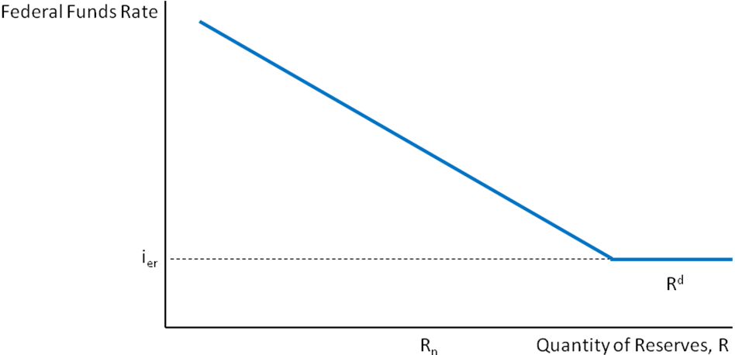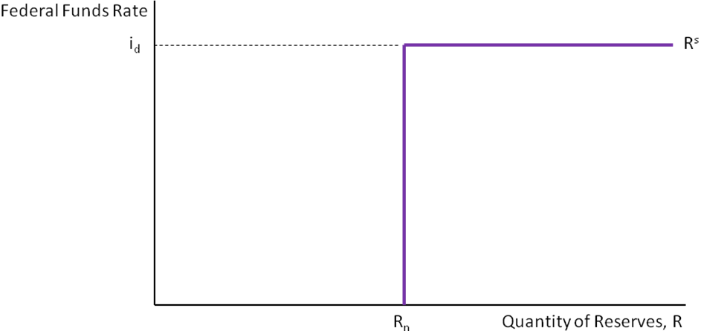
Ceiling (discount rate: i_{d}) Floor (interest rate paid on reserves: i_{er})
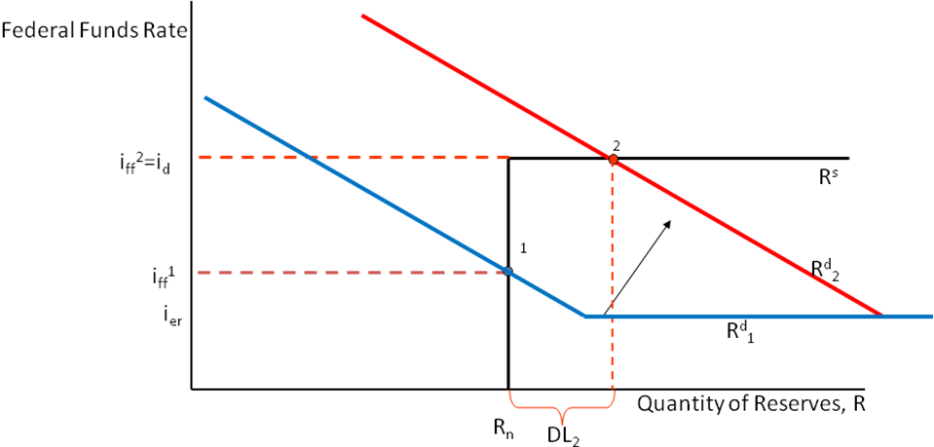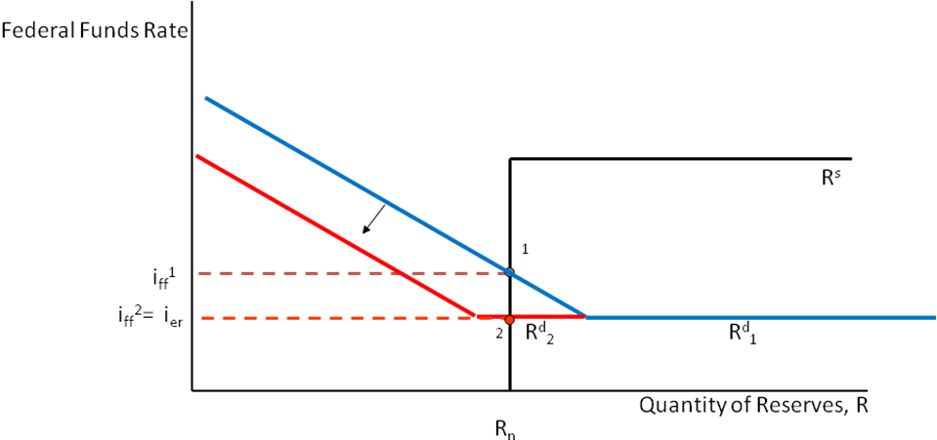
Open market purchase (downward sloping portion) Open market purchase (flat portion of demand curve)
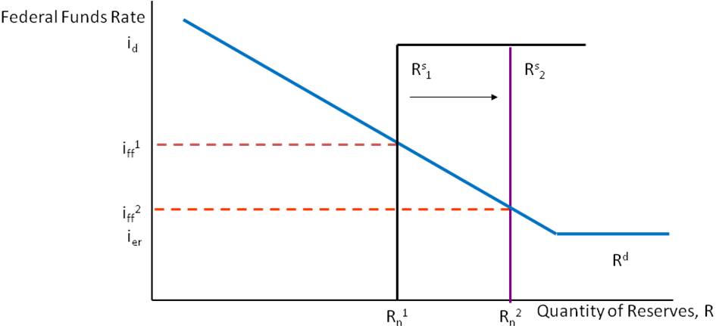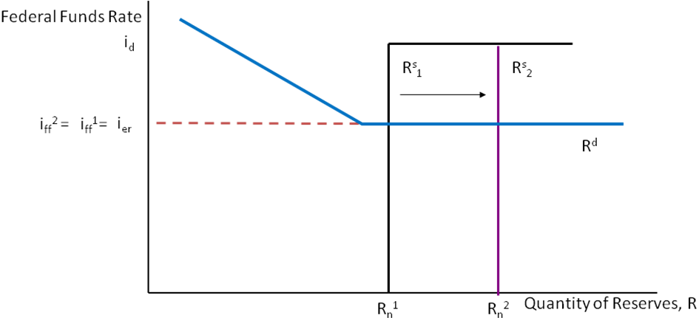
Discount window (vertical portion of supply curve) Discount window (flat portion of supply curve)
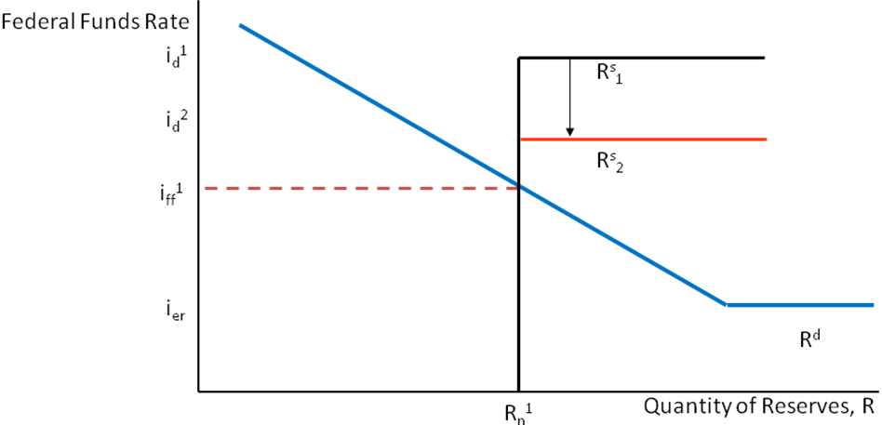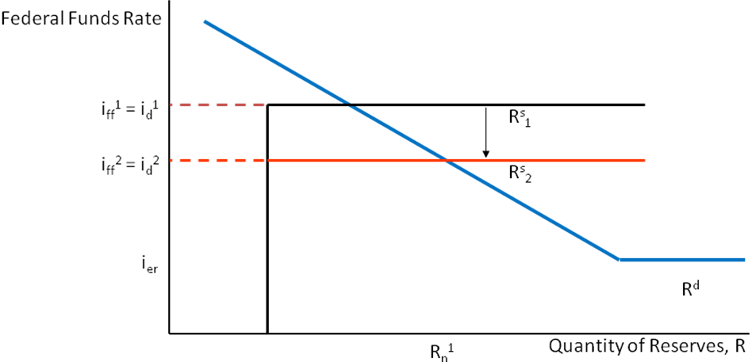
Reserve requirement (downward sloping portion) Reserve requirement (flat portion of demand curve)
