Pre-FDIC Bank Runs & Panics (3/22/2011) Econ 310-008

Definitions
- bank run – many customers simultaneously try to cash out deposits (or banknotes), out of concern that the bank will default if they wait
- bank panic – many banks experience runs in the same period

Principles
- A run on an insolvent bank can force the bank to close before it squanders more on risky investments.
- The threat of a bank run incentivizes depositors to monitor how risky bank investments are.
- When nobody runs on insolvent banks, they often become zombie banks that take ever greater gambling risks to get back to even.
- Depositors can run on a solvent bank that subsequently becomes insolvent due to the run (fire sale losses on assets liquidated to pay withdraws).
- Bank panics were far more frequent in highly regulated countries (e.g., U.K. and United States).
- Countries with free banking had very few bank panics (e.g., Canada, Scotland, & Sweden).
- When country banks needed reserves (due to bond collateral restrictions on banknote issue), they would withdraw from city banks, which would then withdraw from big banks in NYC or Chicago.
- A bad crop could cause locals to believe all banks in the area had bad loans and were insolvent. This would trigger bank runs, and withdrawals up the chain. Fire sale losses to pay out bank depositors could then make the city and big city banks insolvent.

Reasons bank runs are harmful
- shareholders: fire sale losses
- borrowers: interrupts loans
- depositors / note holders: losses

Characteristics of run-prone banks
- debt claim: fixed $
- unconditional redeemability
  - first come, first served
- default likely on last claim

Historical reasons for contagion
- branch banking restrictions
  - reduced diversification
  - limited capitalization
- bond collateral requirement
  - currency demands unmet

Reasons bank panics are harmful
- spreads runs to other banks
  - harms of bank runs apply
- contracts money supply
  - disrupts economy
- fewer deposits
  - less intermediation / loans

Bank Run Solution: modify any 1 of 3 conditions
- debt equity claim
  - money market mutual fund
    - claims = portfolio
    - losses shared by all immediately
    - no reward for first
    - uninsured, but never run
- unconditional conditional redeemability
  - notice-of-withdrawal clause for D
    - e.g., 2 weeks notice
  - option clause for banknotes
    - temporarily suspend redeemability
    - pay interest on period suspended
- default likely on last claim solvency assurances
  - adequate capital, advertised
  - diversified portfolio of safe assets
  - extended liability for shareholders
    - double, triple, unlimited
  - clearinghouse certification

Major bank panics
- 1792 (Bank of NY)
- 1797 (land speculation)
- 1819 (War of 1812 inflation ABC)
- 1837 (Jackson: specie for land)
- 1857 (farmers & railroads)
- 1873 (silver de-monetized)
- 1893 (silver vs. gold)
- 1907 (Copper cornering, banker bailout)
- 1929-1933 (Great Depression)

Panic of 1792
- speculation on Bank of NY stock
  - long: Duer with Macomb
  - short: Duer, Livingston family
- William Duer was double-dealing
  - first insider trader
  - thrown in debtor’s prison
- prices went up a lot, then crashed
- Alexander Hamilton intervened
  - Treasury purchased securities
  - urged banks not to call in loans

Panic of 1797
- land speculation
  - Robert Morris
    - 3M acres in west NY
    - 6M acres in south
  - James Wilson
- land prices plummeted
  - demand fell: Napoleonic Wars
- BoE suspended specie payments
- massive deflation

Panic of 1819
- Rothbard’s Ph.D. dissertation
- boom
  - inflation: War of 1812 financing
  - unsustainable investments
- bust
  - Europe demand for food fell
    - Europe supply had risen
  - Europe hoarded gold & silver
    - Mexican supply lines cut off
- specie payments suspended

Panic of 1837
- Gresham’s Law: silver out of Mexico
- state deficit spending
- Specie Circular executive order
  - only specie accepted for land
  - issued by Andrew Jackson
  - continued by Martin Van Buren
- 343/850 banks totally failed
- 62/850 banks partially failed
- specie payments suspended

Panic of 1857
- western farmer mortgage defaults
  - because grain prices had fallen
- railroad stock prices plummeted
  - due to less western migration
- Ohio Life Insurance & Trust Co. failed
  - made panic more public
- Dred Scott decision on slavery
  - created uncertainty in west
- specie payments suspended
- tariff of 1857 lowered tariffs

Panic of 1873
- Coinage Act of 1873
  - de-monetized silver in U.S.
    - reduced money supply
    - raised interest rates
- Jay Cooke & Company failed
  - bank financing No. Pac. Railroad
- 89/364 railroads went bankrupt
- specie payments suspended
- “Great Depression” in Europe

Panic of 1893
- Philadelphia and Reading Railroad
  - failed after overextending
- Sherman Silver Purchase Act
  - repealed by Grover Cleveland
  - act had promoted silver coinage
- National Cordage Company failed
  - rope co. speculated in hemp
- J.P Morgan lent U.S. $65M gold
- 500 banks failed (many in west)
- specie payments suspended
- Republican landslide 1894, 1896

Panic of 1907
- speculation on United Copper Co.
  - Otto & August Heinze, C. Morse
    - tried to corner, fail
- runs on all their banks & trusts
  - forced to resign from all boards
- run on Knickerbocker Trust Company
  - C. Barney friend of the above
  - 3rd largest trust
  - becomes insolvent and fails
- stock market tumbles
- J.P. Morgan (banker) intervenes
  - lends massively to trusts
  - gets trusts & banks lending
  - Moore & Schley brokerage
    - in trouble due to TC&I stock
    - U.S. Steel buys TC&I
  - lends NYC $30 million
- Rockefeller pledged half his wealth
- Treasury deposited $25M in banks
- NY CLA issued $100M in bank loans

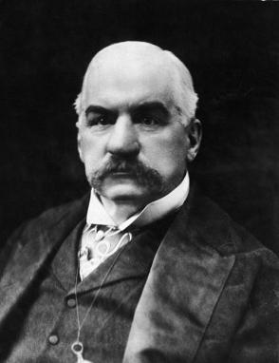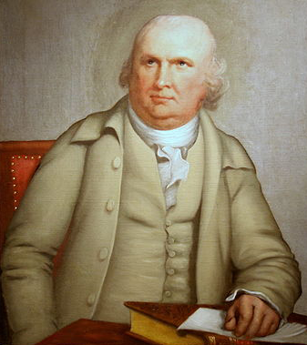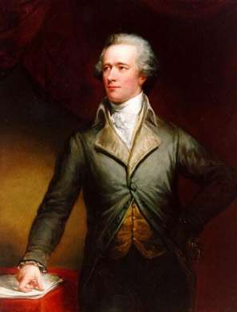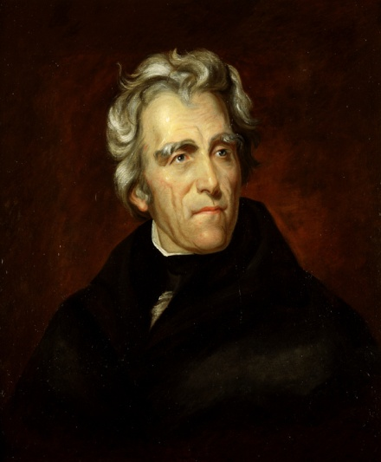
J.P. Morgan Robert Morris Alexander Hamilton Andrew Jackson

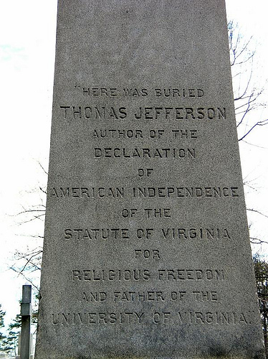
Thomas Jefferson was so embarrassed about the Embargo Act of 1807 destroying the American economy, that he didn’t put “President of the United States” on his headstone.

