Bank Balance Sheet (2/22/2011) Econ 310-008

Definitions
- assets – uses of funds; financial claim or piece of property that is a store of value
- liabilities – sources of funds; IOUs or debts
- deposits – money put in a bank for safekeeping or to earn interest with the intention of withdrawing it later
- checkable deposits – accounts that allow the owner to write a check to third parties
- demand deposits – non-interest bearing checking accounts (included in M1)
- Negotiable Order of Withdraw accounts (NOW) – interest bearing checking accounts (included in M1)
- Money Market Deposit Accounts (MMDA) – similar to money market mutual funds (not included in M1; included in M2; not subject to reserve requirements)
- non-transaction deposits – owners cannot write a check drawn on these, but interest rates are usually higher than on checkable deposits
- savings accounts – money can be added or withdrawn at any time (included in M2; actually regulations limit withdraws to four per month so that they aren’t treated like checking accounts)
- time deposits – fixed maturity length with substantial penalties for early withdraw
- small denomination time deposits – less than $100,000 (included in M2)
- large denomination time deposits (CDs) – more than $100,000 (included in M3)
- discount loans – borrowing from the Federal Reserve
- federal funds rate – interest rate to borrow from other banks
- repurchase agreement – note sold to corporations with the obligation to buy it back the next day (included in M3)
- outside money – full-bodied coins and other full-bodied commodity money (asset for holder, not a liability for someone else)
- inside money – bank issued money (asset for holder, a liability for issuing bank)
- reserves – money physically held by the bank in the medium of redemption (e.g., gold, FRNs)
  - vault cash (currency held at the bank)
  - money deposited at the central bank (e.g., the Federal Reserve).
- 100% reserves – a system in which banks hold all of their deposits as reserves
- fractional-reserve banking – a system in which banks hold a fraction of their deposits as reserves
- reserve requirement – regulation that for every dollar of checkable deposits, a certain fraction (e.g., 10 cents) must be kept as reserves
- required reserves – reserves held due to the reserve requirement
- excess reserves – additional reserves beyond required reserves
- reserve ratio – percentage of liabilities kept as reserves; reserve ratio ≡ reserves/liabilities
- required reserve ratio – central bank required percentage of liabilities kept as reserves
- T-account – a simplified balance sheet that lists only the changes that occur in balance sheet items starting from some initial balance sheet position
- liquidity management – acquisition of sufficiently liquid assets to meet the bank’s depositor obligations
- asset management – banks aspire to minimize risk and maximize returns by seeking low default rate, diversified assets with high yield rates
- liability management – banks aspire to acquire funds at a low cost, seeking to minimize interest paid
- capital adequacy management – banks target and acquire the amount of capital they need to maintain
Equations
- total assets = total liabilities + equity accounting identity
- R + L = N + D + K balance sheet constraint

Variable definitions
- R ≡ reserves
- L ≡ loans + securities
- N ≡ banknotes in circulation
- D ≡ deposits
- K ≡ capital

Principles
- Banks borrow short and lend long.
- Government regulations prohibit banks from holding equity securities (corporate stocks), so they mostly hold government bonds.
- Banks primarily make their profits from loans.
- Banks traditionally have big, fancy buildings as a signal that they won’t run off with your money.
- Inter-bank borrowing is conducted to cover temporary (often overnight) reserve shortfalls.
- Fractional reserve banking operates on the premise that only a small fraction of outstanding depositors (or banknote holders) will want to withdraw their money (or redeem their banknotes) at any given time.
- Murray Rothbard and Milton Friedman favored 100% reserves, but for different reasons. Rothbard: fractional-reserve banking = fraud; Friedman: monetary policy more effective with 100% reserves.
- If banks did not lend out money, they wouldn’t be able to pay interest to depositors. Instead, depositors would have to pay banks a storage fee to hold the money.
- The Federal Reserve recently began paying interest on reserves banks hold at the Fed.
- Federal Reserve issues paper fiat notes; the Treasury issues token coins.
- Fed securities used to only be U.S. bonds, but recently exploded with mortgage backed securities.
- Regulation Q prohibited paying interest on checking accounts
- 3-6-3 banking: pay 3% interest for deposits, charge 6% interest for loans, be on the golf course by 3 pm
- Banks used non-price competition (e.g., toasters) to attract depositors.

Federal Reserve + Treasury balance sheet

Assets | Liabilities + Equity
securities | FRNs
gold | coins
loans | bank reserves
FX reserves
Colsolidated banks balance sheet

Assets | Liabilities + Equity
reserves | deposits
securities | borrowings
loans | banknotes
other | capital

Types of deposits
- checkable deposits
  - demand deposits (M1)
  - NOW accounts (M1)
  - MMDAs (M2)
- non-transaction deposits
  - savings accounts (M2)
  - time deposits
    - small denomination (<$100k) (M2)
    - large denomination (>$100k) (M3)

Types of borrowing
- Federal Reserve (discount loans)
- other banks (at the federal funds rate)
- corporations (repurchase agreements)

Types of loans
- business (commercial and industrial)
- real estate (mortgages)
- consumer (cars, college, etc.)
- interbank (at the federal funds rate)
Fractional-reserve banking
- Benefits
  - bankers earn interest on assets
  - customers earn interest on deposits
(and not have to pay storage fee)
- Costs
  - possible bank runs
  - possible defaults on loans

Examples of fractional reserves
- airline tickets
- parking spaces at GMU
- telephone system
- cafeteria food/meal plans

General principles
- liquidity management
- asset management
- liability management
- capital adequacy management

Capital considerations
- capital↑ → (bank failure)↓
- capital↑ → (owner ROI)↓
- capital required by regulation

T-accounts

Depositing a check
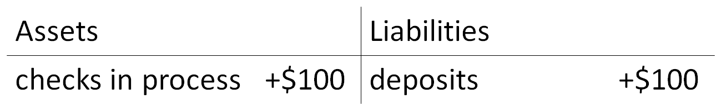
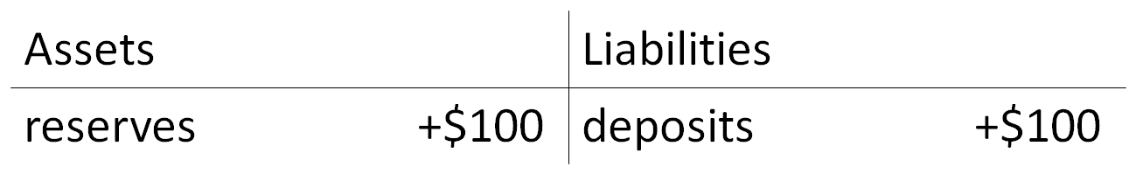

Making a loan
