Asymmetric Information (11/23/2010) Econ 310-004

Definitions
- transaction costs – time & money spent trying to exchange financial assets, goods, or services
- financial intermediaries – institutions that borrow funds from savers and make loans to others
- asymmetric information – unequal knowledge each party to a transaction has about the other party
- adverse selection – ex-ante (before transaction) asymmetric information; the most undesirable people (from the other party’s point of view) are the ones most likely to want to engage in financial transaction
- moral hazard – ex-post (after transaction) asymmetric information; the risk that one party to a transaction will engage undesirable behavior (from the other party’s point of view)
- principal-agent problem – managers act in their interest, not in owners’ interest (incentives problem)
- conflict of interest – type of moral hazard problem caused by economies of scope; organization is involved in multiple objectives and has conflicts between those objectives (one corrupts the other)
- economies of scope – ability to use one resource to provide many different products and services

Financial Structure
- stocks not the primary source of business financing
- debt & equity securities not the primary source of business financing
- indirect financing of businesses > direct financing of businesses (many times >)
- financial intermediaries the primary source of business financing
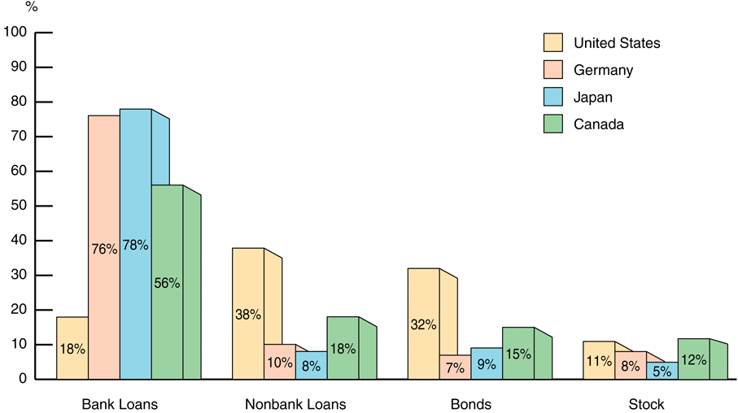
- financial system among most regulated sectors
- only large corporations have easy access to securities
- most debt contracts involve collateral
- debt contracts complicated & regulate behavior

Principles
- Financial intermediaries lower transaction costs.
  - take advantage of economies of scale
  - develop expertise to lower costs
- Transaction costs lead to less transactions.
  - Stock market: Transaction costs means less investment and less diversification.
- Moral hazard
  - Equity: Managers have an incentive for fancy offices or embezzling money, not making a profit.
  - Debt: Borrowers have incentives to take on projects that are riskier than the lenders would like.

Avoiding adverse selection
- private investors research companies
- government requires audits & disclosures
- financial intermediaries use expertise
- collateral & net worth mitigate default

Avoiding moral hazard in debt contracts
- collateral & net worth align incentives
- monitoring and restrictive covenants
  - discourage undesirable behavior
  - encourage desirable behavior
  - keep collateral valuable
- financial intermediaries use expertise

Avoiding moral hazard in equity contracts
- investors audit firms
- government: audits & penalties for fraud
- venture capital firms in management
- use debt contracts instead

Conflict of interest examples
- investment banks: underwriting & research
  - research optimistic for IPO issuers
- accounting firms: auditing & consulting
  - opinions skewed, future consulting
  - opinions audit consultants’ systems
- credit rating agencies: rating & consulting

