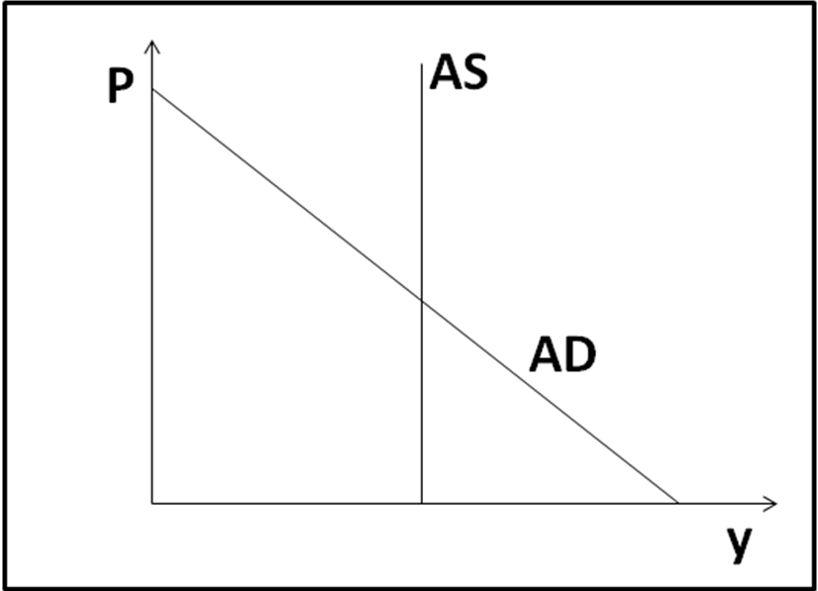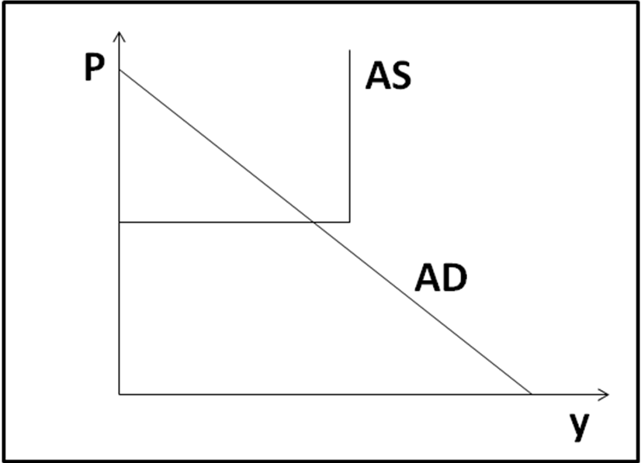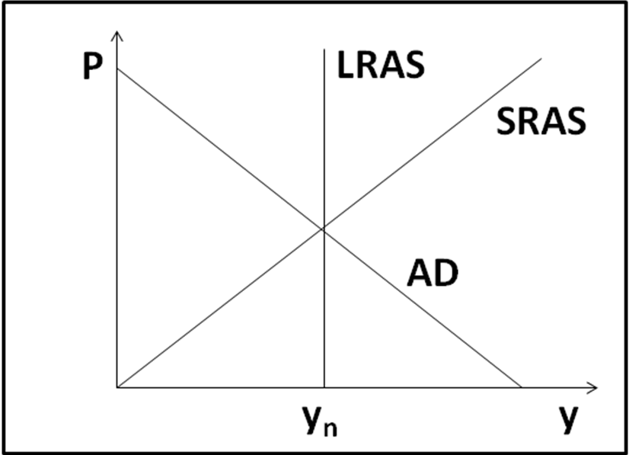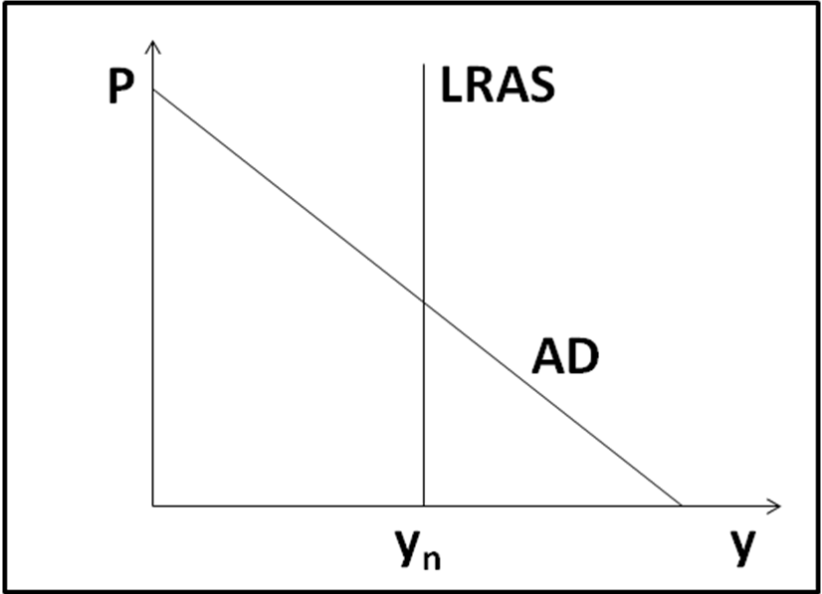
classical model orthodox keynesian model monetarist, new classical, new keynesian real business cycle model

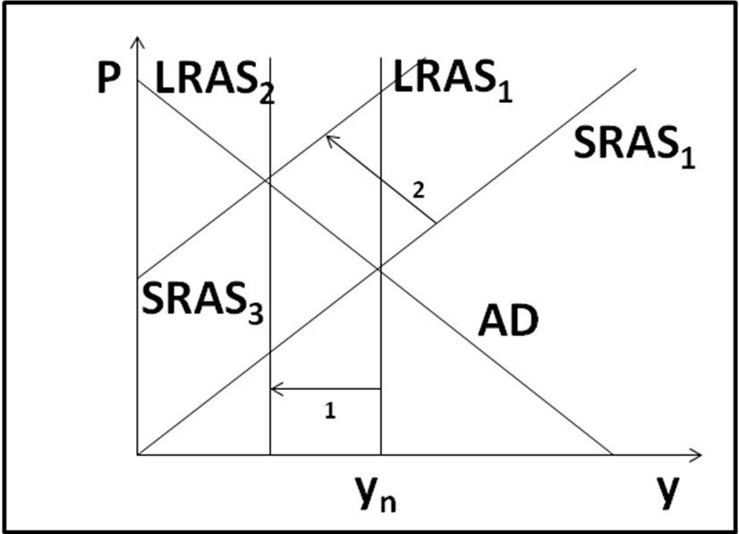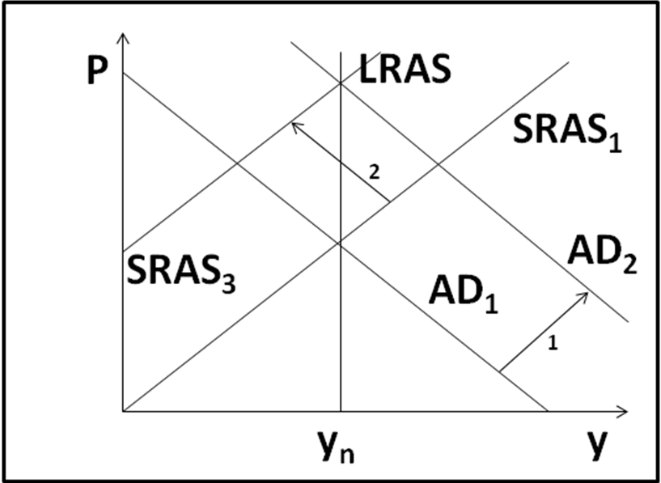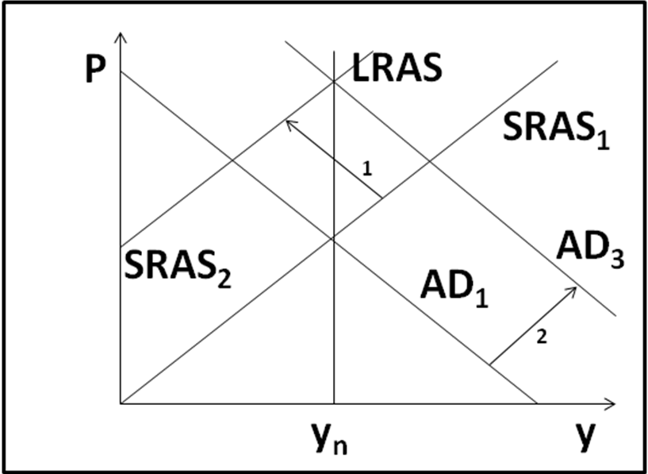
At long run equilibrium, Shifts in LRAS bring SRAS with it. Shifts in AD bring SRAS with it. Shifts in SRAS bring AD with it.
LRAS, SRAS, & AD intersect.

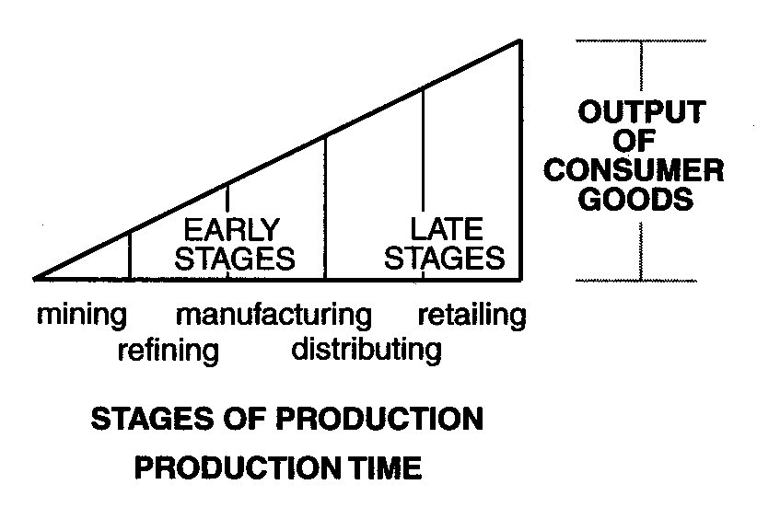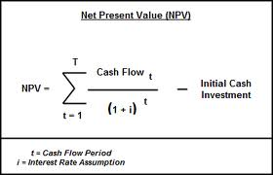
Hayekian triangles present discounted value
(structure of production) lower interest rate → higher PDV

