Monetary Policy Targets (11/2/2010) Econ 310-004

Definitions
- policy instrument – variable that responds to tools and indicates stance (easy, tight) of monetary policy
- intermediate target – stands between the instruments and goals of monetary policy
- monetary targeting – central bank announces targets for annual growth rate of a monetary aggregate
- real bills doctrine – creation of paper or credit money will not cause inflation as long as the money is issued in exchange for sufficient security (thoroughly discredited)
- procyclical – economic quantity positively correlated with state of economy; up in booms, down in busts
- countercyclical – economic quantity negatively correlated with state of economy
- automatic stabilizers – policies that stimulate or depress the economy when necessary without any deliberate policy change (designed to reduce lags)
- rules – policymakers announce in advance how policy will respond in various situations, and commit themselves to following through
- discretion – as events occur and circumstances change, policymakers use their judgment and apply whatever policies seem appropriate at the time
- time inconsistency – policymakers have an incentive to renege on a
previously announced policy once others act

Equations
- i_{ff} = π + 2 + 0.5(π – 2) + 0.5[100(y – y_{n})/y_{n}] Taylor Rule
- i_{ff} = (inflation rate) + (equilibrium real fed funds rate target) + 0.5(inflation gap) + 0.5(GDP gap)

Variable definitions
- i_{ff} ≡ nominal federal funds rate target
- π ≡ inflation rate
- y ≡ real GDP
- y_{n} ≡ real GDP at natural rate of unemployment
- equilibrium real federal funds rate = 2
- inflation gap = π – 2
- GDP gap = 100(y – y_{n})/y_{n}
  - percent GDP below natural rate

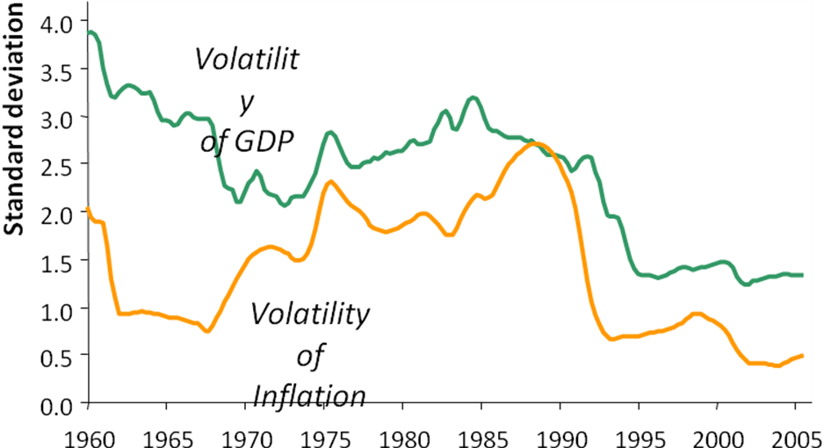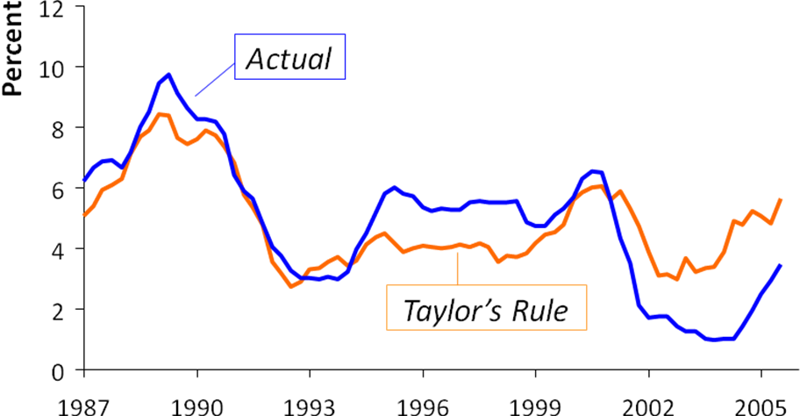

Monetary policy
- tools
  - open market operations
  - discount rate
  - required reserve ratio
- instruments
  - reserve aggregates
    - reserves
    - non-borrowed reserves
    - monetary base
  - interest rates
    - short-term interest rates
    - federal funds rate
- targets
  - monetary aggregates
    - M1
    - M2
  - interest rates
    - inflation rate
    - long-term interest rate
    - short-term interest rate
- goals
  - price stability
  - high employment
  - economic growth
  - financial market stability
  - interest-rate stability
  - foreign exchange stability

Policies
- Active policy advantages
  - monetary policy can stabilize economy
  - fiscal policy can stabilize economy
- Passive policy advatages
  - long & variable lags to policies
    - Milton Friedman emphasized this
    - may de-stabilize when takes effect
- Rules advantages
  - distrust of policymakers & political process
  - time inconsistency

Targeting
- monetary targeting (United States)
  - money supply growth targets announced
    - Arthur Burns in 1975
    - often missed targets
  - focus on non-borrowed reserves
    - Paul Volker in 1979
  - won’t use monetary aggregates
    - Greenspan in 1993
- inflation targeting
  - medium-term numerical target for inflation
    - public announcement
  - commitment to price stability
    - primary, long-run goal
  - many variables are used in making decisions
  - increased transparency of the strategy
  - increased accountability of the central bank
- no explicit nominal anchor
  - no overriding concern for the Fed
  - used by the Fed recently
  - “just do it” approach
  - forward looking behavior
  - periodic “preemptive strikes”
  - goal: prevent inflation from getting started

Monetary policy rules
- constant money supply growth rate
  - advocated by monetarists
  - Friedman k-percent rule
    - 4% per year
- target growth rate of nominal GDP
- target the inflation rate
- the Taylor Rule
  - target the federal funds rate
  - based on
    - inflation rate
    - GDP gap
    - inflation gap
  - proposed by John Taylor
  - examples
    - if π = 2% & y = yn, iff = 4%
    - π↑ by 1% → iff↑ by 1.5%
    - (y – yn)↑ by 1% → iff↑ by 0.5%
History of Federal Reserve policy
- Early years of the Fed (1913-1921)
  - discount loans the primary policy
  - real bills doctrine (discredited)
- Discovery of OMO (1921-1929)
  - Federal Reserve needed more revenue
  - invested in income earning securities
  - open market operations
    - accidentally discovered
- Great Depression (1929-1941)
  - raised discount rate too late
  - bank failures reduced money supply
    - Fed didn’t understand
    - M1 contracted 25%
    - believed was expanding M^{s}
  - Fed didn’t act as LOLR
- Reserve requirements (1933-1941)
- reserve requirements power
  - got 1933, expanded 1935
- ER hurt monetary policy
- raised reserve requirements
  - caused 1937-1938 recession
  - “double dip”
- Pegging of interest rates (1942-1951)
- skyrocketed government spending
  - finance WWII cheaply
- pegged interest rates
- if interest rates on bonds rose
  - open market purchases
  - interest rates would fall
- rapid growth in MB & money supply
- Targeting money market (1950s, 1960s)
- intuitive judgment
  - money market feel
  - i.e., interest rates
- pro-cyclical policy (for M)
  - Y↑ → i↑ → MB↑ → M↑
  - π↑ → πe↑ → i↑ → MB↑ → M↑
  - monetarists criticized
- Targeting monetary aggregates (1970s)
- wasn’t really monetary targeting
  - actually used fed funds rate
- still pro-cyclical policy (for M)
- New operating procedures (1979-1982)
- de-emphasis on fed funds rate
- main: non-borrowed reserves
- still used interest rates
- Paul Volcker was Fed chair
- not serious about aggregates
  - avoided blame for high interest rates
- anti-inflation strategy
- De-emphasis of monetary aggregates (1982-1993)
- borrowed reserves main instrument
  - discount loans
- pro-cyclical policy (for M)
- breakdown in M:GDP relationship
- Federal funds targeting II (1993-present)
- monetary aggregates not used
- federal funds rate main instrument/target
  - announced starting 1994
- Other considerations
- pre-emptive strikes against inflation
- pre-emptive strikes against recessions
- international considerations

