The Federal Reserve (10/14/2010) Econ 310-004

Definitions
- central bank – regulates a nation’s depository institutions and controls the quantity of money
- Federal Reserve (“the Fed”) – central bank in the United States
- Federal Reserve banks (FRB) – 12 regional banks responsible for the regulation of the commercial banks within their own particular district
- Board of Governors (BoG) – main governing body of Federal Reserve System
- Federal Open Market Committee (FOMC) – main policy-making group in the Federal Reserve System
- discount rate – interest rate to borrow funds from Federal Reserve
- federal funds rate – interest rate to borrow from other banks
- required reserve ratio – required percentage of liabilities banks must keep as reserves
- open market operations – purchase or sale of securities by the Federal Reserve in the open market
- service fees – profit that results from fees charged for miscellaneous services performed
- price stability – low and stable inflation
- instrument independence – ability of the central bank to set monetary policy instruments
- goal independence – ability of the central bank to set goals of monetary policy

William Jennings Bryan
- presidential candidate (Democrat)
  - 1896, 1900, 1908
- “cross of gold” speech
- populist for farmers
- disliked gold standard
- wanted free silver coinage
- hated big banks
- Secretary of State under Wilson

Nelson Aldrich
- chair of Senate finance committee
- sponsor: 16th Amend. (income tax)
- sponsor: Aldrich–Vreeland Act of 1908
- wrote Aldrich plan
  - studied European central banks
  - met with bankers on Jekyll Island
  - basis of Federal Reserve Act
- grandfather of VP Nelson Rocketfeller

Fed history
- precipitated by panic of 1907
- Aldrich–Vreeland Act of 1908
  - National Monetary Commission
- Aldrich plan floated
- Federal Reserve Act of 1913
  - introduced by Glass
  - Woodrow Wilson signed
  - William Jennings Bryan supported

Federal Reserve Banks
- 12 regional banks
- Board of Governors
  - 7 governors
- Federal Open Market Committee
  - 7 board governors
  - 1 FRB of NY president
  - 4 other FRB presidents (rotating)
- Federal Advisory Council
  - 12 bankers (1 from each district)

FRB of NY
- Federal Reserve bank
- district with largest commercial banks
- houses open market desk
- open market operations for Fed
- houses foreign exchange desk
- foreign exchange interventions
- member of BIS (with Fed chair)
  - Bank for International Settlements
- repository for $100 billion of gold
- permanent voting member of FOMC

Federal Reserve Banks
- 3 class A directors
  - professional bankers
  - elected by member banks
- 3 class B directors
  - industry, labor, agriculture leaders
  - elected by member banks
- 3 class C directors
  - represent public interest
  - appointed by Board of Governors
  - Bank President must be class C

Roles of federal reserve banks
- clear checks
- issue new currency
- withdraw damaged currency
- discount loans to banks in districts
- evaluate proposed mergers
- liaisons for business community
- examine bank holding companies
- examine state-chartered member banks
- collect data on local economy
- research monetary policy

Member banks
- nationally chartered banks must join
- state chartered banks may join
- all depository institutions
  - must keep reserves at Fed
  - subject to reserve requirements
- member banks
  - associate with 1 FRB (district)
  - invest 6% of capital in FRB stock
  - get 6% dividends on FRB earnings
  - vote on 6/9 FRB directors

Board of Governors
- 7 governors
  - all from different FRB districts
  - 14 year non-renewable terms
  - staggered expiring every 2 years
  - appointed by President
  - confirmed by Senate
- chairman and vice-chairman
  - selected from governors
  - 4 year renewable terms
  - appointed by President
Federal Reserve Chairman
- controls agenda of the Board
- directs board staff
- Federal Reserve spokesperson
- point of contact for
  - President
  - Congress
  - foreign central banks

Federal Open Market Committee
- meets every 6 weeks
- BoG has a majority (7/12)
- formulates monetary policy
- decides open market operations
- sets reserve requirements
- reviews discount rates
- voting members
  - 7 governors from BoG
  - 1 FRB of NY president (permanent)
  - 4 other FRB presidents (rotating)
- chair of BoG chairs the FOMC

Monetary policy tools
- traditional tools
  - required reserve ratios
  - discount rate
  - open market operations
- additional (new) tools
  - interest on reserves
  - term auction facility
  - primary dealer credit facility
  - term securities lending facility

Open market operations
- policy decided by FOMC
- implemented by FRB of NY
- open market desk sells or buys
  - with primary dealers (18 banks)
  - buying increases money supply
  - selling decreases money supply

Reserve banks issue notes
- Department of Treasury prints notes
  - Bureau of Printing & Engraving
- notes made of cloth, not paper
- old: marked by issuing reserve bank
- new: generic federal reserve notes

Federal Reserve revenue
- revenue
  - seigniorage
  - service fees
- fund all operations
- rebate excess to Treasury

Monetary policy goals
- price stability
- high employment
- economic growth
- financial market stability
- interest-rate stability
- foreign exchange stability

Independence
- independent
  - long terms for BoG
  - determines own budget
  - instrument and goal independence
- not independent
  - Congress can amend Fed legislation
  - President appoints BoG and chair
- overall: very independent
- independence leads to lower inflation
  - less political business cycles

European central bank
- patterned after Federal Reserve
- national central banks (NCBs)
- executive board (EB)
- governing council (GC)
- NCBs similar to Fed banks
- EB similar to Fed BoG
- GC similar to FOMC
- NCBs control own budgets
- monetary operations not centralized
- doesn’t regulate financial institutions
- monthly meetings (Frankfurt, Germany)

Federal Reserve districts
- Boston – A
- New York – B
- Philadelphia – C
- Cleveland – D
- Richmond – E
- Atlanta – F
- Chicago – G
- St. Louis – H
- Minneapolis – I
- Denver – J
- Dallas – K
- San Francisco – L

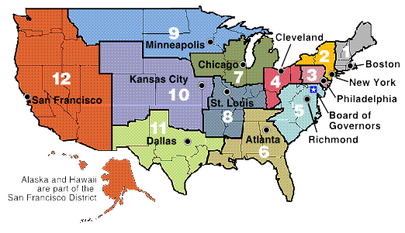
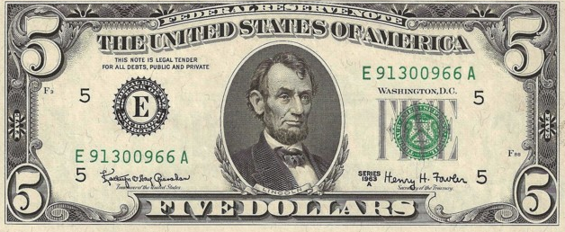
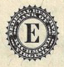 = E = 5th district = Richmond

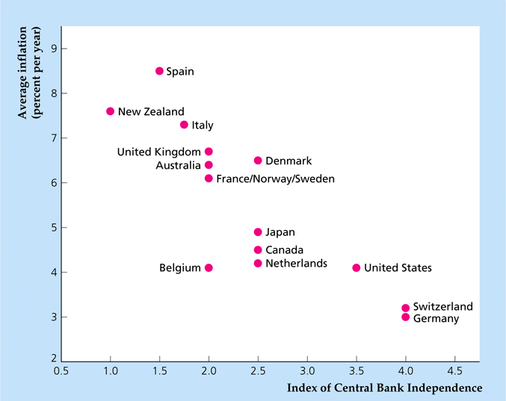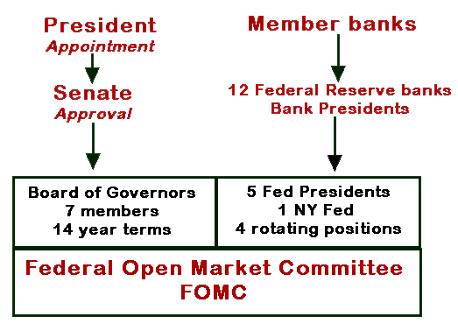
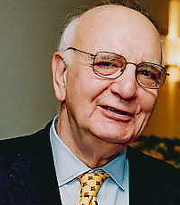
Paul Volcker
- Federal Reserve chairman 1979-1987
  - appointed by Carter
  - reappointed once by Reagan
  - “fired”: didn’t support de-regulation
  - ended 1970’s stagflation
  - caused 1981 recession
  - targeted monetary aggregates
- previously FRBNY president
- Economic Recovery Advisory Board chair

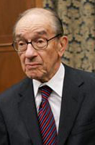
Alan Greenspan
- Federal Reserve chairman 1987-2006
  - appointed by Reagan
  - re-appointed by Bush, Clinton, & Bush 2
  - very stable economy / low inflation
  - obfuscated his words
  - acted first at FOMC meetings
  - policy in 2000’s caused housing bubble?
- chair of Council of Economic Advisers (Ford)
- economic consulting firm (numbers guy)
- friend of objectivist philosopher Ayn Rand

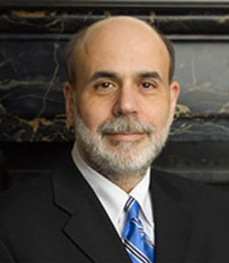
Ben Bernanke
- Federal Reserve chairman 2006-present
  - appointed by Bush 2
  - re-appointed by Obama
  - scholar of Great Depression
  - big on transparency
  - speaks clearly
  - acts last at FOMC meetings
- economics professor (Stanford, Princeton)
- Federal Reserve Governor 2002-2005
- chair of Council of Economic Advisers (Bush 2)

