Bonds & Stock Market (9/21/2010) Econ 310-004

Equations
- i_{nt} = (i_{t} + i^{e}_{t+1} + i^{e}_{t+2} + … + i^{e}_{t+(n–1)})/n Expectations formula
- i_{nt} = (i_{t} + i^{e}_{t+1} + i^{e}_{t+2} + … + i^{e}_{t+(n–1)})/n + l_{nt} Liquidity premium formula
- p₀ = D₁/(1 + k_{e}) + p₁/(1 + k_{e}) One-Period Stock Valuation Model
- p₀ = D₁/(1 + k_{e})¹ + D₂/(1 + k_{e})² + … Dividend Valuation Model
+ D_{n}/(1 + k_{e})^{n} + p_{n}^{e}/(1 + k_{e})^{n}
  - fundamentals: D₁/(1 + k_{e})¹ + … + D_{n}/(1 + k_{e})^{n}
  - bubble: p_{n}^{e}/(1 + k_{e})^{n}
- p₀ = ∑D_{t}/(1 + k_{e})^{t} Dividend Valuation Model without final sale
- p₀ = D₀(1 + g)¹/(1 + k_{e})¹ + D₀(1 + g)²/(1 + k_{e})² + Gordon Growth Model
… + D₀(1 + g)∞/(1 + k_{e})∞
- p₀ = D₀(1 + g)/(k_{e} – g) = D₁/(k_{e} – g) Gordon Growth Model (simplified)

Definitions
- risk structure of interest rates – the relationship among the interest rates on various bonds with the same term to maturity
- term structure of interest rates – the relationship among the interest rates on various bonds with different terms to maturity
- default – party issuing debt instrument is unable to make interest payments or pay off the amount owed at maturity
- default-free bonds – bonds with no default risk
- risk premium – interest rate spread between bonds with default risk and default-free bonds
- yield curve – plot of the yields of bonds with differing terms to maturity but the same risk structure (risk, liquidity, and tax considerations)
- inverted yield curve – downward sloping yield curve
- expectations theory – the interest rate of a long-term bond will equal the average of short-term interest rates people expect over the life of the long-term bond
  - Assumption: Bonds of different maturities are perfect substitutes.
  - Implication: Re on bonds of different maturities are equal.
- segmented markets theory – markets for different maturity bonds are completely separate; interest rates are determined by supply and demand for that bond only
  - Assumption: Bonds of different maturities are not substitutes.
  - Implication: Interest rate at each maturity determined seperately.
- liquidity premium theory – the interest rate of a long-term bond will equal the average of short-term interest rates people expect over the life of the long-term bond plus a liquidity premium
  - Assumption: Bonds of different maturities are substitutes, but not perfect substitutes.
  - Implication: Modifies expectations theory with features of segmented markets theory.
- adaptive expectations – expectations are formed from past experience only
- rational expectations – expectations will be identical to optimal forecasts (the best guess of the future) using all available information
- arbitrage – market participants eliminate unexploited profit opportunities
- efficient market hypothesis – applies rational expectations to financial markets; stock prices reflect all available information
  - weak form – stock prices reflect past stock price history
  - semi-strong form – stock prices reflect all publicly available information
  - strong form – stock prices reflect all information (public and insider)

Variable definitions
- i_{t} ≡ interest rate on one-period bond
- i^{e}_{t+1} ≡ expected interest rate on one-period bond next period
- i_{2t} ≡ interest rate on two-period bond
- l_{nt} ≡ liquidity premium for n-period bond at time t
- p₀ ≡ current price of stock
- D₁ ≡ dividend paid for year 1
- k_{e} ≡ required return in equity
- p₁ ≡ stock price at the end of year 1
- D₀ ≡ most recent dividend paid
- g ≡ expected constant growth rate

Principles
- Government bonds are not necessarily default-free.
- Default risk, liquidity, & tax treatment are relative to alternative assets.
- A bond with a default risk will always have a positive risk premium.
- Credit rating agencies rate the quality of bonds by probability of default (AAA default less than CCC).
- Junk bonds often facilitated leveraged buyouts, increasing firm productivity.
- Income from municipal bonds is not taxed by the federal government due to state sovereignty reasons.
- l_{nt} always positive, rises with maturity.
- Current stock values are the present discounted value of future dividends.
- Market price is set by the buyer willing to pay the most (buyer who can make best use of the asset).
- Superior information about an asset can increase its value by reducing its perceived risk.
- When new information is released about a firm, expectations and prices change.
- Rational expectations assumes agents use the same model as the researcher (“model-consistent”).
- In rational expectations people can make mistakes, but they do not make systematic forecasting errors.
- Arbitrage is the mechanism tending toward the efficient market hypothesis.
- Efficient market holds even if there are some uninformed, irrational participants.

Risk structure factors
- default risk: risk_{B}↑ → B^{D}↓ → P_{B}↓
- liquidity: liquidity_{B}↓ → B^{D}↓ → P_{B}↓
- income tax: tax_{B}↓ → B^{D}↑ → P_{B}↑

Term structure empirical facts
- interest rates on bonds of different maturities move together over time
- low short-term interest rates usually mean upward sloping yield curves; high short-term interest rates usually mean downward sloping yield curves
- yield curves almost always slope upward

Term structure theories
- expectations theory: explains 1 & 2, not 3
- segmented markets theory: explains 3, not 1 & 2
- liquidity premium theory: explains 1, 2, & 3

Setting prices
- uncertainty↑ → k_{e}↑ → p₀↓
- economy growth↑ → g↑ → p₀↑
- dividends↑ → D₀↑ → p₀↑

Favorable evidence – efficient market hypothesis
- Investment analysts and mutual funds don’t beat the market
- Anticipated announcements don’t affect stock price
- Stock prices close to random walk
- Technical analysis doesn’t outperform market

Unfavorable evidence – efficient market hypothesis
- Small-firm effect: small firms have abnormally high returns
- January effect: high returns in January
- Market overreaction
- Excessive volatility
- Mean reversion
- New information is not always immediately incorporated into prices

Implications – efficient market hypothesis
- Published reports of financial analysts not very valuable
- Should be skeptical of hot tips
- Stock prices may fall on good news
- Prescription for investor
  - Shouldn’t try to outguess market
  - Buy and hold
  - Diversify with no-load mutual fund

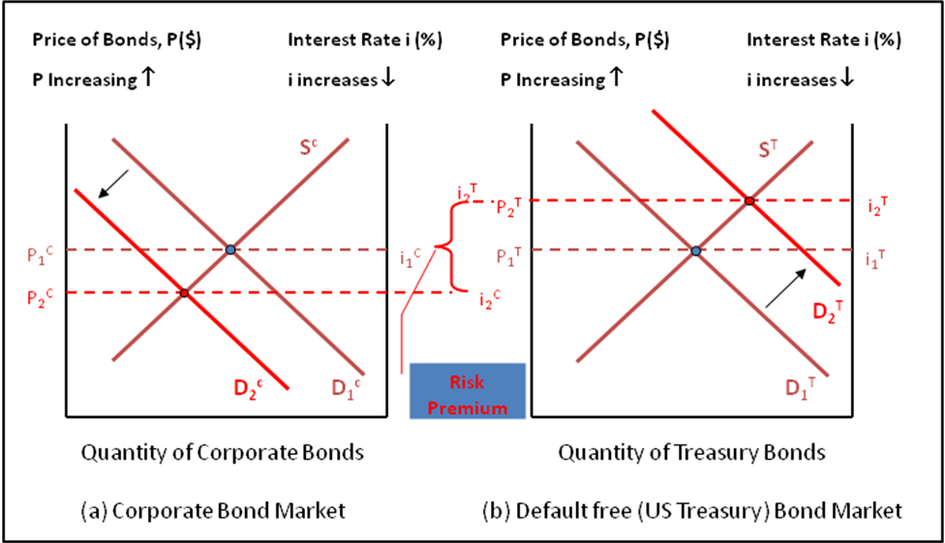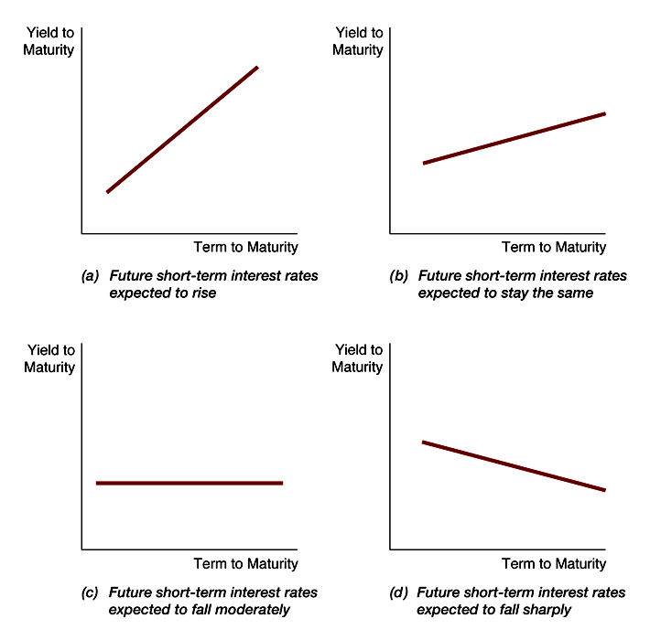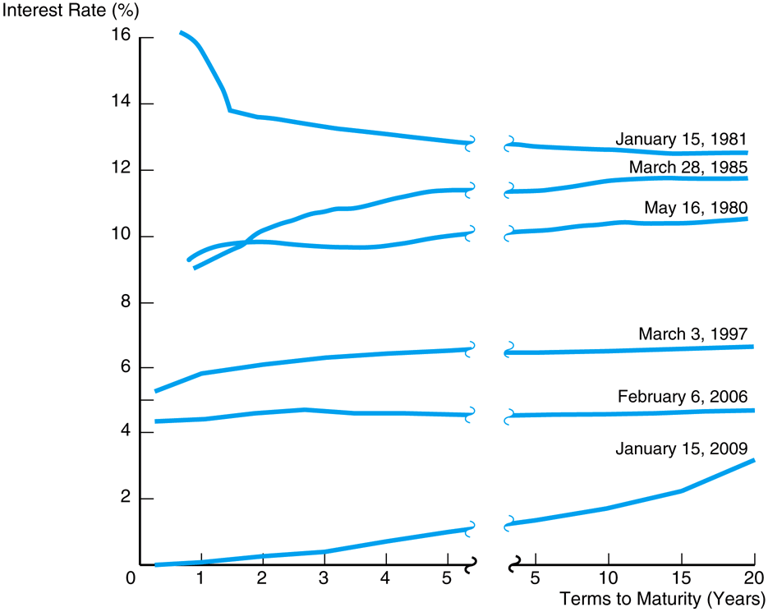

Missed part of past notes:
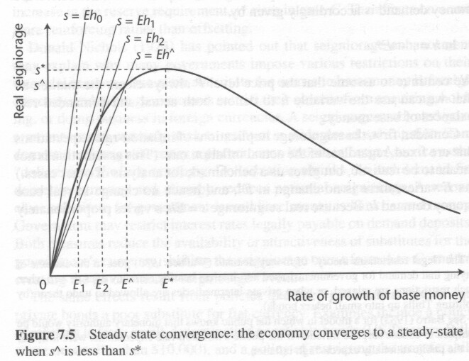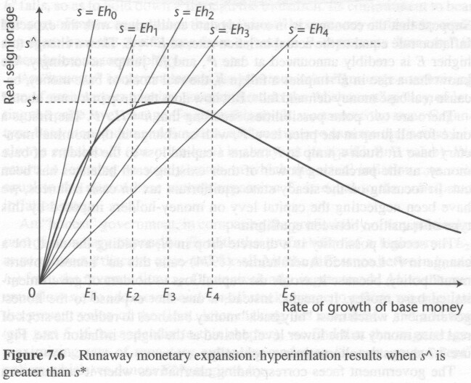
normal inflation hyperinflation

