Interest Rates (9/16/2010) Econ 310-004

Equations
- PV = FV/(1 + i)^{n} simple loan
- PV = FP/(1 + i)¹ + FP/(1 + i)² + FP/(1 + i)³ + … + FP/(1 + i)^{n} fixed-payment loan
- i = (F - P)/P discount bond
- PV = FV/(1 + i)^{n} + C/(1 + i)¹ + C/(1 + i)² + … + C/(1 + i)^{n} coupon bond
  - FV/(1 + i)^{n} PDV of bond selling price
  - C/(1 + i)¹ + C/(1 + i)² + … + C/(1 + i)^{n} PDV of coupon payments
- P_{C} = C/i_{C} consol
- R = i_{C} + g rate of return
- i = r + π^{e} fisher equation

Definitions
- interest rate – the price of time (not the price of money); price paid for rental of funds
- yield to maturity – interest rate that equates the present value of payments received from a credit market instrument with its value today
- present discounted value (PDV) – today’s value of future payment
- cash flows – cash payments to holder of a security
- bond – debt security with periodic payments for a specified period of time
- simple loan – lender provides funds to borrower; at the maturity date the principal plus additional interest is due
- fixed-payment loan – lender provides funds to borrower; funds are repaid by making the same payment every period with part of the principal plus interest for a set number of years
- discount bond (zero-coupon bond) – bought at a price below face value; face value repaid on maturity date
- coupon bond – pays the owner of the bond a fixed interest payment (coupon payment) every period until the maturity date when face value is repaid
- consol (perpetuity) – a coupon bond with no maturity date and no repayment of principal

Variable definitions
- PV ≡ present value
- FV ≡ future value (or CF for cash flow)
- C ≡ coupon payment
- i ≡ interest rate
- n ≡ time to maturity (usually in years)
- R ≡ rate of return
- i_{C} ≡ current yield
- g ≡ rate of capital gain
- i ≡ nominal interest rate
- r ≡ real interest rate
- π^{e} ≡ expected inflation
- P_{B} ≡ price of bonds
- B^{S} ≡ supply of bonds
- B^{D} ≡ demand for bonds
- L^{S} ≡ supply of loanable funds
- L^{D} ≡ demand for loanable funds
Principles
- rise in interest rates → fall in bond prices: i↑ → P_{B}↓
- prices and returns more volatile for long term bonds than short term bonds
- even bonds with huge interest rates can have negative returns if interest rates rise
- when holding periods don’t match maturity periods, there is interest rate risk
- some factors influence both supply and demand (e.g., expected inflation)
- bond price and the interest rate are inversely related, so when we see bond price go down that means interest rate goes up
- Keynes talked about the liquidity effect.
- Friedman rebutted him by noticing the other secondary effects.

Types of credit market instruments
- simple loan
- fixed-payment loan (fully amortized loan)
- discount bond (zero-coupon bond)
- coupon bond

Determinates of Bond Demand
- wealth: W↑ → B^{D}↑
- expected returns: R^{e}↑ → B^{D}↑
- risk or uncertainty: risk↑ → B^{D}↓
- liquidity: liquidity↑ → B^{D}↑
Determinates of Bond Supply
- profitability of investments:
I profitability↑ → B^{S}↑
- expected inflation: π^{e}↑ → B^{S}↑
- government deficit: (G – T)↑ → B^{S}↑

Effects on interest rate
- liquidity effect: M^{S}↑ → i↓
- income effect: M^{S}↑ → W↑, y↑ → i↑
- price-level effect: M^{S}↑ → P↑ → i↑
- fisher effect: M^{S}↑ → π^{e}↑ → i↑

Bond market (stock):
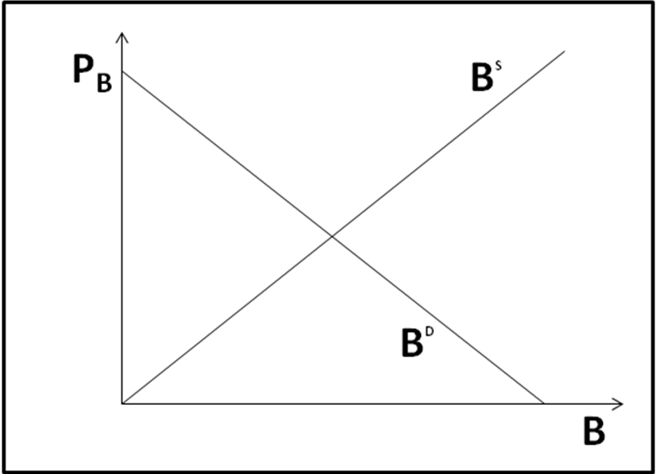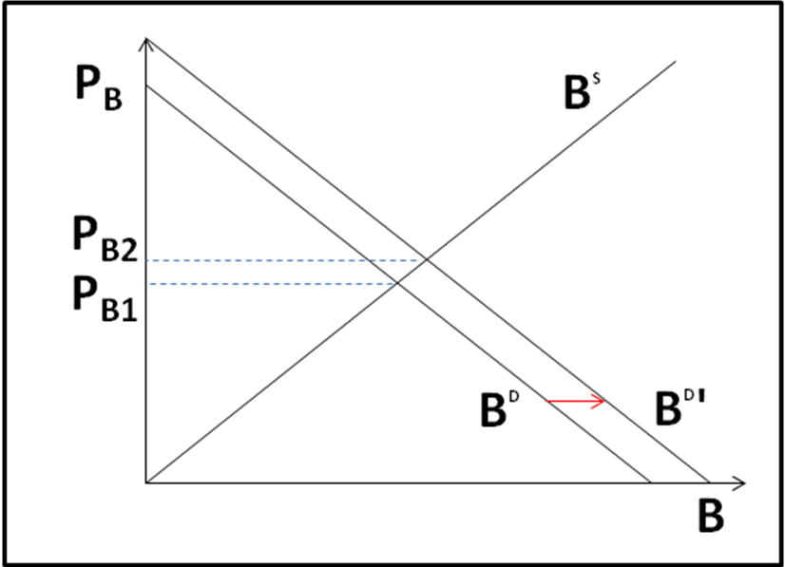

Loanable funds market (flow):
